**HO CHI MINH UNIVERSITY OF TECHNOLOGY AND EDUCATION**

**FACULTY FOR HIGH QUALITY TRAINING**

**--------****--------**



**CAPSTONE PROJECT**

**BUILD AN AGRICULTURAL PRODUCT TRADING SYSTEM**

**Instructor:**

**Nguyen Thien Bao, PhD**

**Students:**

|  |  |
| --- | --- |
| **Pham Viet Anh** | * **19110151** |
| **Tran Dang Khoa** | * **19110145** |
| **Nguyen Le Minh Nhut** | * **19110100** |
|  |  |

--- Ho Chi Minh, July 2023 ---

**HO CHI MINH UNIVERSITY OF TECHNOLOGY AND EDUCATION**

**FACULTY FOR HIGH QUALITY TRAINING**

**--------****--------**



**CAPSTONE PROJECT**

**BUILD AN AGRICULTURAL PRODUCT TRADING SYSTEM**

**Instructor:**

**Nguyen Thien Bao, PhD**

**Students:**

|  |  |
| --- | --- |
| **Pham Viet Anh** | * **19110151** |
| **Tran Dang Khoa** | * **19110145** |
| **Nguyen Le Minh Nhut** | * **19110100** |
|  |  |

--- Ho Chi Minh, July 2023 ---

**SOCIALIST REPUBLIC OF VIETNAM**

**Independence - Freedom – Happiness**

**\*\*\*\*\*\*\***

**GRADUATION THESIS**

**Student Name**: Pham Viet Anh **Student ID:** 19110151

**Student Name**: Tran Dang Khoa **Student ID:** 19110145

**Student Name**: Nguyen Le Minh Nhut **Student ID:** 19110100

1. **Major:** Software Engineering.
2. **Project title:** Build an agricultural product trading system.
3. **Advisor:** Nguyen Thien Bao, PhD.
4. Original data and documents:

- Research and learn Angular, React JS, React Native, Spring Boot.

- Research and learn Tensorflow for detecting fruits.

- Research and learn MySql for database.

1. Content implementation of the topic:

- Learn about Angular, React JS, React Native, Spring Boot, MySql, Material, Tensorlow.

- Building a system of buying and selling agricultural products between merchants and farmers:

* For admin: login/logout, view information about farmers, merchants, products, orders, etc…
* For farmer: login/logout, manage agricutural products, manage profiles, manage orders, etc…
* For merchant: login/logout, find agricutural products, manage profiles, manage orders, etc…

**INSTRUCTOR**

Nguyen Thien Bao

**SOCIALIST REPUBLIC OF VIETNAM**

**Independence - Freedom – Happiness**

**\*\*\*\*\*\*\***

**ADVISOR’S EVALUATION SHEET**

**Student Name**: Pham Viet Anh **Student ID:** 19110151

**Student Name**: Tran Dang Khoa **Student ID:** 19110145

**Student Name**: Nguyen Le Minh Nhut **Student ID:** 19110100

**Major:** Software Engineering.

**Project title:** Build an agricultural product trading system.

**Advisor:** Dr. Nguyen Thien Bao

**EVALUATION**

1. Content of the project:
2. Theory: Angular, React JS, React Native, Spring Boot, MySQL, Tensorflow.
3. Experiments:

- Research renowned websites about agricultural products to decide what features and functions to include in our projects. To determine the project's requirements, identify key points and significant business - build a system to trade agricultural products, meaning a system of buying and selling agricultural products between merchants and farmers.

- Discover Angular, SpringBoot, React JS and React Native. Effectively using additional libraries, apply it to the project.

- Build Back-end (with SpringBoot) and front-end (React Native, React JS and Angular). Connect them together libraries to build up the construction of an online can interact between a website and a mobile device with both basic and advanced features.

- Use Tensorflow to detect fruit with high-resolution image.

1. Links: <https://github.com/nohoopes/KLTN_K19_CLA_Farmhome>
2. Strengths:

- The system incorporates seamless file uploading, internet-based hosting, an agricultural detection model, and thorough error testing.

- The interface is improved based on instructor feedback for wider user suitability. Statistical indicators are carefully sourced and consulted with experts. Optimizing simple functions maximizes efficiency and effectiveness.

- Contains the basic functions used for trading argicultural products in the “Merchant” and “Farmer” side.

- There will be some functions that used to support for the trading.

- Collecting data to show the price to the users so thay can know about the price in the market right now.

- Notifications will be sent to the user’s phone to make sure they will notice when there is an event to their orders.

- Fruit detection helps users identify different types of fruits, facilitating the easy recording of information through images using a pre-trained model.

1. Weaknesses:

- The current system lacks some features such as message, language switching, notification in website, not support for IOS right now in mobile, social media login, etc…

- The application's lack of optimization can lead to slower access speed, potential errors, and misclassification of new agricultural products by the machine learning model used for classification.

- In real-world scenarios, there may be instances where certain features are missing or insufficient, which can present challenges for users.

- Limited advanced permission management features may compromise system security and control by hindering effective user role and access level management.

- The absence of a dedicated reference price management feature for farmers complicates the process of setting competitive prices based on reliable market references.

1. Approval for oral defense? (Approved or denied)

...........................................................................................................................................

1. Overall evaluation: (Excellent, Good, Fair, Poor)

...........................................................................................................................................

1. Mark: ………. (in words: .........................................................................................)

Ho Chi Minh City, July 2023

**ADVISOR**

*(Sign with full name)*

**SOCIALIST REPUBLIC OF VIETNAM**

**Independence - Freedom – Happiness**

**\*\*\*\*\*\*\***

**PRE-DEFENSE EVALUATION SHEET**

**Student Name**: Pham Viet Anh **Student ID:** 19110151

**Student Name**: Tran Dang Khoa **Student ID:** 19110145

**Student Name**: Nguyen Le Minh Nhut **Student ID:** 19110100

**Major:** Software Engineering.

**Project title:** Build an agricultural product trading system.

**Reviewer:** ..............................................................................................

**EVALUATION**

1. Content of the project:
2. Theory: Angular, React JS, React Native, Spring Boot, MySQL, Tensorflow.
3. Experiments:

- Research renowned websites about agricultural products to decide what features and functions to include in our projects. To determine the project's requirements, identify key points and significant business - build a system to trade agricultural products, meaning a system of buying and selling agricultural products between merchants and farmers.

- Discover Angular, SpringBoot, React JS and React Native. Effectively using additional libraries, apply it to the project.

- Build Back-end (with SpringBoot) and front-end (React Native and Angular). Connect them together libraries to build up the construction of an online can interact between a website and a mobile device with both basic and advanced features.

- Use Tensorflow to detect fruit with high image.

1. Strengths:

...........................................................................................................................................

...........................................................................................................................................

...........................................................................................................................................

1. Weaknesses:

...........................................................................................................................................

...........................................................................................................................................

...........................................................................................................................................

1. Approval for oral defense? (Approved or denied)

...........................................................................................................................................

1. Overall evaluation: (Excellent, Good, Fair, Poor)

...........................................................................................................................................

1. Mark:…. (in words: .........................................................................................)

Ho Chi Minh City, July 2023

**REVIEWER**

*(Sign with full name)*

**SOCIALIST REPUBLIC OF VIETNAM**

**Independence - Freedom – Happiness**

**\*\*\*\*\*\*\***

**EVALUATION SHEET OF**

**DEFENSE COMMITTEE MEMBER**

**Student Name**: Pham Viet Anh **Student ID:** 19110151

**Student Name**: Tran Dang Khoa **Student ID:** 19110145

**Student Name**: Nguyen Le Minh Nhut **Student ID:** 19110100

**Major:** Software Engineering.

**Project title:** Build an agricultural product trading system.

**Name of Defense Committee Member:**

...........................................................................................................................................

...........................................................................................................................................

...........................................................................................................................................

**EVALUATION**

1. Content of the project:
2. Theory: Angular, React JS, React Native, Spring Boot, MySQL, Tensorflow.
3. Experiments:

- Research renowned websites about agricultural products to decide what features and functions to include in our projects. To determine the project's requirements, identify key points and significant business - build a system to trade agricultural products, meaning a system of buying and selling agricultural products between merchants and farmers.

- Discover Angular, SpringBoot, React JS and React Native. Effectively using additional libraries, apply it to the project.

- Build Back-end (with SpringBoot) and front-end (React Native and Angular). Connect them together libraries to build up the construction of an online can interact between a website and a mobile device with both basic and advanced features.

- Use Tensorflow to detect fruit with high image.

1. Strengths:

...........................................................................................................................................

...........................................................................................................................................

...........................................................................................................................................

1. Weaknesses:

...........................................................................................................................................

...........................................................................................................................................

...........................................................................................................................................

1. Approval for oral defense? (Approved or denied)

...........................................................................................................................................

1. Overall evaluation: (Excellent, Good, Fair, Poor)

...........................................................................................................................................

1. Mark: ……. (in words: .........................................................................................)

Ho Chi Minh City, July 2023

**COMMITTEE MEMBER**

*(Sign with full name)*

**ACKNOWLEDGEMENT**

Mr. Nguyen Thien Bao, the instructor of our course, deserves special thanks from our team. Throughout this course, you have constantly assisted us with our difficulties in the study process as well as provided us with excellent feedback and recommendations to help us grow as developers in the future. As a result, you have become our inspiration for this final project, and we would like to express our gratitude for the opportunity to learn from you in this course.

Everyone on our team has various talents, and we have discovered our shortcomings in each other over this final assignment, but we've all managed to face this challenge as a team. As a result, everyone on our team is really grateful for the opportunity to collaborate.

Thank you to the teachers in the Faculty for High Quality Training for always being enthusiastic, dedicated, and dedicated to answering our questions. Besides, we would like to thank our classmates and seniors who did not hesitate to share useful information and experiences to help us improve our thesis.

This final project is the result of our tireless efforts throughout the semester. Because we are still novices, we are aware that our design has numerous shortcomings. We welcome any feedback as well as suggestions for improving our project. We appreciate it. Sincerely!

Ho Chi Minh city, July …., 2023

Group

Pham Viet Anh

Tran Dang Khoa

Nguyen Le Minh Nhut

TABLE OF CONTENTS

CHAPTER 1: INTRODUCTION 1

1.1. Urgency of the topic 1

1.2. The purpose of project 1

1.3. Object and scope of the study 2

1.4. Expected results 2

CHAPTER 2. THEORY FUNDAMENTALS 3

2.1. Angular 3

2.1.1. Definition 3

2.1.2. Key features 3

2.1.3. Why we use it? 4

2.2. React Native 5

2.2.1. Definition 5

2.2.2. Key features 5

2.2.3. Why we use it? 6

2.3. ReacJs 7

2.3.1. Definition 7

2.3.2. Key features 8

2.3.3. Why we use it? 9

2.4. Spring Boot 10

2.4.1. Definition 10

2.4.2. Key features 10

2.4.3. Why we use it? 11

2.5. MySQL 12

2.5.1. Definition 12

2.5.2. Key features 13

2.5.3. Why we use it? 14

2.5. Postman 15

2.5.1. Definition 15

2.5.2. Key features 15

2.5.3. Why we use it? 16

2.6. Tensorflow 17

2.6.1. Definition 17

2.6.2. Key features 18

2.6.3. Why we use it? 19

CHAPTER 3. STATE OF THE ART AND SYSTEM EQUIREMENT MODELING 21

3.1. State of the art 21

3.1.2. Domestic 21

3.1.2. International 21

3.2. System requirements 22

3.3. Requirement analysis 23

3.3.1. Functional requirements 23

3.3.2. Non-functional requirements 27

3.4. Bussiness model 29

CHAPTER 4. SYSTEM DESIGN 30

4.1. List of actors and usecases 30

4.1.1. Identify actors and use cases in use case diagrams 30

4.1.2. Detailed description 31

4.1.3. Usecase summary 33

4.1.4. Usecase diagram 34

4.2. Usecase specifications 38

4.2.1. Description of Login 38

4.2.2. Description of Edit Account 38

4.2.3. Description of Register 39

4.2.4. Description of View List of agricultural products 39

4.2.5. Description of View list of agricultural products that farmers own 40

4.2.6. Description of Search 40

4.2.7. Description of Order 41

4.2.8. Description of Cancel the ordered agricultural product 42

4.2.9. Description of See the list of ordered agricultural products 42

4.2.10. Description of Deal new agricultural products’s price 43

4.2.11. Description of Decision final deal price 43

4.2.12. Description of Manage agricultural product 44

4.2.13. Description of Validate agricultural products 44

4.3. Sequence diagrams 45

4.3.1. Login 45

4.3.2. Register 46

4.3.3. Create fruit 47

4.3.4. Show fruit 48

4.3.5. Create order 49

4.3.6. Accept order 50

4.3.7. Decline order 50

4.3.8. Report 51

4.3.9. Complete 51

4.3.10. Search fruit 52

4.4. Database design 52

4.4.1. Database table 52

4.4.2. Relational diagram 59

4.5. User interface 60

4.5.1. Mobile for merchant 60

4.5.2. Website for farmer 79

4.5.3. Website for admin 97

CHAPTER 5: IMPLEMENTATION AND TESTING 108

5.1. Overall architecture of the system 108

5.2. Tensorflow 110

5.3. Testing 111

CHAPTER 6. CONCLUSION 131

6.1. Achieved result 131

6.1.1. About knowledge and skills: 131

6.1.2. About the topic: 132

6.2. Strengths 132

6.3. Drawbacks 133

6.4. Future developments 134

**LIST OF TABLES**

Table 1. 1. Business functional requirements of merchant department 24

Table 1. 2. Business functional requirements of farmer department 26

Table 1. 3. System functional requirements 27

Table 1. 4. Non-functional requirements 28

Table 2. 1. Identify actors and use cases in use case diagrams………………………31

Table 2. 2. Detailed description 33

Table 2. 3. Usecase summary 34

Table 2. 4. Description of Login 38

Table 2. 5. Description of Edit Account 39

Table 2. 6. Description of Register 39

Table 2. 7. Description of View List of agricultural products 40

Table 2. 8. Description of View list of agricultural products that farmers own 40

Table 2. 9. Description of Search 41

Table 2. 10. Description of Order 41

Table 2. 11. Description of Cancel the ordered agricultural product 42

Table 2. 12. Description of See the list of ordered agricultural products 43

Table 2. 13. Description of Deal new agricultural products’s price 43

Table 2. 14. Description of Decision final deal price 43

Table 2. 15. Description of Manage agricultural product 44

Table 2. 16. Description of Validate agricultural products 44

Table 2. 17. District database table 53

Table 2. 18. Fruit database table 53

Table 2. 19. Fruit image database table 53

Table 2. 20. History database table 54

Table 2. 21. Location database table 54

Table 2. 22. News database table 55

Table 2. 23. Order database table 56

Table 2. 24. Province database table 56

Table 2. 25. Role database table 56

Table 2. 26. Status product database table 56

Table 2. 27. Status user database table 57

Table 2. 28. User database table 57

Table 2. 29. User role database table 58

Table 2. 30. Role database table 58

Table 2. 31. List of mobile screens for merchants 61

Table 2. 32. Mobile login screen event 62

Table 2. 33. Mobile register screen event 64

Table 2. 34. Home screen event 65

Table 2. 35. Me screen event 66

Table 2. 36. Explore screen event 67

Table 2. 37. Search screen event 67

Table 2. 38. Product detail screen event 69

Table 2. 39. Order event 70

Table 2. 40. Payment waiting list event 70

Table 2. 41. History list event 71

Table 2. 42. Order details screen event 73

Table 2. 43. Notification screen event 73

Table 2. 44. Message screen event 74

Table 2. 45. Change password screen event 75

Table 2. 46. Update profile screen event 77

Table 2. 47. List of message event 78

Table 2. 48. Change language screen event 79

Table 2. 49. List of website page for farmer 80

Table 2. 50. Login page event 81

Table 2. 51. Register page event 84

Table 2. 52. Home page event 85

Table 2. 53. Prices page event 86

Table 2. 54. Products page event 87

Table 2. 55. Update product event 88

Table 2. 56. Delete product event 88

Table 2. 57. Add product dialog event 90

Table 2. 58. Order page event 91

Table 2. 59. Accept order event 92

Table 2. 60. Discuss price event 92

Table 2. 61. Decline order event 93

Table 2. 62. Order with dealing status event 94

Table 2. 63. Order with canceled status event 95

Table 2. 64. History page event 95

Table 2. 65. Profile page event 96

Table 2. 66. Change password event 97

Table 2. 67. List of website page for admin 98

**LIST OF FIGURES**

Figure 2. 1. General usecase diagram 34

Figure 2. 2. Usecase for merchant 35

Figure 2. 3. Usecase for farmer 36

Figure 2. 4. Usecase for admin 37

Figure 2. 5. Login sequence diagram 45

Figure 2. 6. Register sequence diagram 46

Figure 2. 7. Create fruit sequence diagram 47

Figure 2. 8. Show fruit sequence diagram 48

Figure 2. 9. Create order sequence diagram 49

Figure 2. 10. Accept order sequence diagram 50

Figure 2. 11. Decline order sequence diagram 50

Figure 2. 12. Report sequence diagram 51

Figure 2. 13. Complete sequence diagram 51

Figure 2. 14. Search fruit sequence diagram 52

Figure 2. 15. Database relational diagram 59

Figure 2. 16. Mobile login screen 61

Figure 2. 17. Mobile register screen 1 62

Figure 2. 18. Mobile register screen 2 63

Figure 2. 19. Home screen 64

Figure 2. 20. Me screen 65

Figure 2. 21. Explore screen 66

Figure 2. 22. Search screen 67

Figure 2. 23. Product detail screen 68

Figure 2. 24. Order bottom sheet 69

Figure 2. 25. Payment waiting list 70

Figure 2. 26. History list 71

Figure 2. 27. Order details screen 72

Figure 2. 28. Notification screen 73

Figure 2. 29. Message screen 74

Figure 2. 30. Change password screen 75

Figure 2. 31. Update profile screen 1 76

Figure 2. 32. Update profile screen 2 76

Figure 2. 33. List of message 78

Figure 2. 34. Change language screen 79

Figure 2. 35. Login page 80

Figure 2. 36. Register page 81

Figure 2. 37. Home page 84

Figure 2. 38. Reference page 85

Figure 2. 39. Reference price website 86

Figure 2. 40. Products page 86

Figure 2. 41. Update product 87

Figure 2. 42. Delete product 88

Figure 2. 43. Add product dialog 89

Figure 2. 44. Order page 90

Figure 2. 45. Accept order 91

Figure 2. 46. Discuss price 92

Figure 2. 47. Decline order 93

Figure 2. 48. Order with dealing status 94

Figure 2. 49. Order with canceled status 94

Figure 2. 50. History page 95

Figure 2. 51. Profile page 96

Figure 2. 52. Change password 97

Figure 2. 53. Login Page 99

Figure 2. 54. Statistic Page 99

Figure 2. 55. Merchant List Page 100

Figure 2. 56. Merchant detail page 100

Figure 2. 57. Farmer detail page 101

Figure 2. 58. News list page 103

Figure 2. 59. Category list page 103

Figure 2. 60. Report list page 104

Figure 2. 61. Statistic detail 105

Figure 3. 1. Architecture of the system 108

Figure 3. 2. Login page 112

Figure 3. 3. Home page 112

Figure 3. 4. Product page 113

Figure 3. 5. Add new product 113

Figure 3. 6. Detect product 114

Figure 3. 7. New product is added 114

Figure 3. 8. Edit product 115

Figure 3. 9. Delete product 116

Figure 3. 10. Login screen 117

Figure 3. 11. Explore screen 118

Figure 3. 12. Product details screen 119

Figure 3. 13. Order 120

Figure 3. 14. Choose location 121

Figure 3. 15. Go to payment waiting list 122

Figure 3. 16. Payment waiting list 122

Figure 3. 17. Order page 123

Figure 3. 18. Accept order 124

Figure 3. 19. Negotiating about the new price 124

Figure 3. 20. Decline order 125

Figure 3. 21. Discuss new price and amount 125

Figure 3. 22. Dealing tab 126

Figure 3. 23. Phone recived notification 126

Figure 3. 24. Order details 128

Figure 3. 25. Pending tab 128

Figure 3. 26. Accept order 129

Figure 3. 27. History page 130

Figure 3. 28. History screen 130

# CHAPTER 1: INTRODUCTION

## 1.1. Urgency of the topic

Vietnam is an agricultural nation, agricultural products continued to account for a sizable share of the country's exports.

The remaining agricultural products were previously mostly consumed at wholesale marketplaces, with purchasing agents in large centers before coming to the market, in addition to being supplied to supermarkets and import-export businesses. consumers.

The growth of the digital economy has altered how society currently views business. As can be seen, any good or service, including agricultural goods, can be advertised and made "for sale" online. Additionally, consumers want to know whether the agricultural products they buy are of good quality and safe for their health.

Therefore, managers need a more effective communication channel and website/mobile design is the chosen option. This is in addition to enhancing the quality of agricultural products, communicating the brand, and improving the packaging to uphold the quality reputation.

## 1.2. The purpose of project

The portal allows farmers to first post agricultural items that are only available for a limited time, along with personal and contact information. The merchandiser's mobile application will then show the products, allowing them to select the ones that are best suited to their requirements. The retailer will provide a pricing after determining the appropriate goods and quantity, and will then send the gardener a request along with contact details like their phone number, address, and shipping address. If the farmer accepts, he will confirm and the merchant will receive a successful notification. In contrast, if the farmer rejects the request, it will be declined and a notice of the rejection will be given to the merchant. The farmer may also recommend a different price, and the two parties may speak over the phone to discuss it. Once both parties have consented, the farmer can use the exchange button to display the form, fill it out with the new price, and submit it back to the merchant for confirmation before resuming the transaction. The merchant will receive updated information to review and validate. The deal is finished if everything goes according to plan and the farmer confirms; if not, it is canceled.

## 1.3. Object and scope of the study

Two focus groups of participants, including those with and without prior knowledge of technology, were used in the investigation.

Which covers the Angular, React Native, React JS, MySQL database, Spring Boot, as well as a little application about tensorflow among the group of technical knowledge areas. Many useful Javascript libraries are adding to the list of research topics on technology expertise.

The research's main objectives are outlined, and the researcher has a general understanding of its subject matter and is able to apply each knowledge point to the finished product without heavily emphasizing theories, non-applicable.

## 1.4. Expected results

Topic “BUILD A SYSTEM TO TRADE AGRICULTURAL PRODUCTS” serves following purposes:

- Building a website for farmers can management their products as well as orders.

- Building a mobile application for merchants can find and trade agricultural products with farmers.

- Building a system of buying and selling agricultural products between merchants and farmers with a user-friendly interface, easy to use.

# CHAPTER 2. THEORY FUNDAMENTALS

## 2.1. Angular

### 2.1.1. Definition

Angular is a popular open-source framework for building web applications. It is developed and maintained by Google. Angular is designed to simplify the process of building dynamic, single-page applications by providing a structured framework and a set of tools and libraries.

One of the key features of Angular is its use of a component-based architecture. It allows developers to build modular and reusable components that encapsulate the application's logic and user interface. These components can be composed and combined to create complex applications.

Angular uses TypeScript, a superset of JavaScript, as its primary language for development. TypeScript adds static typing and other features to JavaScript, making it more robust and maintainable. This helps in catching errors at compile-time and provides better tooling support for code editors.

### 2.1.2. Key features

*Component-Based Architecture:* Angular follows a component-based architecture, where the application is divided into modular and reusable components. Components encapsulate the logic, data, and user interface of different parts of the application, making it easier to develop, test, and maintain.

*Two-Way Data Binding:* Angular offers two-way data binding, which means changes made to the data in the model are automatically reflected in the view, and vice versa. This simplifies keeping the user interface in sync with the underlying data and reduces the amount of boilerplate code.

*Dependency Injection:* Angular has built-in support for dependency injection, a design pattern that helps manage dependencies between different parts of the application. Dependency injection promotes modularity, reusability, and testability by making it easier to replace or update components without affecting other parts of the application.

*Templating and Directives:* Angular provides a powerful templating system based on HTML. It allows developers to define the structure and behavior of the user interface using declarative templates. Angular also introduces directives, which are custom HTML tags or attributes that extend the functionality of HTML and enable the creation of dynamic and interactive views.

*TypeScript Language:* Angular is written in TypeScript, a superset of JavaScript that adds static typing and other features to the language. TypeScript improves the maintainability and scalability of Angular applications by catching errors at compile-time and providing better tooling support for code editors.

*Reactive Programming:* Angular integrates well with reactive programming libraries like RxJS. Reactive programming allows developers to handle asynchronous operations, such as HTTP requests or user input, in a more declarative and manageable way. This leads to cleaner and more maintainable code.

### 2.1.3. Why we use it?

*Enhanced Productivity:* Angular provides a powerful command-line interface (CLI) that automates many common development tasks, such as scaffolding components, generating code, and running tests. This helps developers to be more productive and focus on building features rather than configuring the project.

*Two-Way Data Binding:* Angular offers two-way data binding, which means any changes made to the data in the application's model are automatically reflected in the view, and vice versa. This simplifies the process of keeping the user interface in sync with the underlying data.

*Dependency Injection:* Angular has built-in support for dependency injection, which makes it easier to manage dependencies between different parts of the application. This promotes modularity, testability, and code reusability.

*Powerful Templating System:* Angular provides a declarative templating system that allows developers to define the structure and behavior of the user interface in HTML templates. These templates can contain expressions, directives, and other features to create dynamic and interactive views.

R*obust Community and Ecosystem:* Angular has a large and active community of developers, which means there are plenty of resources, tutorials, and libraries available to support development. Additionally, Angular integrates well with other popular libraries and frameworks, such as RxJS for reactive programming and NgRx for state management.

## 2.2. React Native

### 2.2.1. Definition

React Native is an open-source framework developed by Facebook that allows developers to build mobile applications using JavaScript and React, a popular JavaScript library for building user interfaces. React Native enables the development of native mobile apps for iOS and Android platforms while leveraging the benefits of React's component-based architecture.

### 2.2.2. Key features

*Cross-Platform Development:* React Native enables developers to write code once and deploy it on multiple platforms, such as iOS and Android. This significantly reduces development time and effort compared to building separate native applications for each platform.

*Native-Like Performance:* React Native uses native components and APIs, allowing applications to deliver near-native performance and user experience. It achieves this by rendering components using native UI elements rather than web views.

Reusable Components: React Native promotes a component-based architecture, where the application is built by combining reusable UI components. These components can be shared across different parts of the application or even between different React Native projects, improving code reusability and maintainability.

*Hot Reloading:* React Native supports hot reloading, which allows developers to see the changes they make in the code immediately reflected in the running application. This accelerates the development process and provides a smooth feedback loop for developers.

*Access to Native APIs:* React Native provides a bridge that allows JavaScript code to interact with platform-specific APIs. This means developers can access various native functionalities, such as camera, GPS, storage, and push notifications, by writing JavaScript code.

*Third-Party Library Ecosystem:* React Native benefits from a vast ecosystem of third-party libraries and packages that can be easily integrated into projects. These libraries cover a wide range of functionalities, including UI components, state management, navigation, and more, saving development time and effort.

*Community and Support:* React Native has a large and active community of developers who contribute to its development, share knowledge, and provide support. This community-driven nature ensures the framework's continuous improvement, offers access to resources and tutorials, and helps resolve issues efficiently.

### 2.2.3. Why we use it?

*Code Reusability:* With React Native, developers can write a single codebase that works across multiple platforms. This reduces the need for separate development teams or rewriting code from scratch, resulting in faster development cycles and reduced maintenance efforts.

*Faster Development:* React Native's hot reloading feature allows developers to see changes instantly, speeding up the development process. Additionally, the availability of pre-built UI components and third-party libraries enables rapid prototyping and development.

*Native-Like Performance:* React Native offers near-native performance by rendering components using native UI elements. This ensures smooth animations, gestures, and overall responsiveness, providing a native-like user experience.

*Cost-Effectiveness:* Building a mobile app using React Native can be more cost-effective compared to developing separate apps for different platforms. It reduces the resources required for development, maintenance, and ongoing updates.

*Developer Efficiency:* React Native leverages JavaScript, a widely adopted programming language, and React's component-based architecture. This allows developers with web development experience to transition into mobile app development more easily and efficiently.

*Platform-Specific Functionality:* React Native provides access to native APIs, allowing developers to access platform-specific features and functionalities. This ensures that the application can leverage the full capabilities of the underlying platform.

*Easy Updates and Maintenance:* With React Native, updates and bug fixes can be applied to the codebase quickly and efficiently. Changes made to the codebase are reflected across all supported platforms, ensuring consistent updates and reducing maintenance overhead.

While React Native offers numerous advantages, it's important to consider that certain platform-specific features or complex UI elements may require additional customization or native code integration. Additionally, apps with high-performance requirements or intensive graphics processing may still benefit

## 2.3. ReacJs

### 2.3.1. Definition

React JS, also known as React, is an open-source JavaScript library for building user interfaces. It was developed by Facebook and is widely adopted by developers for creating interactive and dynamic web applications. React follows a component-based architecture, allowing developers to build reusable UI components and efficiently manage the application state.

### 2.3.2. Key features

*Component-Based Architecture:* React organizes the UI into reusable components that encapsulate their own logic and state. Components can be composed together to build complex user interfaces. This component-based approach promotes reusability, maintainability, and modularity in the application development process.

*Virtual DOM:* React utilizes a virtual representation of the Document Object Model (DOM), known as the Virtual DOM. This lightweight abstraction allows React to efficiently update and render the components by comparing the virtual DOM with the actual DOM, minimizing the number of updates and improving performance.

JSX Syntax: React uses JSX (JavaScript XML), an extension to JavaScript, which allows developers to write HTML-like syntax directly within JavaScript code. JSX makes it easier to describe the structure and behavior of UI components, enhancing the readability and maintainability of the code.

*Unidirectional Data Flow:* React follows a unidirectional data flow pattern, also known as one-way data binding. This means that the data flows in a single direction, from parent components to child components. This pattern ensures predictable data updates and helps maintain a clear data flow within the application.

*React Hooks:* React Hooks are functions introduced in React 16.8 that allow developers to add state and other React features to functional components. Hooks provide a simpler and more concise way to manage component state and lifecycle events without the need for class components.

*React Router:* React Router is a popular routing library for React applications. It enables developers to handle navigation and routing within a single-page application, allowing for the creation of multiple views and providing a seamless user experience.

### 2.3.3. Why we use it?

*Component Reusability:* React's component-based architecture allows developers to create reusable UI components. These components can be composed and combined in various ways, promoting code reusability and reducing development time.

*Virtual DOM Efficiency:* React's use of the Virtual DOM enables efficient updates and rendering of components. By minimizing direct manipulations to the actual DOM, React optimizes performance and provides a smoother user experience.

*Developer Efficiency:* React's declarative syntax and component reusability improve developer productivity. The use of JSX makes it easier to visualize and create UI components, while React's component architecture facilitates code organization and maintenance.

*Large Community and Ecosystem:* React has a vast and active community of developers, which results in extensive documentation, tutorials, and third-party libraries. This active ecosystem provides access to a wide range of resources, tools, and solutions, accelerating development and problem-solving.

*SEO-Friendly:* React supports server-side rendering (SSR) and can render components on the server before sending the HTML to the client. This improves search engine optimization (SEO) by ensuring that search engines can crawl and index the application's content more effectively.

*Mobile App Development:* React Native, a framework based on React, allows for the development of native mobile applications for iOS and Android platforms. React developers can leverage their existing skills and codebase to build mobile apps, promoting code reuse and reducing development time.

*Stability and Backward Compatibility:* React has a strong commitment to maintaining backward compatibility. This means that React applications built using older versions of the library can often be easily upgraded to newer versions without significant code changes.

React JS is widely used in the industry due to its efficiency, developer-friendly features, and vibrant community support. Its focus on reusable components and efficient rendering makes it a popular choice for building complex and interactive user interfaces in web applications.

## 2.4. Spring Boot

### 2.4.1. Definition

Spring Boot is an open-source Java framework designed to simplify the development of standalone, production-ready Spring applications. It builds on top of the popular Spring Framework and provides a convention-over-configuration approach, allowing developers to quickly create robust and scalable applications with minimal boilerplate code.

### 2.4.2. Key features

*Auto-configuration:* Spring Boot provides automatic configuration for various components based on the dependencies present in the project's classpath. It eliminates the need for manual configuration by intelligently configuring defaults and reducing the amount of configuration code required.

Standalone Applications: Spring Boot allows you to create standalone applications that can be executed directly without the need for complex deployment procedures or external application servers. It embeds an embedded web server, such as Apache Tomcat or Jetty, within the application, making it self-contained and easy to run.

*Spring Actuator:* Spring Boot Actuator provides powerful features for monitoring and managing applications. It offers built-in endpoints that expose various metrics, health checks, and runtime information about the application, making it easier to monitor and manage the application in production environments.

*Opinionated Defaults:* Spring Boot follows an opinionated approach to provide sensible defaults for application configurations. It minimizes the configuration burden on developers by making intelligent assumptions about the project's requirements, while still allowing customization when needed.

*Production-Ready Features:* Spring Boot incorporates several features that are essential for developing production-ready applications. It includes support for metrics, logging, security, caching, and database integration, among others. These features help developers focus on business logic rather than dealing with low-level infrastructure concerns.

*Developer Tools:* Spring Boot offers a range of developer tools that enhance the development experience. Features such as automatic application restart, live reloading of static resources, and interactive debugging make the development process faster and more efficient.

*Seamless Integration with Spring Ecosystem:* Spring Boot seamlessly integrates with the wider Spring ecosystem, including popular projects like Spring Data, Spring Security, Spring Cloud, and Spring Integration. It simplifies the integration of these components, enabling developers to leverage their functionalities effortlessly.

### 2.4.3. Why we use it?

*Rapid Application Development:* Spring Boot's convention-over-configuration approach and auto-configuration capabilities significantly reduce the amount of boilerplate code and manual configuration required. This speed up the development process and allows developers to focus more on writing business logic rather than dealing with infrastructure concerns.

*Increased Productivity:* Spring Boot's opinionated defaults and pre-configured dependencies enable developers to get started quickly with a fully functional application. The out-of-the-box support for commonly used features and integrations eliminates the need for manual setup, saving time and effort.

*Microservices Architecture:* Spring Boot works well in microservices-based architectures. Its lightweight and standalone nature make it suitable for building and deploying independent microservices. The seamless integration with Spring Cloud provides additional features for service discovery, load balancing, configuration management, and distributed tracing.

*Production-Ready Applications:* Spring Boot incorporates production-ready features such as health checks, metrics, and monitoring capabilities through Spring Actuator. These features enable efficient management and monitoring of applications in production environments, enhancing reliability and scalability.

*Extensive Community and Support*: Spring Boot has a vast and active community of developers, providing access to extensive documentation, tutorials, and community-driven support. The large ecosystem ensures that developers can find solutions to common challenges and leverage community-developed libraries and plugins.

*Industry Adoption:* Spring Boot has gained significant popularity and is widely adopted in the industry. Its reputation for reliability, scalability, and ease of development makes it a preferred choice for building enterprise-grade applications. The availability of skilled developers and resources further contributes to its popularity.

In summary, Spring Boot simplifies the development process, enhances productivity, and provides a solid foundation for building production-ready Java applications. Its opinionated defaults, auto-configuration, and seamless integration with the Spring ecosystem make it a powerful framework for developing a wide range of applications, from simple microservices to complex enterprise systems.

## 2.5. MySQL

### 2.5.1. Definition

MySQL is an open-source relational database management system (RDBMS) that is widely used for storing and managing structured data. It is one of the most popular databases in the world and is known for its ease of use, scalability, and performance. MySQL is used by a wide range of applications, from small personal projects to large enterprise systems.

### 2.5.2. Key features

*Relational Database Management:* MySQL is based on the relational model, which organizes data into tables with rows and columns. It provides a structured and organized approach to storing and retrieving data, allowing for efficient data management.

*Scalability and Performance:* MySQL is designed to handle large amounts of data and high traffic loads. It supports various indexing techniques, query optimization, and caching mechanisms to ensure fast and efficient data retrieval. It also offers options for horizontal scaling through replication and clustering.

*Multi-User and Concurrent Access:* MySQL supports multiple users accessing the database simultaneously, making it suitable for applications with concurrent access requirements. It provides mechanisms for managing concurrent data modifications and enforcing data consistency and integrity.

*Data Security:* MySQL offers robust security features to protect data from unauthorized access and ensure data integrity. It supports user authentication, access control, and encryption of data in transit and at rest. MySQL also provides mechanisms for auditing and logging activities for compliance and troubleshooting purposes.

*Wide Platform Support:* MySQL is available for various platforms, including Windows, macOS, Linux, and other Unix-like operating systems. It is compatible with different programming languages and frameworks, making it versatile and suitable for a wide range of application development scenarios.

*Replication and High Availability:* MySQL supports replication, allowing data to be copied across multiple database servers in real-time. This enables load balancing, data backup, and high availability scenarios where one server can take over in case of failure.

*Community and Ecosystem:* MySQL has a large and active community of developers, providing extensive documentation, tutorials, and forums for support. It also has a rich ecosystem of third-party tools, libraries, and frameworks that integrate well with MySQL, further enhancing its functionality and ease of use.

### 2.5.3. Why we use it?

*Ease of Use:* MySQL is known for its ease of installation, configuration, and administration. It provides a user-friendly command-line interface and graphical tools for managing databases and executing queries. Its simplicity makes it suitable for beginners and experienced developers alike.

Performance and Scalability: MySQL is optimized for performance and can handle large datasets and high traffic loads efficiently. It supports advanced indexing techniques, caching mechanisms, and query optimization to deliver fast response times, even with complex queries.

*Cost-Effective:* MySQL is an open-source database, which means it is free to use and comes with a vibrant community of contributors and support. This makes it a cost-effective choice for small projects and startups with limited budgets.

Reliability and Stability: MySQL has been around for many years and has a proven track record of stability and reliability. It is extensively tested, widely used, and has a large user base, which contributes to its robustness and ensures ongoing development and support.

*Compatibility and Integration:* MySQL is compatible with various programming languages, frameworks, and tools. It provides connectors and drivers for popular programming languages like Java, Python, PHP, and more, allowing easy integration with different application stacks.

*Wide Range of Applications:* MySQL is suitable for a wide range of applications, from small websites to large-scale enterprise systems. It can be used for content management systems, e-commerce platforms, data-driven applications, business intelligence, and analytics solutions, among others.

*Community and Support:* MySQL has a large and active community of developers and users who contribute to its development, share knowledge, and provide support. The community-driven nature ensures that there are ample resources, documentation, and forums available for assistance.

In summary, MySQL is a powerful and widely adopted relational database management system. Its ease of use, scalability, performance, security features, and extensive community support make it a popular choice for managing and storing structured data in various applications.

## 2.5. Postman

### 2.5.1. Definition

Postman is a popular collaboration platform and API development tool used by developers and API providers to streamline the process of building, testing, documenting, and sharing APIs. It provides a user-friendly interface for making HTTP requests, inspecting responses, and managing APIs efficiently. Postman simplifies the workflow involved in API development and allows developers to interact with APIs easily.

### 2.5.2. Key features

*API Request Building:* Postman offers an intuitive interface for constructing and sending HTTP requests. Developers can specify request parameters, headers, authentication methods, and body content in a straightforward manner. It supports various HTTP methods like GET, POST, PUT, DELETE, etc., and allows customization of request details.

*Response Inspection and Validation:* Postman provides a robust response viewer that displays detailed information about API responses. Developers can inspect headers, status codes, response body, and response times. Additionally, it supports the validation of responses against predefined criteria, ensuring the accuracy and conformity of API data.

*Environment and Variables:* Postman allows the creation of environments to manage variables and configurations specific to different development environments. This feature enables developers to switch seamlessly between environments, making it easier to work with multiple API endpoints or testing scenarios without the need to modify requests manually.

*Automated Testing:* Postman enables the creation of test scripts using JavaScript. Developers can define tests to verify the correctness of API responses, validate specific data elements, or perform complex workflow testing. These tests can be executed automatically, providing quick feedback on the functionality of APIs.

*Collections and Workspaces:* Postman allows the organization of requests into collections, which can be grouped by projects, APIs, or any desired criteria. Collections facilitate better project management and allow easy sharing and collaboration with team members. Workspaces provide a way to organize and share collections across teams, ensuring a centralized repository for API documentation and testing.

*Mock Servers and Documentation:* Postman allows the generation of mock servers based on API specifications or examples. Mock servers simulate the behavior of actual APIs, enabling frontend developers or third-party consumers to interact with the API even before it is fully implemented. Postman also provides tools for generating API documentation, making it easier to communicate API functionality to consumers.

*Integration and Collaboration:* Postman offers various integrations with version control systems like Git, CI/CD pipelines, and popular collaboration platforms. This allows seamless integration into the development workflow and facilitates collaboration among team members, making it easier to share and sync API-related activities.

### 2.5.3. Why we use it?

*Rapid API Development:* Postman accelerates the API development process by providing an intuitive interface for constructing and testing API requests. It eliminates the need for manual command-line testing or custom scripts, saving time and effort during development.

*Testing and Validation:* Postman simplifies the testing and validation of API responses. It enables developers to define tests and assertions, ensuring the correctness and integrity of the API. Automated testing and response validation provide confidence in the quality of the API.

*Collaboration and Documentation:* Postman facilitates collaboration among team members by allowing the sharing of collections, environments, and documentation. It provides a centralized platform for documenting APIs, making it easier to communicate API functionality, endpoints, and request/response structures to stakeholders and consumers.

*Mocking and Prototyping:* Postman's mock server feature enables frontend developers or third-party consumers to interact with the API even before it is fully implemented. This promotes early feedback and validation of API design and functionality.

*Integration and Workflow Support:* Postman integrates well with other development tools, version control systems, and collaboration platforms. It seamlessly fits into the development workflow, ensuring smooth integration with existing processes and tools.

*Community and Learning Resources:* Postman has a vibrant community of developers and provides extensive learning resources, tutorials, and documentation. It offers a platform for knowledge sharing, problem-solving, and staying updated with the latest developments in API development.

In summary, Postman is a powerful and user-friendly tool for simplifying API development, testing, documentation, and collaboration. Its rich feature set, including API request building, response inspection, automated testing, mocking, and documentation generation, makes it an essential tool for developers and API providers.

## 2.6. Tensorflow

### 2.6.1. Definition

TensorFlow is an open-source machine learning framework developed by Google. It provides a comprehensive ecosystem for building and deploying machine learning models. TensorFlow is designed to handle both deep learning and traditional machine learning tasks, making it a versatile tool for a wide range of applications.

### 2.6.2. Key features

*Computational Graph:* TensorFlow represents computations as a directed graph, known as a computational graph. Nodes in the graph represent operations, while edges represent data flow. This graph-based approach allows for efficient execution and optimization of complex computations involved in training and deploying machine learning models.

*Flexible Architecture:* TensorFlow offers a flexible architecture that supports a variety of deployment options. It can run on a single CPU, multiple CPUs, or GPUs, as well as distributed computing environments. This flexibility enables scaling and parallelism, allowing for efficient utilization of hardware resources.

*Neural Networks and Deep Learning:* TensorFlow provides extensive support for building and training neural networks, particularly deep learning models. It offers a wide range of pre-built layers, activation functions, and optimization algorithms that simplify the development of deep learning architectures such as convolutional neural networks (CNNs) and recurrent neural networks (RNNs).

*Automatic Differentiation:* TensorFlow incorporates automatic differentiation, which simplifies the process of computing gradients for training models. It enables the efficient calculation of gradients required for gradient-based optimization algorithms, such as backpropagation, which is widely used in training neural networks.

*Model Serving and Deployment:* TensorFlow facilitates the deployment of machine learning models in production environments. It provides tools and libraries for exporting trained models, creating APIs, and serving predictions. TensorFlow Serving and TensorFlow Lite are examples of deployment options that enable efficient model serving in various contexts, including mobile devices and cloud-based systems.

*High-Level APIs and Abstractions:* TensorFlow offers high-level APIs and abstractions, such as Keras and Estimators, that simplify the development process. These APIs provide intuitive interfaces for defining models, handling data preprocessing, and training models. They also encapsulate many low-level details, making it easier for beginners to get started with machine learning.

*Community and Ecosystem:* TensorFlow has a vibrant community of developers and researchers. It has a vast ecosystem of libraries, tools, and resources that extend its capabilities. This includes TensorFlow Hub for sharing and discovering pre-trained models, TensorFlow.js for machine learning in the browser, and TensorFlow Extended (TFX) for building end-to-end machine learning pipelines.

### 2.6.3. Why we use it?

*Flexibility and Scalability:* TensorFlow's flexible architecture allows developers to leverage different hardware resources and scale their machine learning workloads efficiently. It can handle projects of varying sizes, from small experiments to large-scale production systems.

*Deep Learning Support:* TensorFlow provides comprehensive support for building and training deep learning models. It offers a wide range of pre-built layers, activation functions, and optimization algorithms that simplify the development of sophisticated neural network architectures.

*Production-Ready Deployment:* TensorFlow offers tools and libraries for exporting, serving, and deploying trained models in production environments. It provides options for integrating models into web applications, mobile devices, and distributed systems, making it easier to operationalize machine learning models.

*Extensive Community and Ecosystem:* TensorFlow has a large and active community of developers and researchers. It benefits from continuous development, improvements, and contributions from the community. This results in a rich ecosystem of libraries, resources, and pre-trained models that enhance the capabilities of TensorFlow.

*Integration with Other Libraries:* TensorFlow integrates well with other popular libraries and frameworks used in the machine learning ecosystem. It can be combined with libraries such as NumPy, Pandas, and scikit-learn, allowing seamless data manipulation, preprocessing, and post-processing tasks.

*Research and Experimentation:* TensorFlow is widely used in the research community due to its flexibility and extensibility. It provides a platform for experimenting with new machine learning techniques, exploring novel architectures, and pushing the boundaries of what is possible in the field of artificial intelligence.

In summary, TensorFlow is a powerful machine learning framework that provides a comprehensive set of tools and resources for building, training, and deploying machine learning models. Its flexibility, deep learning support, deployment options, extensive community, and integration capabilities make it a popular choice for machine learning practitioners and researchers.

# CHAPTER 3. STATE OF THE ART AND SYSTEM EQUIREMENT MODELING

## 3.1. State of the art

### 3.1.2. Domestic

In the domestic context, the application of technology in agricultural product consumption is a topic that receives much attention and research. The research aims to provide solutions to enhance the consumption of agricultural products, reduce costs, ensure product quality, and solve the problem of congestion in goods and agricultural products.

Some ongoing research includes:

The study " Đề xuất hoạt động bán hàng trực tuyến trên sàn thương mại điện tử cho cửa hàng sepon 8s". In this research, the research team focuses on understanding the support for businesses to introduce, promote, and successfully apply e-commerce platforms to minimize intermediaries' costs and increase revenue for products, including locally characteristic agricultural products.

The study " Thương mại điện tử cho mặt hàng nông sản gắn với nông hộ". This research identifies the actual needs of farmers, the conditions and accessibility of farmers to e-commerce, and based on that, proposes the construction of a suitable e-commerce website for agricultural products, suitable for the target audience's operation, use, and transactions on the website.

### 3.1.2. International

Currently, the application of technology in the trade of agricultural products is a widely researched field worldwide, with significant contributions to the development of agricultural economy and addressing issues related to food security. Here are some notable research studies in this field:

The study on applying Blockchain to e-commerce platforms for agricultural products. This research points out the shortcomings and limitations of existing e-commerce platforms that can be overcome by applying the new electronic information technology, blockchain, to compensate for the deficiencies of the e-commerce platform in this stage.

The study on the development of e-commerce in the agricultural sector in Poland. The research has highlighted the development of e-commerce in Poland through different stages as well as the benefits that e-commerce platforms bring. The study also provides an evaluation of current e-commerce platforms for agricultural products and compares them with the actual situation in Poland.

## 3.2. System requirements

Store information about farmers, agricultural products, merchants, registration information, … Merchants who want to order agricultural products such as mango, watermelon, … must log in to the system by mobile app. Farmers will be able to add and delete their agricultural products on management website. Process for agricultural products ordering:

- Merchants will log into the system.

- Merchants looking for agricultural that match their needs.

- After finding the agricultural products, they will proceed to order on the system.

- The system will send an order to farmer in order to accept or not.

**\* Archive:**

The system stores information about:

- Farmer information

- Merchant information

- Agricultural information…

- Optional information: offers, deals, ...

**\* Lookup:**

- Merchants:

+Look up agricultural products infomation.

+ Look up farmers infomation.

- Farmers:

+ Look up order history.

**\* Calculate:**

-Farmers:

+Number of their agricultural products.

+ Number of merchants ordered.

- Merchants:

+ Number of orders.

+ Total order amount.

## 3.3. Requirement analysis

### 3.3.1. Functional requirements

**\*** **Business functional requirements:**

***Department: Merchant***

|  |  |  |  |  |  |
| --- | --- | --- | --- | --- | --- |
| **No.** | **Work** | **Work type** | **Regulations/Related Formulas** | **Related forms** | **Note** |
| 1 | View the list of agricultural products | Search |  |  |  |
| 2 | Validate farmer’s deal | Store |  |  | Accept/Deline the final price of the order |
| 3 | Agricultural products search | Search | Search by agricultural products name |  |  |
| 4 | Orders | Store |  |  |  |
| 5 | Delete the ordered agricultural product | Store |  |  |  |
| 6 | See the list of ordered agricultural products | Search |  |  | See the list of agricultural products that have been ordered |

Table 1. . Business functional requirements of merchant department

***Department: Farmer***

|  |  |  |  |  |  |
| --- | --- | --- | --- | --- | --- |
| **No.** | **Work** | **Work type** | **Regulations/Related Formulas** | **Related Forms** | **Note** |
| 1 | View Agricultural products list | Search |  |  | View all the agricultural products that agricultural products has publiced. |
| 2 | Add Agricultural products | Store |  |  | Agricultural products’s manager can add more agricultural products into the web page. |
| 3 | Delete Agricultural products | Store |  |  | Delete the agricultural products when that agricultural products does not want to public it anymore. |
| 4 | Update Agricultural products | Store |  |  | Update the agricultural products’ information when ever there are any changes in the agricultural products’ information. |
| 5 | View Ordered Agricultural products | Search |  |  | View all the agricultural products that have been ordered by the user and some information of that user for the agricultural products to contact. |
| 6 | Show The Agricultural products | Store |  |  | Show the agricultural products that are available for users to view and order. |
| 7 | Validate Ordered Agricultural products | Store |  |  | When Merchant order, farmer will accept or decline. |
| 8 | Deal orders | Store |  |  | Farmer can deal a new price with merchant. |

Table 1. . Business functional requirements of farmer department

**\* System functional requirements:**

|  |  |  |  |
| --- | --- | --- | --- |
| **No.** | **Content** | **Detail description** | **Note** |
| **1** | Description  of permissions | **- Merchants**: have the right to view agricultural products information, view prices, agricultural products owner, look up agricultural product.  **- Farmers**: Each owner of each agricultural products will have full control over their agricultural products. |  |

Table 1. . System functional requirements

### 3.3.2. Non-functional requirements

|  |  |  |  |
| --- | --- | --- | --- |
| **No.** | **Content** | **Standard** | **Notes** |
| 1 | The software can be edited and upgraded to suit the tastes of Merchants and needs of the agricultural products owner. | Evolution |  |
| 2 | - User-friendly.  - Easy to manipulate.  - The software interacts well with many devices.  - The function buttons are arranged not too complicated and easy to see.  - Functional monitors interact well with each other, creating convenience for users. | Convenience |  |
| 3 | - Databases are stored safely and easily retrieved.  - The software operates stably, fast access and processing speed. | Effectiveness |  |
| 4 | - Software placed in different machines can share information with each other.  - The software can meet the user's requirements without affecting the operation of other machines. | Compatibility |  |
| 5 | The design and functionality of the software can be reused for later developments.  The code can be used many times and can be applied to many different programs without having to change the code too much. | Reusability |  |

Table 1. . Non-functional requirements

## 3.4. Bussiness model

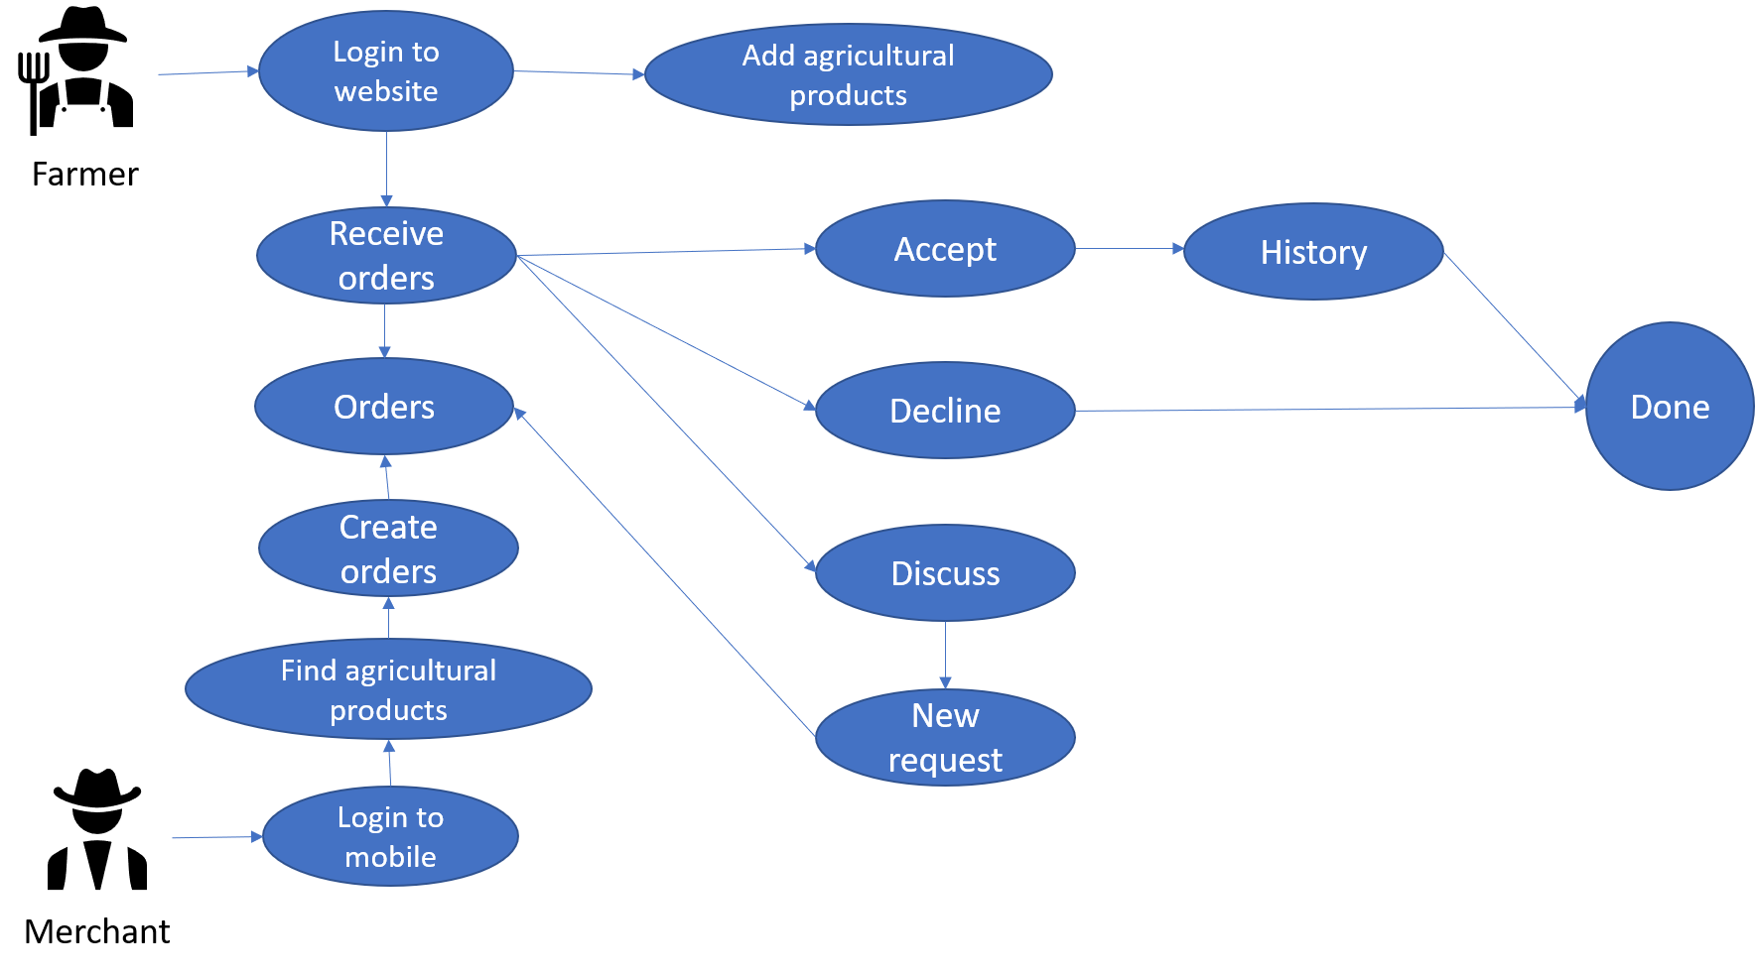

Figure 1. . Bussiness model

The portal allows farmers to first post agricultural items that are only available for a limited time, along with personal and contact information. The merchandiser's mobile application will then show the products, allowing them to select the ones that are best suited to their requirements.

The retailer will provide a pricing after determining the appropriate goods and quantity, and will then send the gardener a request along with contact details like their phone number, address, and shipping address. If the farmer accepts, he will click "Confirm," and the merchant will receive a successful notification. In contrast, if the farmer rejects the request, it will be declined and a notice of the rejection will be given to the merchant. The farmer may also recommend a different price, and the two parties may speak over the phone to discuss it. Once both parties have consented, the farmer can use the exchange button to display the form, fill it out with the new price, and submit it back to the merchant for confirmation before resuming the transaction. The merchant will receive updated information to review and validate. The deal is finished if everything goes according to plan and the farmer confirms; if not, it is canceled.

# CHAPTER 4. SYSTEM DESIGN

## 4.1. List of actors and usecases

### 4.1.1. Identify actors and use cases in use case diagrams

|  |  |
| --- | --- |
| **Actors** | **Usecases** |
| Merchant | - Login/Register/Logout  - Manage profile  - View the list of agricultural products  - View the farmers  - Search (text/image)  - Orders  - Decision final deal price (if have)  - Delete the ordered agricultural product  - See the list of ordered agricultural products  - View other information |
| Farmer | - Login/Register/Logout  - Manage profile  - Manage agricultural products  - Validate agricultural orders (Accept/Discuss/Decline)  - View agricultural products’ orders  - Deal new agricultural products’s price  - View other information  - Detect a product |
| Admin | - Login  - View the statistic of the products and transactions  - Filter the data of the statistic by days  - View the farmer list and farmer detail  - View the merchant list and merchant detail  - Ban a user  - View the reports of the users  - View the news  - View the categories of the fruit  - Logout |

Table 2. . Identify actors and use cases in use case diagrams

### 4.1.2. Detailed description

|  |  |
| --- | --- |
| **Actors** | **Usecases** |
| Merchant | - Login  - Register  - Edit profile  - View the list of agricultural products  - View the farmers  - Search agricultural products with text  - Search agricultural products with image  - Search farmer name  - Orders  - Decision final deal price (if have)  - Delete the ordered agricultural product  - See the list of ordered agricultural products  - See ordered history  - Log out |
| Farmer | - Login  - Register  - Edit profile  - Add agricultural products  - Delete agricultural products  - Accept agricultural orders  - Discuss agricultural orders  - Decline agricultural orders  - View agricultural products’ orders  - Deal new agricultural products’s price  - View agricultural product prices  - Detect a product  - Logout |
| Admin | - Login  - View the statistic of the products and transactions  - Filter the data of the statistic by days  - View the farmer list and farmer detail  - View the merchant list and merchant detail  - Ban a user  - View the reports of the users  - View the news  - View the categories of the fruit  - Logout |

Table 2. . Detailed description

### 4.1.3. Usecase summary

|  |  |  |
| --- | --- | --- |
| **No** | **Usecases** | **Actors** |
| 1 | Login | Merchant, Farmer, Admin |
| 2 | Edit account | Merchant, Farmer |
| 3 | Register | Merchant, Farmer |
| 4 | View list of agricultural products | Merchant, Farmer, Admin |
| 5 | View list of agricultural products that farmers own | Merchant, Farmer, Admin |
| 6 | Search | Merchant |
| 7 | Order | Merchant |
| 8 | Cancel the ordered agricultural product | Merchant |
| 9 | See the list of ordered agricultural products | Merchant, Farmer, Admin |
| 10 | Deal new agricultural products’s price | Farmer |
| 11 | Decision final deal price | Merchant |
| 12 | Manage agricultural product | Farmer |
| 13 | Validate agricultural orders (Accept/Discuss/Decline) | Farmer |
| 14 | Detect agricultural product | Merchant, Farmer |
| 15 | Statistic | Admin |

Table 2. . Usecase summary

### 4.1.4. Usecase diagram

**\*General usecase diagram**

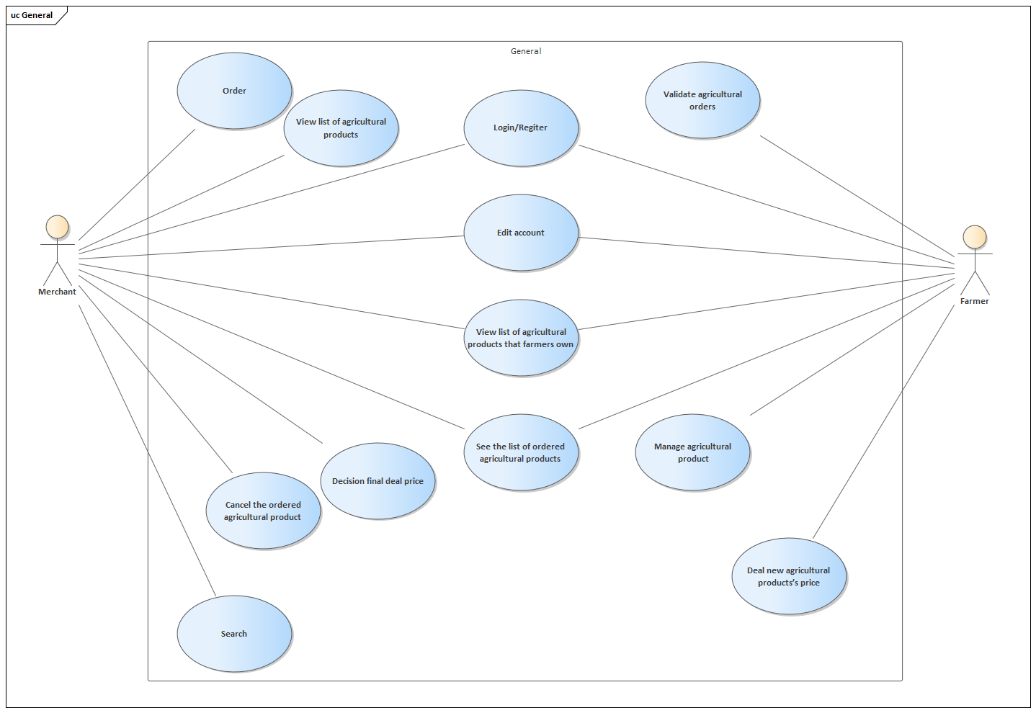

Figure 2. . General usecase diagram

**\*****Usecase for merchant**

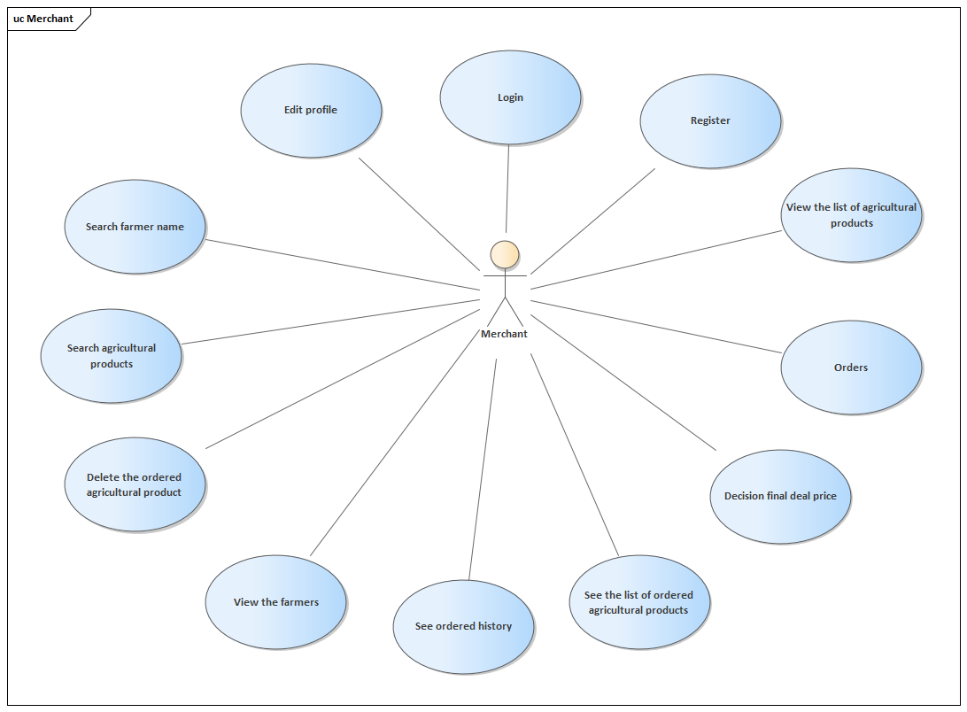

Figure 2. . Usecase for merchant

**\*****Usecase for farmer**

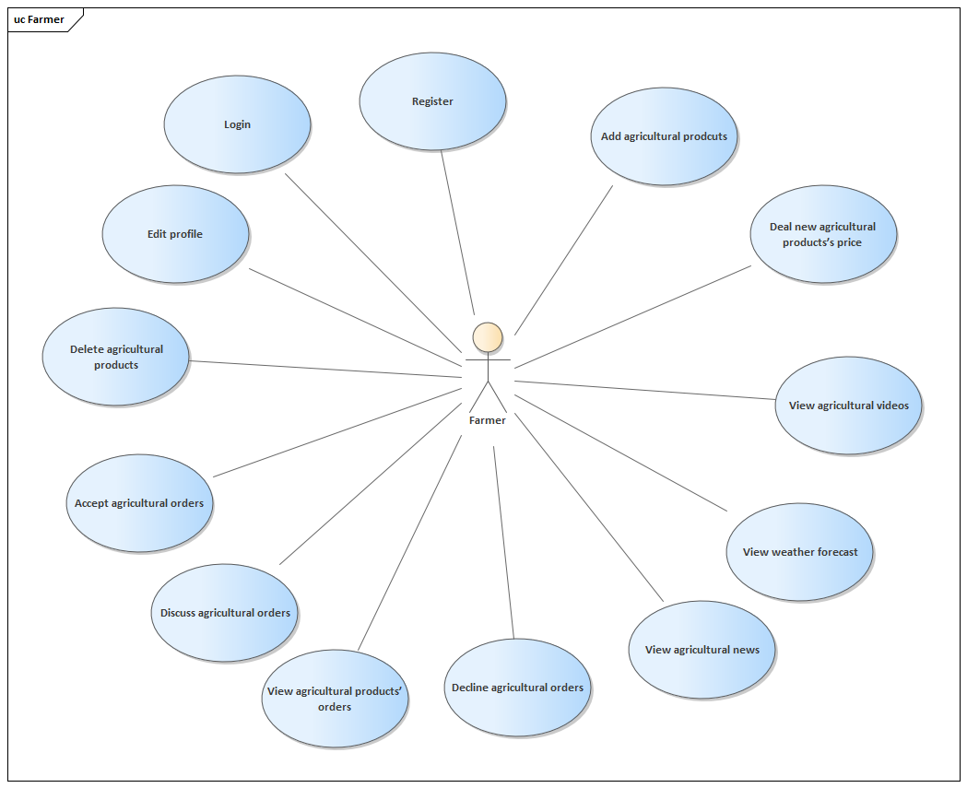

Figure 2. . Usecase for farmer

**\*Usecase for admin**

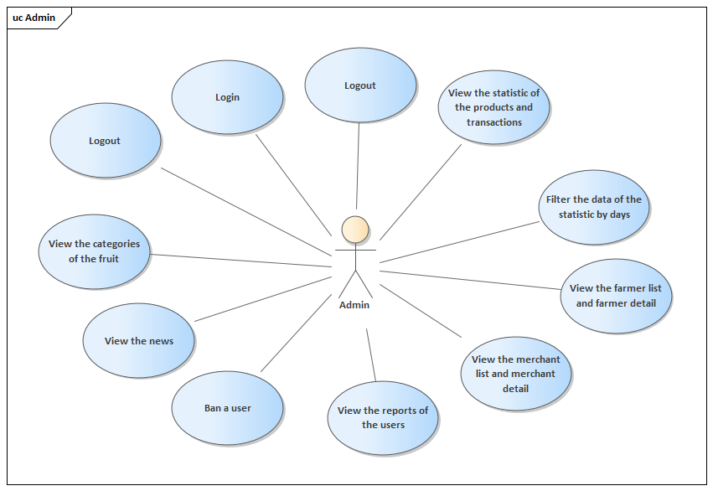

Figure 2. . Usecase for admin

## 4.2. Usecase specifications

### 4.2.1. Description of Login

|  |  |
| --- | --- |
| **Use Case Login** | |
| **Description** | Actor logs into the system |
| **Actors** | Merchant (m), Farmer (f) |
| **Precondition** | When the actor wants to log into the system to do something |
| **Steps** | 1. Actor open the mobile (m) / web (f) 2. Enter username and password into login form 3. Press login button 4. The system sends information to the database for validation. 5. Password and username are correct and the actor will log into the system with his/her correct role. |

Table 2. . Description of Login

### 4.2.2. Description of Edit Account

|  |  |  |
| --- | --- | --- |
| **Use Case Edit Account** | | |
| **Description** | Actor edits the information of actor’s account |
| **Actors** | Merchant (m), Farmer (f) |
| **Precondition** | When the actor wants to change the information on edit account |
| **Steps** | 1. Actor open the mobile (m) / web (f) 2. Actor go to the setting information. 3. Actor can change the information (that needs to be checked for validation). 4. Actor click on the Change button to update the new information and the data will be saved. |

Table 2. . Description of Edit Account

### 4.2.3. Description of Register

|  |  |
| --- | --- |
| **Use Case Register** | |
| **Description** | Actor registers an account in the system |
| **Actors** | Merchant (m), Farmer (f) |
| **Precondition** | When the actor wants to have an account in the system to become a Merchant or a Farmer. |
| **Steps** | **(1)** Actor open the mobile (m) / web (f).  **(2)** Actor click to the Register (Sign up) Button and will be navigated to the Register Screen (Page).  **(3)** Actor need to fill in all required information and have that information checked for validation before sign up.  **(4)** Actor click on the Register to create a new account (after checking whether the account has existed or the password is correct or not). |

Table 2. . Description of Register

### 4.2.4. Description of View List of agricultural products

|  |  |
| --- | --- |
| **Use View List of agricultural products** | |
| **Description** | Actor sees a list of all Agricultural products. |
| **Actors** | Merchant (m) |
| **Precondition** | When the actor wants to see all Agricultural products. |
| **Steps** | **(1)** Actor open the mobile (m)  **(2)** Actor need to login the app and after login sucessful actor will be move to the Home Screen.  **(3)** Actor click on the Explore Tab at the bottom and will see the catrgory and a list of products. |

Table 2. . Description of View List of agricultural products

### 4.2.5. Description of View list of agricultural products that farmers own

|  |  |
| --- | --- |
| **Use Case View list of agricultural products that farmers own** | |
| **Description** | Actor sees all Agricultural products of a specific Farmer. |
| **Actors** | Merchant (m), Farmer (f) |
| **Precondition** | When the actor wants to see all Agricultural products of a specific Farmer. |
| **Steps** | **(1)** Actor open the mobile (m) / web (f)  Mobile:  **(2)** In the Explore Tab, Actor can input the name of the farm and search.  **(3)** The results will be shown (including the farm) the actor can click into the farm.  **(4)** The products of that farm can be shown on that farm detail screen. |

Table 2. . Description of View list of agricultural products that farmers own

### 4.2.6. Description of Search

|  |  |
| --- | --- |
| **Use Search** | |
| **Description** | Actor search for a specific Agricultural product in the system. |
| **Actors** | Merchant (m) |
| **Precondition** | When the actor wants to see a specific Agricultural product in the system. |
| **Steps** | **(1)** Actor open the mobile (m)  Mobile:  **(2)** In the Explore Tab, Actor can input the name/image of the product and search.  **(3)** The results will be shown (including the product) the actor can click into the product.  **(4)** The product’s detail of that farm can be shown on that product detail screen. |

Table 2. . Description of Search

### 4.2.7. Description of Order

|  |  |
| --- | --- |
| **Use Case Order** | |
| **Description** | Actor order an agricultural product. |
| **Actors** | Merchant (m) |
| **Precondition** | When the actor wants to buy an agricultural product in the system. |
| **Steps** | **(1)** Actor open the mobile (m)  **(2)** When found the need agricultural products, actor can order button  **(3)** The result will be showed in order screen. |

Table 2. . Description of Order

### 4.2.8. Description of Cancel the ordered agricultural product

|  |  |
| --- | --- |
| **Use Case Cancel the ordered agricultural product** | |
| **Description** | Actor cancels an order of agricultural product. |
| **Actors** | Merchant (m) |
| **Precondition** | When the actor does not want the agricultural product. |
| **Steps** | **(1)** Actor open the mobile  **(2)** In the Waiting Order in the ‘Me’ Tab Actor can view the order that had been sent.  **(3)** Actor can choose that order to view the detail screen of that order and choose the deleted button in the top right corner. |

Table 2. . Description of Cancel the ordered agricultural product

### 4.2.9. Description of See the list of ordered agricultural products

|  |  |
| --- | --- |
| **Use Case See the list of ordered agricultural products** | |
| **Description** | Actor sees the list of ordered agricultural products. |
| **Actors** | Merchant (m), Farmer (f) |
| **Precondition** | When the actor sees the list of ordered agricultural products. |
| **Steps** | **(1)** Actor open the mobile (m) / web (f)  Mobile:  **(2)** In the Waiting Order in the ‘Me’ Tab Actor can view the order that had been sent.  Web:  **(3)** Open Order page to see. |

Table 2. . Description of See the list of ordered agricultural products

### 4.2.10. Description of Deal new agricultural products’s price

|  |  |
| --- | --- |
| **Use Case Deal new agricultural products’s price** | |
| **Description** | Actor accepts the deal of new agricultural products’s price from the merchant. |
| **Actors** | Farmer (f) |
| **Precondition** | When the actor deals the new agricultural products’s price from the merchant. |
| **Steps** | **(1)** Actor open the web (f)  **(2)** Click the discuss button in the order list.  **(3)** A form to deal new price will be show for actor to fill information.  **(4)** Click request button to sent the request. |

Table 2. . Description of Deal new agricultural products’s price

### 4.2.11. Description of Decision final deal price

|  |  |
| --- | --- |
| **Use Case Decision final deal price** | |
| **Description** | Actor accepts the final deal price from the farmer. |
| **Actors** | Merchant (m) |
| **Precondition** | When the actor deals the final price of farmer’s agricultural products. |
| **Steps** | **(1)** Actor open the mobile (m).  **(2)** If farmers deal new price, a message will be sent to actor.  **(3)** The request will be showed in waiting screen with the mark “dealing” |

Table 2. . Description of Decision final deal price

### 4.2.12. Description of Manage agricultural product

|  |  |
| --- | --- |
| **Use Case Manage agricultural product** | |
| **Description** | Actor manages actor’s agricultural products. |
| **Actors** | Farmer (f) |
| **Precondition** | When the actor wants to change actor’s agricultural products. |
| **Steps** | **(1)** Actor open the mobile web (f)  **(2)** Open agricultural product page.  **(3)** Fill all information to add new product or delete product. |

Table 2. . Description of Manage agricultural product

### 4.2.13. Description of Validate agricultural products

|  |  |
| --- | --- |
| **Use Case Validate agricultural products** | |
| **Description** | Actor validates the actor’s agricultural products. |
| **Actors** | Farmer (f) |
| **Precondition** | When the actor validates the actor’s agricultural products. |
| **Steps** | **(1)** Actor open the web (f)  **(2)** Open order page.  **(3)** Here the actor can accept/discuss/decline the orders. |

Table 2. . Description of Validate agricultural products

## 4.3. Sequence diagrams

### 4.3.1. Login

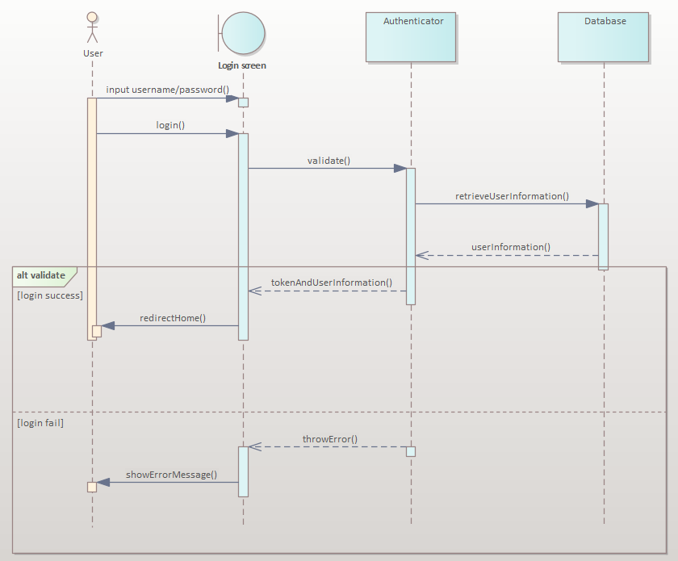

Figure 2. . Login sequence diagram

### 4.3.2. Register

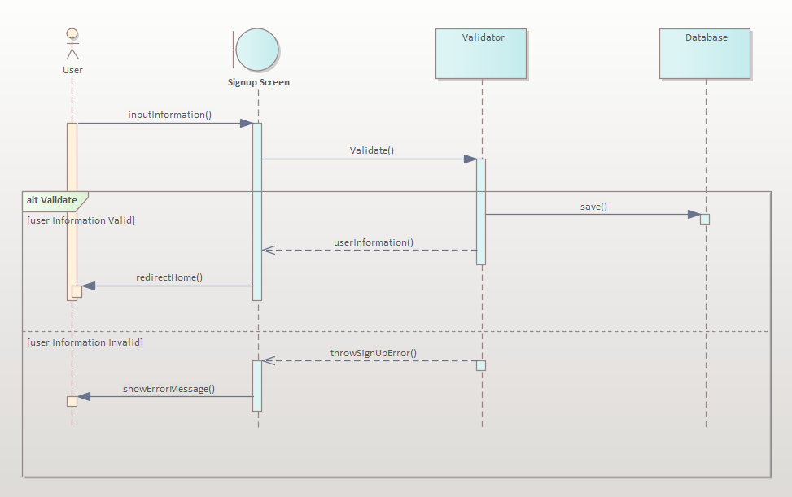

Figure 2. . Register sequence diagram

### 4.3.3. Create fruit

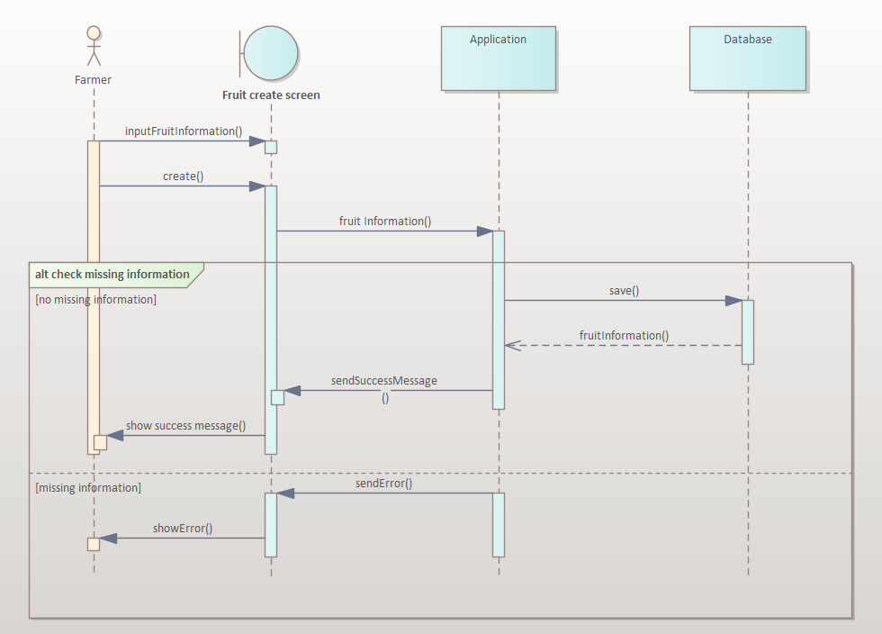

Figure 2. . Create fruit sequence diagram

### 4.3.4. Show fruit

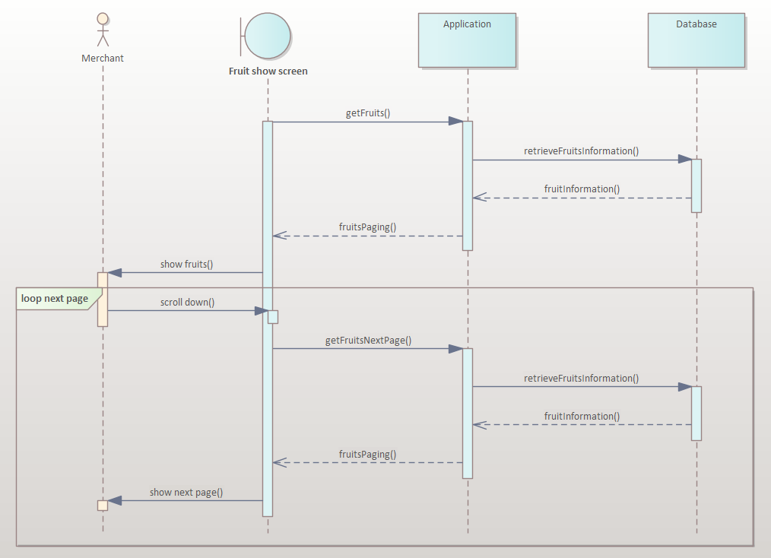

Figure 2. . Show fruit sequence diagram

### 4.3.5. Create order

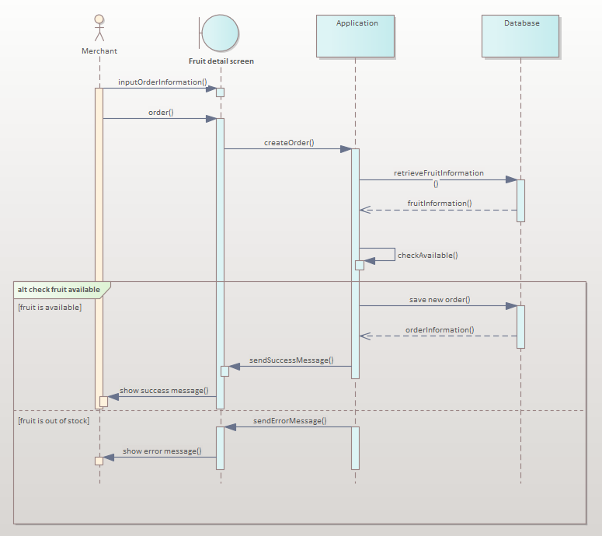

Figure 2. . Create order sequence diagram

### 4.3.6. Accept order

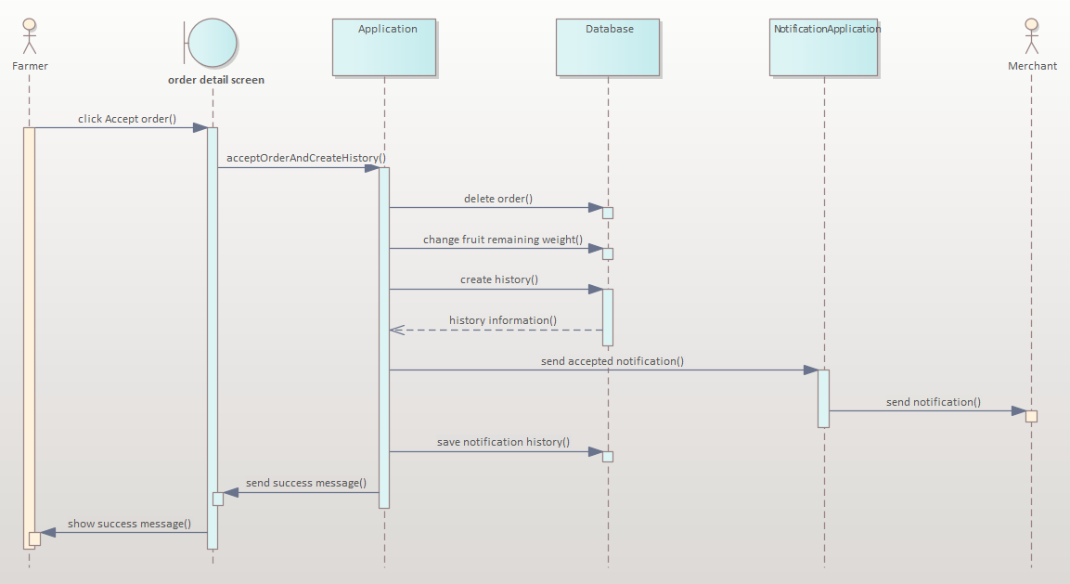

Figure 2. . Accept order sequence diagram

### 4.3.7. Decline order

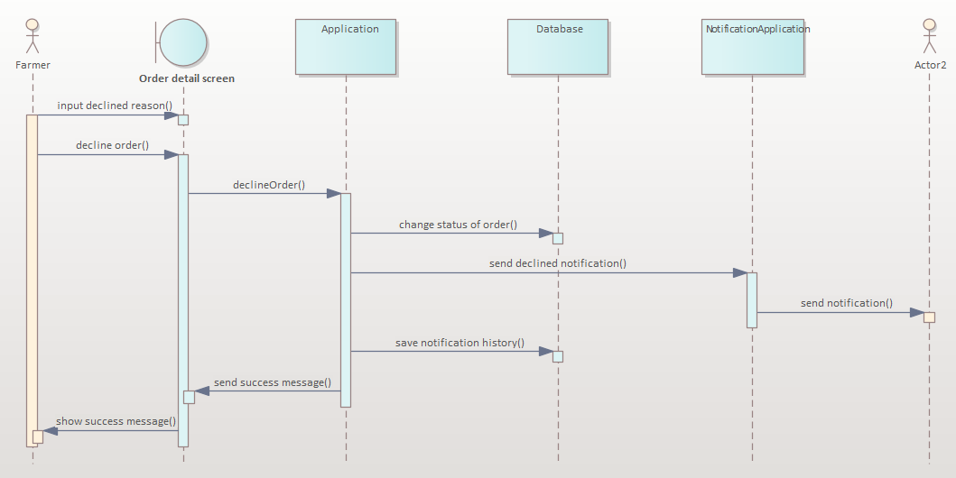

Figure 2. . Decline order sequence diagram

### 4.3.8. Report

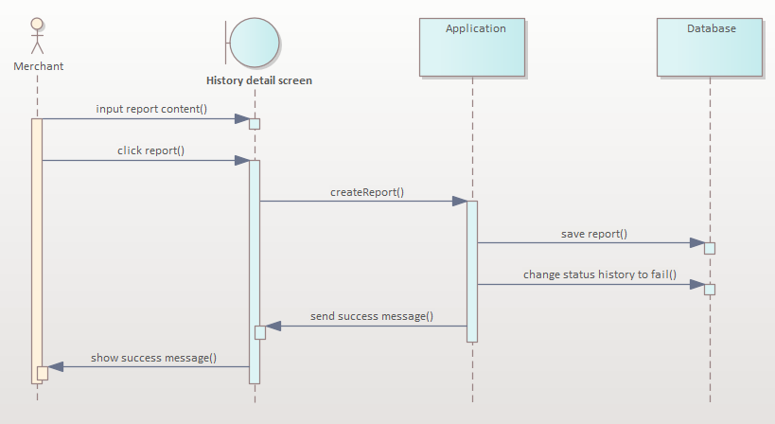

Figure 2. . Report sequence diagram

### 4.3.9. Complete

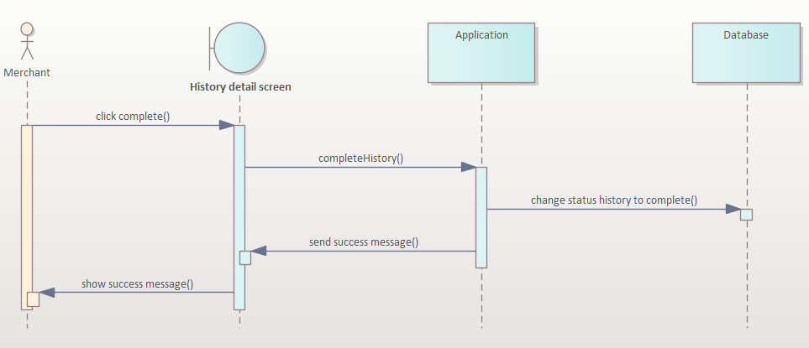

Figure 2. . Complete sequence diagram

### 4.3.10. Search fruit

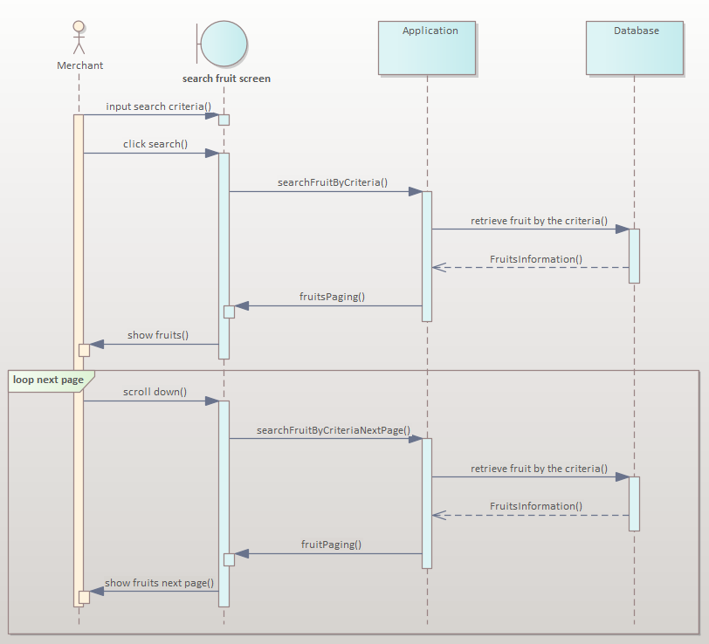

Figure 2. . Search fruit sequence diagram

## 4.4. Database design

### 4.4.1. Database table

***1. District***

|  |  |  |  |
| --- | --- | --- | --- |
| **No** | **Property** | **Type** | **Description** |
| 1 | id | int | Id |
| 2 | name | Varchar (255) | District Name |
| 3 | province_id | int | Province Id |

Table 2. . District database table

***2. Fruit***

|  |  |  |  |
| --- | --- | --- | --- |
| **No** | **Property** | **Type** | **Description** |
| 1 | id | int | Id |
| 2 | date | date | Date |
| 3 | description | Varchar (255) | Description |
| 4 | name | Varchar (255) | Name |
| 5 | popular | Bit (1) | Popular |
| 6 | season | Varchar (255) | Season |
| 7 | unit | Varchar (255) | Unit |
| 8 | userid | int | User Id |
| 9 | weight | float | Weight |

Table 2. . Fruit database table

***3. Fruit image***

|  |  |  |  |
| --- | --- | --- | --- |
| **No** | **Property** | **Type** | **Description** |
| 1 | id | int | Id |
| 2 | fruit_id | int | Fruit Id |
| 3 | url | Varchar (255) | Url Of Image |

Table 2. . Fruit image database table

***4. History***

|  |  |  |  |
| --- | --- | --- | --- |
| **No** | **Property** | **Type** | **Description** |
| 1 | id | int | Id |
| 2 | amount | int | Amount |
| 3 | date | date | Date |
| 4 | farmer_id | int | Farmer Id |
| 5 | fruit_id | int | Fruit Id |
| 6 | merchant_id | int | Merchant Id |
| 7 | price | float | Price |
| 8 | transport | bool | Transport (Yes/No) |

Table 2. . History database table

***6. Location***

|  |  |  |  |
| --- | --- | --- | --- |
| **No** | **Property** | **Type** | **Description** |
| 1 | id | int | Id |
| 2 | address | Varchar (255) | Address |
| 3 | ward_id | int | Ward Id |

Table 2. . Location database table

***7. News***

|  |  |  |  |
| --- | --- | --- | --- |
| **No** | **Columm** | **Type** | **Description** |
| 1 | id | int | Id |
| 2 | author | Varchar (255) | Author |
| 3 | category | Varchar (255) | Category |
| 4 | content | Varchar (255) | Content |
| 5 | date | date | Date |
| 6 | image_banner | Varchar (255) | Image Banner |
| 7 | image_content | Varchar (255) | Image Content |
| 8 | tittle | Varchar (255) | Tittle |

Table 2. . News database table

***8. Order***

|  |  |  |  |
| --- | --- | --- | --- |
| **No** | **Property** | **Type** | **Description** |
| 1 | id | int | Id |
| 2 | amount | int | Amount |
| 3 | date | date | Date |
| 4 | deal_amount | int | Deal Amount |
| 5 | deal_price | float | Deal Price |
| 6 | farmer_id | int | Farmer Id |
| 7 | fruit_id | int | Fruit Id |
| 8 | merchant_id | int | Merchant Id |
| 9 | price | float | Price |
| 10 | status_id | int | Status Id |
| 11 | transport | bool | Transport |

Table 2. . Order database table

***9. Province***

|  |  |  |  |
| --- | --- | --- | --- |
| **No** | **Property** | **Type** | **Description** |
| 1 | id | int | Id |
| 2 | name | Varchar (255) | Name |

Table 2. . Province database table

***10. Role***

|  |  |  |  |
| --- | --- | --- | --- |
| **No** | **Property** | **Type** | **Description** |
| 1 | id | int | Id |
| 2 | name | Varchar (255) | Name |

Table 2. . Role database table

***11. Status product***

|  |  |  |  |
| --- | --- | --- | --- |
| **No** | **Property** | **Type** | **Description** |
| 1 | id | int | Id |
| 2 | name | Varchar (255) | Name |

Table 2. . Status product database table

***12. Status user***

|  |  |  |  |
| --- | --- | --- | --- |
| **No** | **Property** | **Type** | **Description** |
| 1 | id | int | Id |
| 2 | name | Varchar (255) | Name |

Table 2. . Status user database table

***13. User***

|  |  |  |  |
| --- | --- | --- | --- |
| **No** | **Property** | **Type** | **Description** |
| 1 | id | int | Id |
| 2 | avatar | Varchar (255) | Avatar |
| 3 | birth_day | date | Birthday |
| 4 | create_day | date | Create Day |
| 5 | description | Varchar (255) | Description |
| 6 | email | Varchar (255) | Email |
| 7 | first_name | Varchar (255) | First Name |
| 8 | last_name | Varchar (255) | Last Name |
| 9 | location_id | int | Location Id |
| 10 | password | Varchar (255) | Password |
| 11 | phone | Varchar (255) | Phone |
| 12 | status_id | int | Status Id |
| 13 | username | Varchar (255) | Username |

Table 2. . User database table

***14. User role***

|  |  |  |  |
| --- | --- | --- | --- |
| **No** | **Property** | **Type** | **Description** |
| 1 | role_id | int | Role Id |
| 2 | user_id | int | User Id |

Table 2. . User role database table

***15. Role***

|  |  |  |  |
| --- | --- | --- | --- |
| **No** | **Property** | **Type** | **Description** |
| 1 | id | int | Id |
| 2 | district_id | int | District Id |
| 3 | name | Varchar (255) | Name |

Table 2. . Role database table

### 4.4.2. Relational diagram

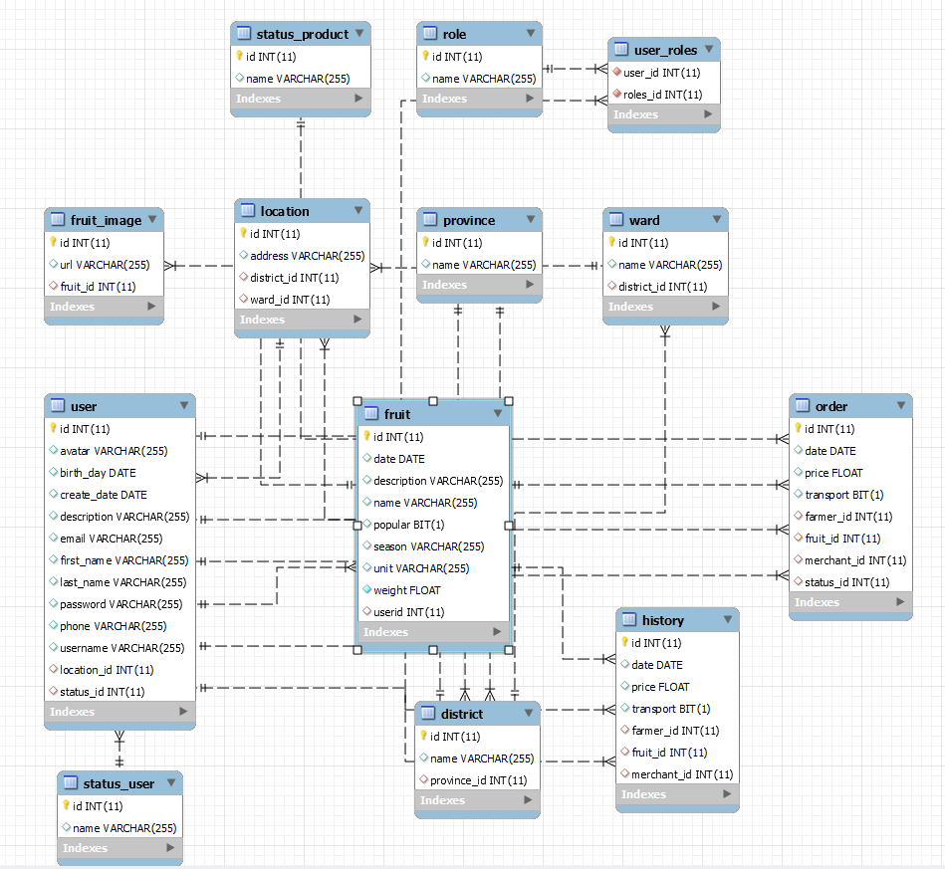

Figure 2. . Database relational diagram

## 4.5. User interface

### 4.5.1. Mobile for merchant

|  |  |  |
| --- | --- | --- |
| **No.** | **Screen name** | **Description** |
| **1** | Login | Login for registered users |
| **2** | Register | Users will be forced to fill in all of the fields in the form for registering an account |
| **3** | Home | Introduction about application |
| **4** | Me | Explore about payment and accountt |
| **5** | Explore | View and find information about products added by farmers |
| **6** | Category | View all categories of the products |
| **7** | Search | Help merchants can find which products they want by using text or image |
| **8** | Product detail | View all information about the product and merchants can order here |
| **9** | Payment waiting list | See a list of all ordered products |
| **10** | History | See a list of all completed orders |
| **11** | Order | View the details of the order and validate the discussion of new prices if have |
| **12** | Message | Chatting here |
| **13** | Notification | See all notification such as when farmers accept, discuss, decline, etc … |
| **14** | Change password | Change the password if need |
| **15** | Change information | Change the personal information if need |
| **16** | Change language | Merchant can change language between English and Vietnamese |

Table 2. . List of mobile screens for merchants

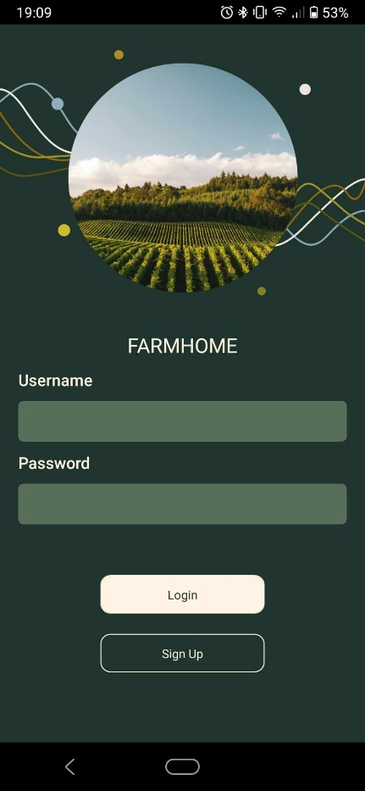

Figure 2. . Mobile login screen

|  |  |  |  |
| --- | --- | --- | --- |
| **No** | **Name** | **Type** | **Event** |
| 1 | Input username | Textbox | For user input username |
| 2 | Input password | Textbox | For user input password |
| 3 | Login button | Button | Click to send user’s account to backend for authorization |
| 4 | Signup button | Button | After clicking, go to register screen |

Table 2. . Mobile login screen event

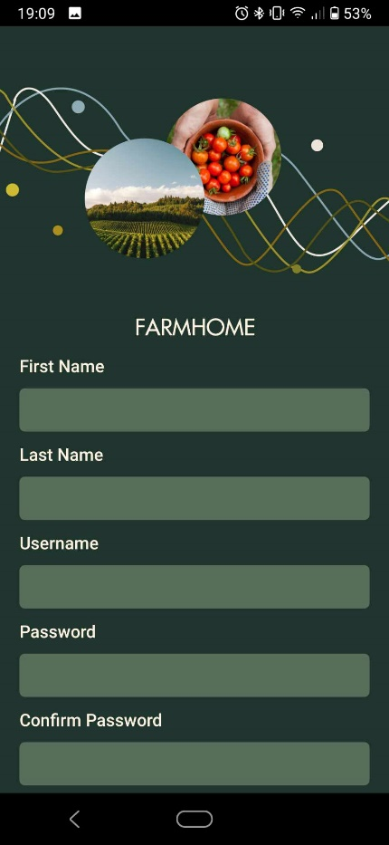

Figure 2. . Mobile register screen 1

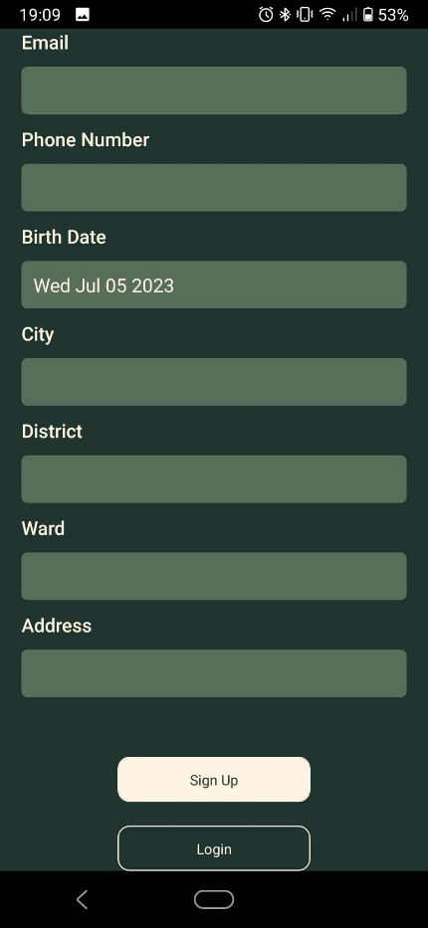

Figure 2. . Mobile register screen 2

|  |  |  |  |
| --- | --- | --- | --- |
| **No** | **Name** | **Type** | **Event** |
| 1 | Input firstname | Textbox | For user input firstname |
| 2 | Input lastname | Textbox | For user input lastname |
| 3 | Input username | Textbox | For user input username |
| 4 | Input password | Textbox | For user input password |
| 5 | Input confirm password | Textbox | For user input confirm password |
| 6 | Input email | Textbox | For user input email |
| 7 | Input phone | Textbox | For user input phone |
| 8 | Input birthday | Textbox | For user input birthday |
| 9 | Input city | Textbox | For user input city |
| 10 | Input district | Textbox | For user input district |
| 11 | Input ward | Textbox | For user input ward |
| 12 | Input address | Textbox | For user input address |
| 13 | Signup button | Button | Click to new user’s information to send to backend for the register |
| 14 | Login button | Button | After clicking, go to login screen |

Table 2. . Mobile register screen event

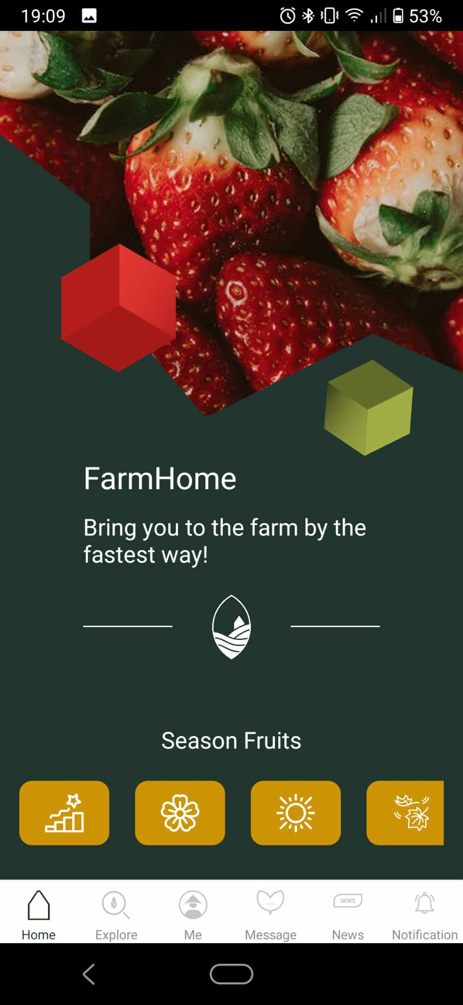

Figure 2. . Home screen

|  |  |  |  |
| --- | --- | --- | --- |
| **No** | **Name** | **Type** | **Event** |
| 1 | Home | Button | Go to home screen |
| 2 | Explore | Button | Go to explore screen |
| 3 | Me | Button | Go to presonal information screen |
| 4 | Message | Button | Go to message screen |
| 5 | News | Button | Go to news screen |
| 6 | Notification | Button | Go to notification screen |

Table 2. . Home screen event

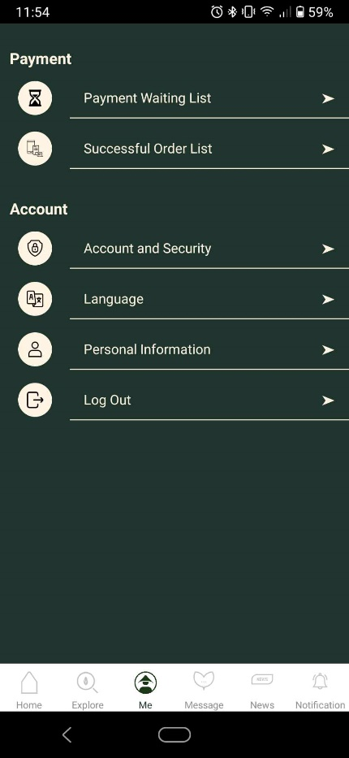

Figure 2. . Me screen

|  |  |  |  |
| --- | --- | --- | --- |
| **No** | **Name** | **Type** | **Event** |
| 1 | Payment waiting list | Tab | Go to the screen that shows ordered list |
| 2 | Successful order list | Tab | Go to history of orders |
| 3 | Account and security | Tab | Go to presonal information screen |
| 4 | Language | Tab | Go to message screen |
| 5 | Personal information | Tab | Go to news screen |
| 6 | Log out | Tab | Go to notification screen |

Table 2. . Me screen event

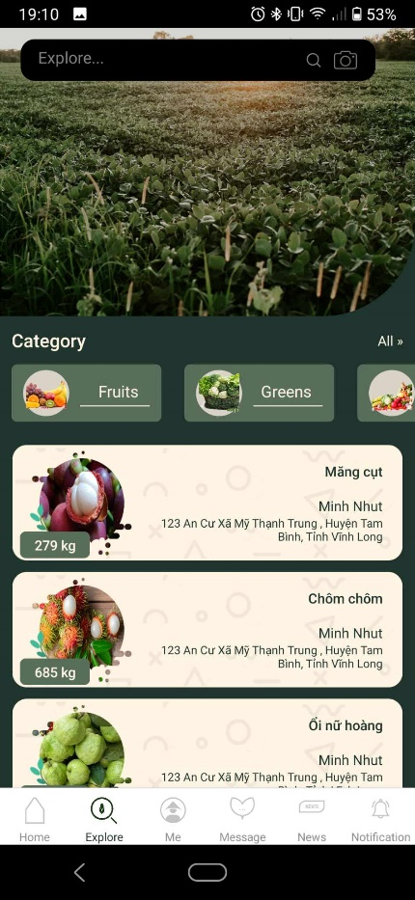

Figure 2. . Explore screen

|  |  |  |  |
| --- | --- | --- | --- |
| **No** | **Name** | **Type** | **Event** |
| 1 | Search bar | Textbox | Help users search by text/image |
| 2 | Category | Tab | Filter with category |
| 3 | Prroduct card | Card | Show some information about the product and can click to go to product details |

Table 2. . Explore screen event

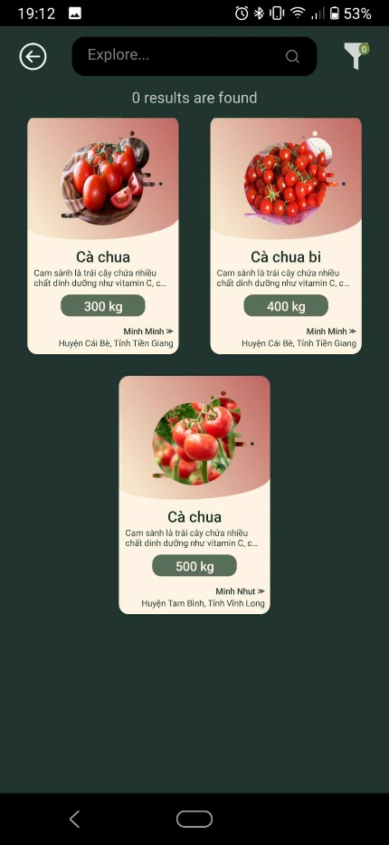

Figure 2. . Search screen

|  |  |  |  |
| --- | --- | --- | --- |
| **No** | **Name** | **Type** | **Event** |
| 1 | Back button | Button | Back to previous screen |
| 2 | Product card | Card | Show some information about the product and can click to go to product details if found |

Table 2. . Search screen event

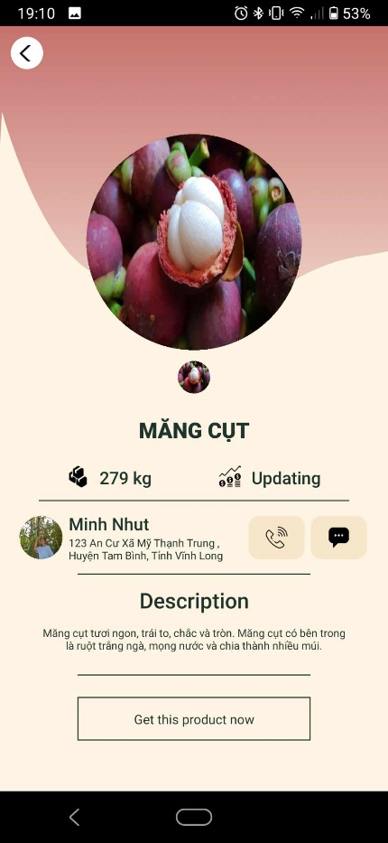

Figure 2. . Product detail screen

|  |  |  |  |
| --- | --- | --- | --- |
| **No** | **Name** | **Type** | **Event** |
| 1 | Product image | Image | Show the image of product |
| 2 | Product name | Text | Show the name of product |
| 3 | Product weight | Text | Show the weight of product |
| 4 | Product market price | Text | Show the market price got from the reference market |
| 5 | Farmer information | Text | Show farmer image and information |
| 6 | Call button | Button | Make a phone call |
| 7 | Message button | Button | Go to chat |
| 8 | Description | Text | Show the description of product |
| 9 | Get product button | Button | Click to get the product |

Table 2. . Product detail screen event

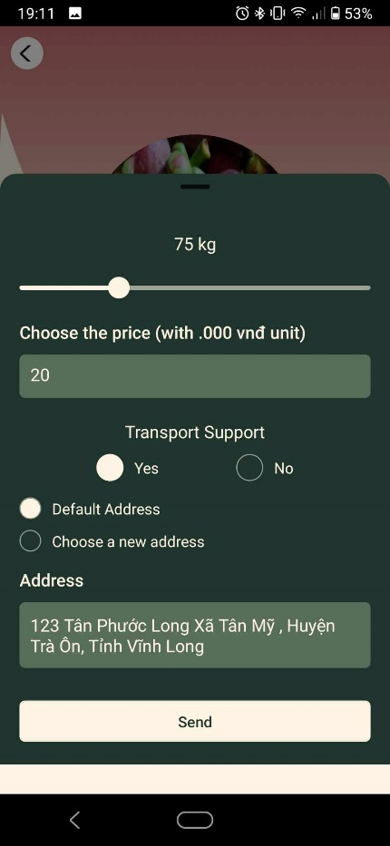

Figure 2. . Order bottom sheet

|  |  |  |  |
| --- | --- | --- | --- |
| **No** | **Name** | **Type** | **Event** |
| 1 | Order sheet | Bottom sheet | Fill all information to get product |
| 2 | Weight slider | slider | Choose the weight user wanted |
| 3 | Price | Textbox | Input the price to buy the product |
| 4 | Transport support | Text | Show the market price got from the reference market |
| 5 | Address | Radio button | Choose the address if user need transport support |
| 6 | Send button | Button | Send order to farmer |

Table 2. . Order event

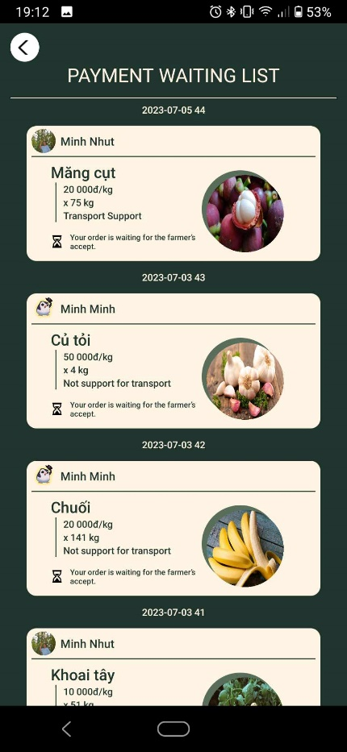

Figure 2. . Payment waiting list

|  |  |  |  |
| --- | --- | --- | --- |
| **No** | **Name** | **Type** | **Event** |
| 1 | Order card | Card | Show some information of orders and can click to go to the details of orders |

Table 2. . Payment waiting list event

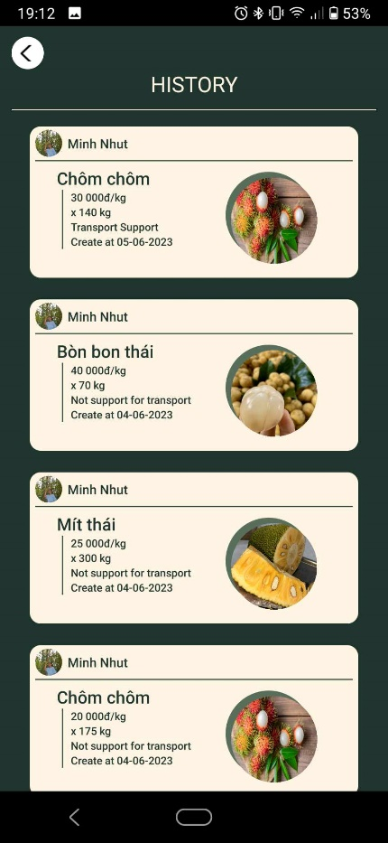

Figure 2. . History list

|  |  |  |  |
| --- | --- | --- | --- |
| **No** | **Name** | **Type** | **Event** |
| 1 | History card | Card | Show history information |

Table 2. . History list event

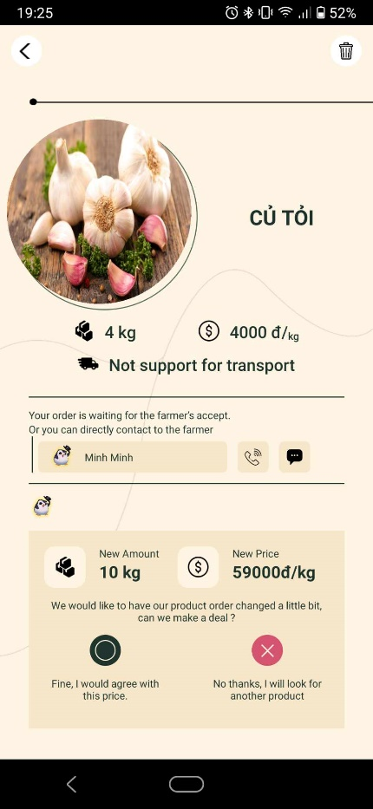

Figure 2. . Order details screen

|  |  |  |  |
| --- | --- | --- | --- |
| **No** | **Name** | **Type** | **Event** |
| 1 | Product image | Image | Show the image of product |
| 2 | Product name | Text | Show the name of product |
| 3 | Order information | Text | Show the information of order: weight, suggested price, transport support |
| 4 | Farmer information | Text | Show the information of farmer |
| 5 | New amount | Text | New amount after discussion |
| 6 | New price | Button | New price after discussion |
| 7 | Confirm button | Button | Confirm information after discussion |
| 8 | Decline button | Button | Decline discussion information |

Table 2. . Order details screen event

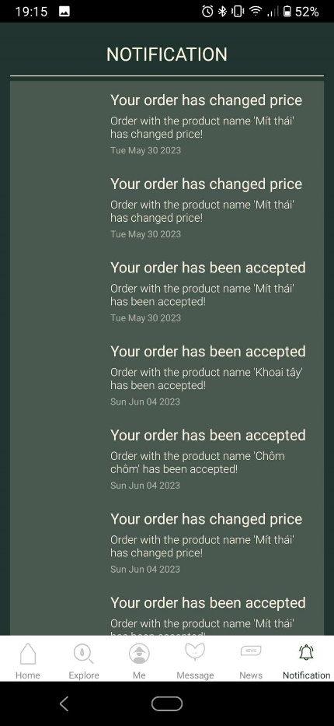

Figure 2. . Notification screen

|  |  |  |  |
| --- | --- | --- | --- |
| **No** | **Name** | **Type** | **Event** |
| 1 | Notification | List | Show the list of notification |

Table 2. . Notification screen event

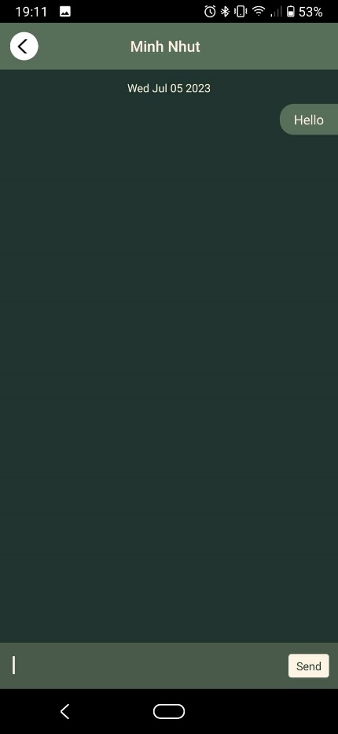

Figure 2. . Message screen

|  |  |  |  |
| --- | --- | --- | --- |
| **No** | **Name** | **Type** | **Event** |
| 1 | Name | Text | Show the name of farmer |
| 2 | Chat area | Area | Show the message |
| 3 | Input text | Textbox | Input message |
| 4 | Send button | Button | Click to send the message |

Table 2. . Message screen event

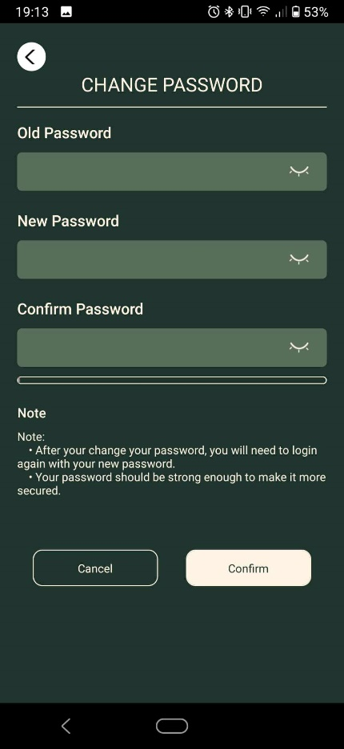

Figure 2. . Change password screen

|  |  |  |  |
| --- | --- | --- | --- |
| **No** | **Name** | **Type** | **Event** |
| 1 | Input old password | Textbox | For user input old password |
| 2 | Input new password | Textbox | For user input new password |
| 3 | Input confirm password | Textbox | For user input confirm password |
| 4 | Cancel button | Text | Cancel the action |
| 5 | Confirm button | Button | Confirm the action |

Table 2. . Change password screen event

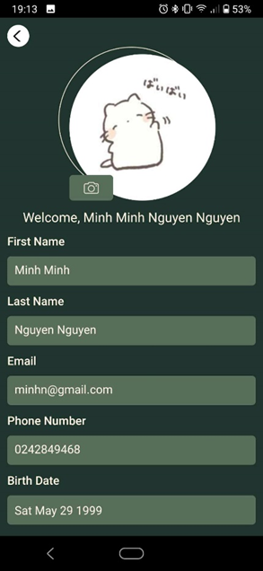

Figure 2. . Update profile screen 1

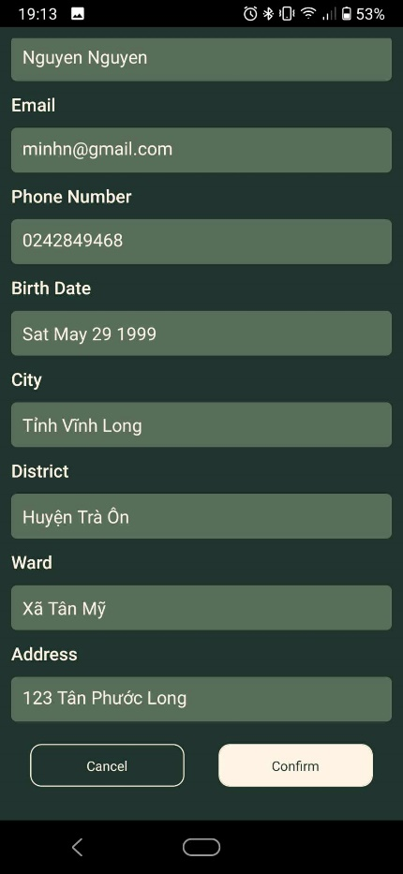

Figure 2. . Update profile screen 2

|  |  |  |  |
| --- | --- | --- | --- |
| **No** | **Name** | **Type** | **Event** |
| 1 | Avatar | Image | For user change image |
| 2 | Input firstname | Textbox | For user input firstname |
| 3 | Input lastname | Textbox | For user input lastname |
| 4 | Input email | Textbox | For user input email |
| 5 | Input phone | Textbox | For user input phone |
| 6 | Input birthday | Textbox | For user input birthday |
| 7 | Input city | Textbox | For user input city |
| 8 | Input district | Textbox | For user input district |
| 9 | Input ward | Textbox | For user input ward |
| 10 | Input address | Textbox | For user input address |
| 11 | Cancel button | Button | Cancel the action |
| 12 | Confirm button | Button | Click to update new information |

Table 2. . Update profile screen event



Figure 2. . List of message

|  |  |  |  |
| --- | --- | --- | --- |
| **No** | **Name** | **Type** | **Event** |
| 1 | Message information | Card | Show some information of conservation |

Table 2. . List of message event

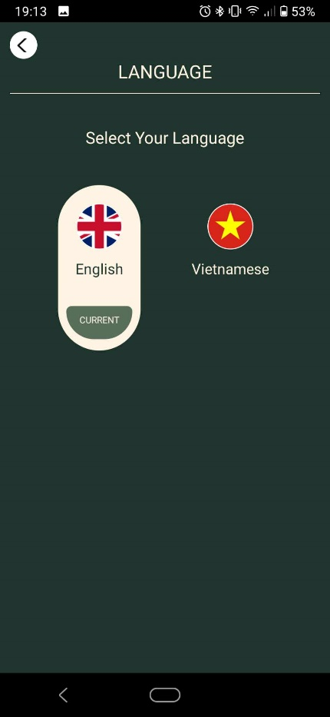

Figure 2. . Change language screen

|  |  |  |  |
| --- | --- | --- | --- |
| **No** | **Name** | **Type** | **Event** |
| 1 | English language | Radio button | Switch language to English |
| 2 | Vietnamese language | Radio button | Switch language to Vietnamese |

Table 2. . Change language screen event

### 4.5.2. Website for farmer

|  |  |  |
| --- | --- | --- |
| **No.** | **Screen name** | **Description** |
| **1** | Login | Login for registered users |
| **2** | Register | Users will be forced to fill in all of the fields in the form for registering an account |
| **3** | Home | Introduction about application |
| **4** | Overview | Some basic statistics |
| **5** | Prices | Go to reference market |
| **6** | Products | Display of information and product management |
| **7** | Orders | View the details of the order and validate the orders |
| **8** | History | See a list of all completed orders |
| **9** | Profile | Manage profile information |
| **10** | News | View news |
| **11** | Message | Chatting here |

Table 2. . List of website page for farmer

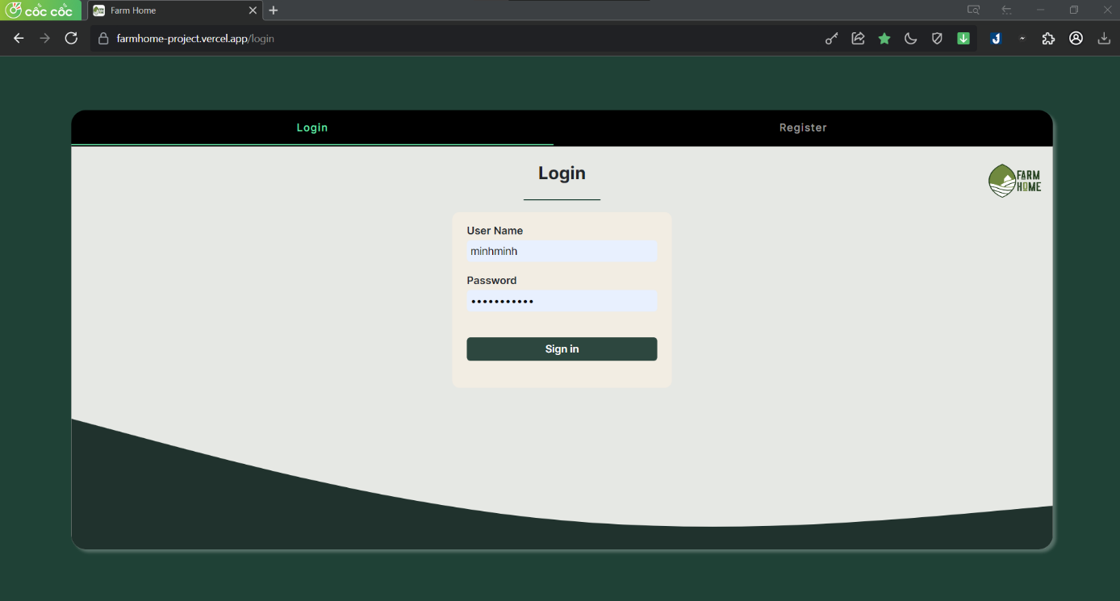

Figure 2. . Login page

|  |  |  |  |
| --- | --- | --- | --- |
| **No** | **Name** | **Type** | **Event** |
| 1 | Input username | Textbox | For user input username |
| 2 | Input password | Textbox | For user input password |
| 3 | Login button | Button | Click to send user’s account to backend for authorization |
| 4 | Login tab | Tab | After clicking, switch to login panel |
| 5 | Register tab | Tab | After clicking, switch to register panel |

Table 2. . Login page event

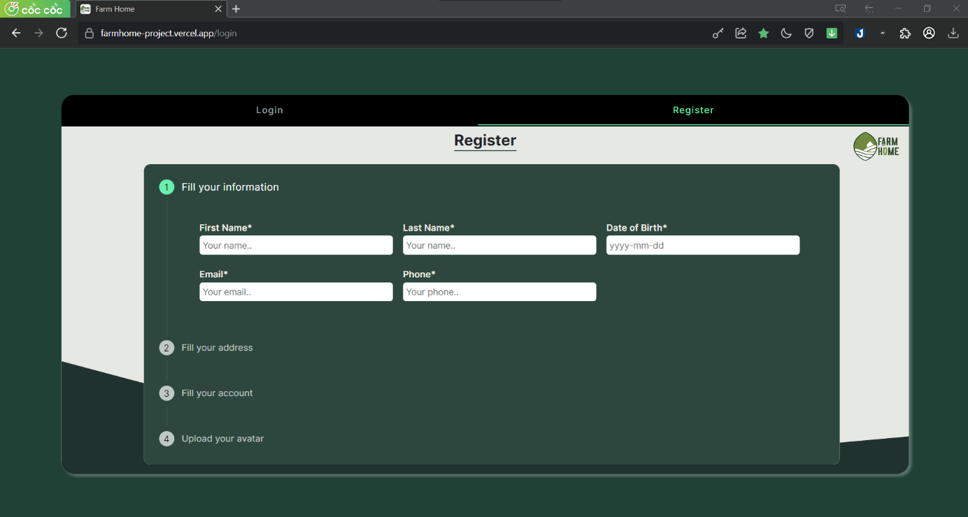

Figure 2. . Register page

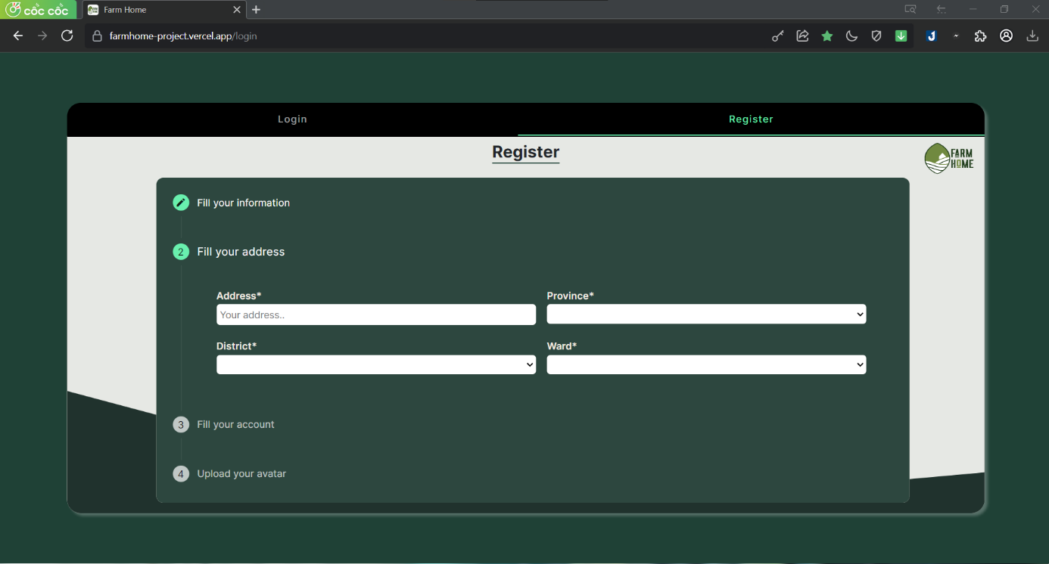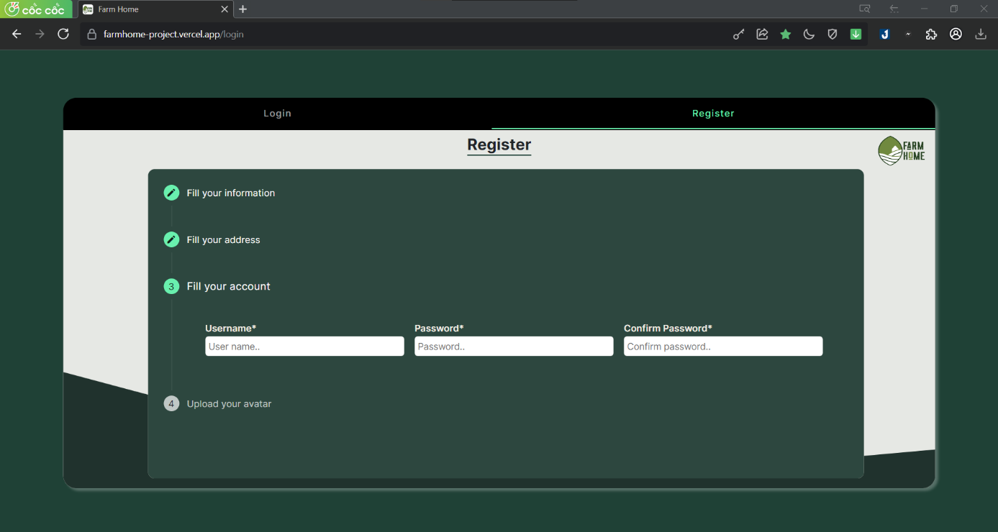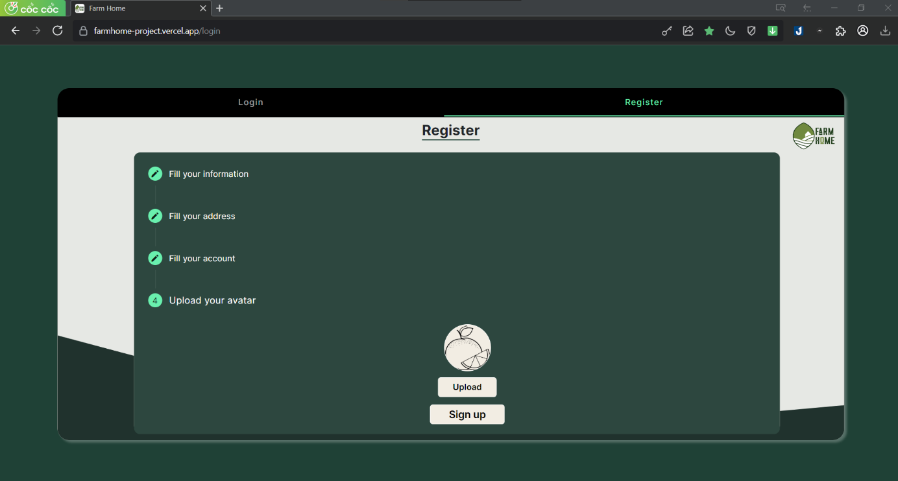

|  |  |  |  |
| --- | --- | --- | --- |
| **No** | **Name** | **Type** | **Event** |
| 1 | Input firstname | Textbox | For user input firstname |
| 2 | Input lastname | Textbox | For user input lastname |
| 3 | Input birthday | Textbox | For user input birthday |
| 4 | Input email | Textbox | For user input email |
| 5 | Input phone | Textbox | For user input phone |
| 6 | Input address | Textbox | For user input address |
| 7 | Input city | Textbox | For user input city |
| 8 | Input district | Textbox | For user input district |
| 9 | Input ward | Textbox | For user input ward |
| 10 | Input username | Textbox | For user input username |
| 11 | Input password | Textbox | For user input password |
| 12 | Input confirm password | Textbox | For user input confirm password |
| 13 | Upload image button | Button | Help user choose avatar |
| 14 | Register button | Button | Click to new user’s information to send to backend for the register |

Table 2. . Register page event

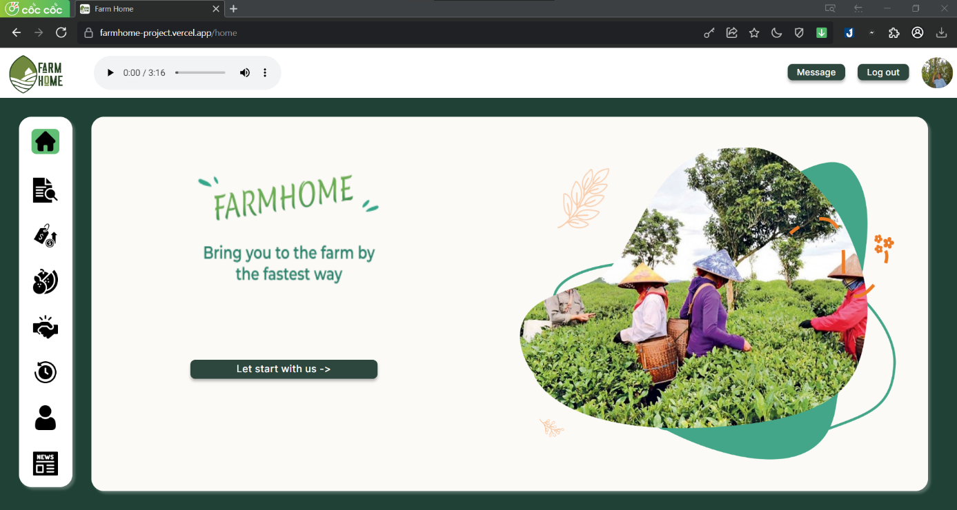

Figure 2. . Home page

|  |  |  |  |
| --- | --- | --- | --- |
| **No** | **Name** | **Type** | **Event** |
| 1 | Farmhome logo | Image | Click to go to home page |
| 2 | Music player | Mp3 | Play music to chill |
| 3 | Message button | Button | Click to go to message page |
| 4 | Log out button | Button | Click to go log out |
| 5 | User avatar | Image | Show user avatar |
| 6 | Home banner | Image | Show slogan and image intro |
| 7 | Home | Button | Click to go to home page |
| 8 | Overviews | Button | Click to go to overviews page |
| 9 | Prices | Button | Click to go to price page |
| 10 | Products | Button | Click to go to products page |
| 11 | Orders | Button | Click to go to orders page |
| 12 | History | Button | Click to go to history page |
| 13 | Profile | Button | Click to go to profile page |
| 14 | News | Button | Click to go to news page |
| 15 | Let start button | Button | Click to go to product page |

Table 2. . Home page event

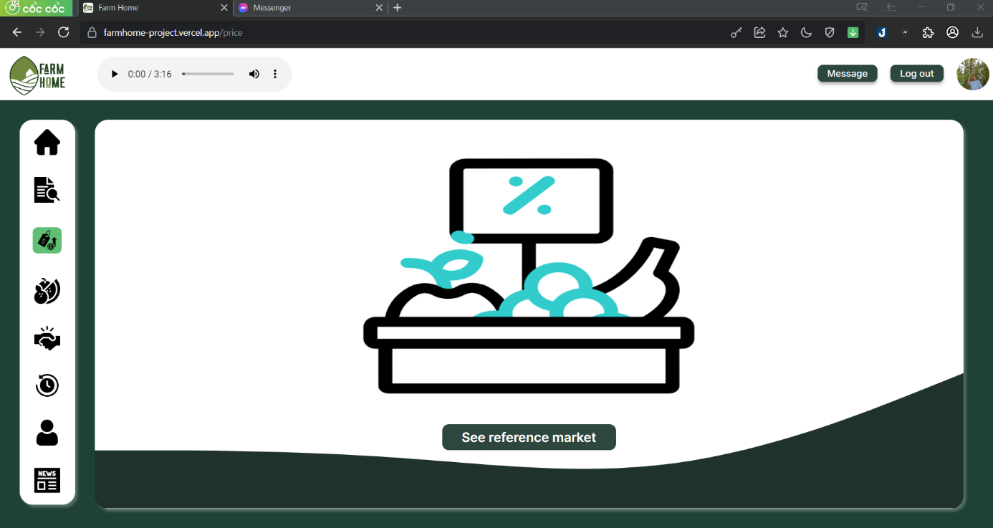

Figure 2. . Reference page

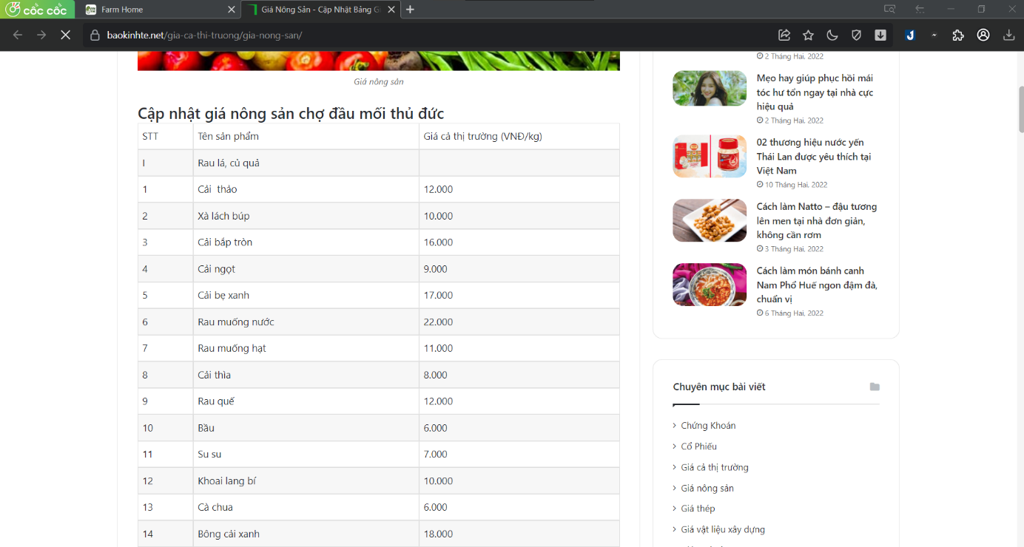

Figure 2. . Reference price website

|  |  |  |  |
| --- | --- | --- | --- |
| **No** | **Name** | **Type** | **Event** |
| 1 | See reference market button | Button | Click to go to reference market |

Table 2. . Prices page event

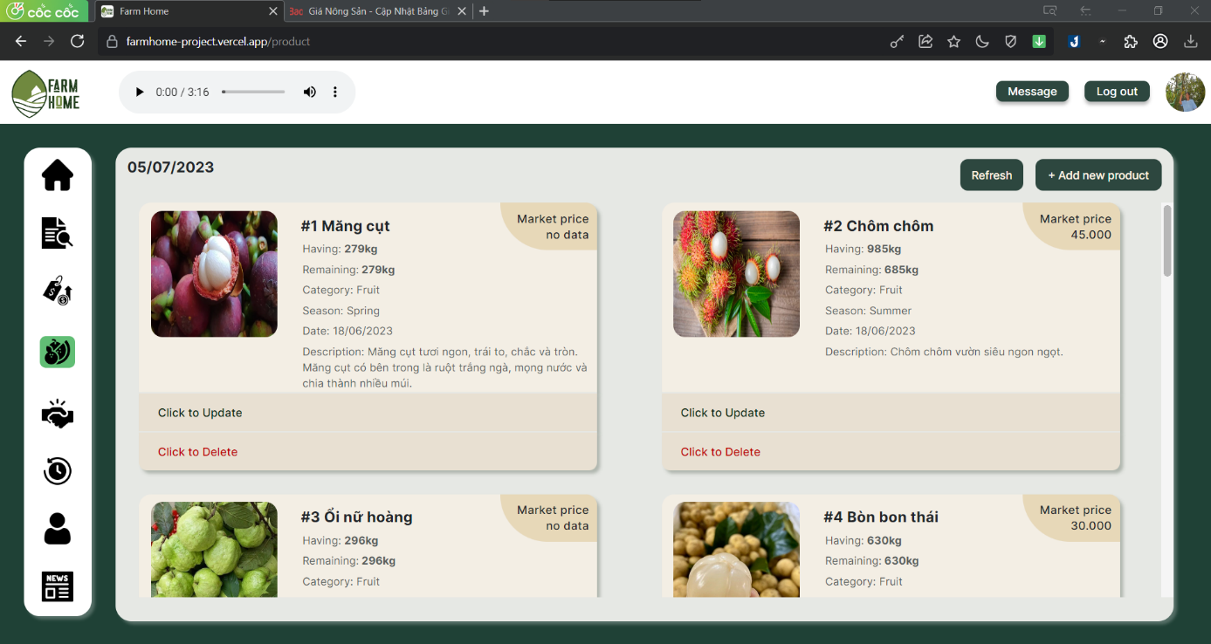

Figure 2. . Products page

|  |  |  |  |
| --- | --- | --- | --- |
| **No** | **Name** | **Type** | **Event** |
| 1 | Refresh button | Button | Click to refresh the list of products |
| 2 | Add new product button | Button | Open the dialog to add new product |
| 3 | Market price | Text | Show reference price if available |
| 4 | Product image | Image | Show product image |
| 5 | Product information | Text | Show product information |
| 6 | Expansion panel | Panel | Expand to update/delete product |

Table 2. . Products page event

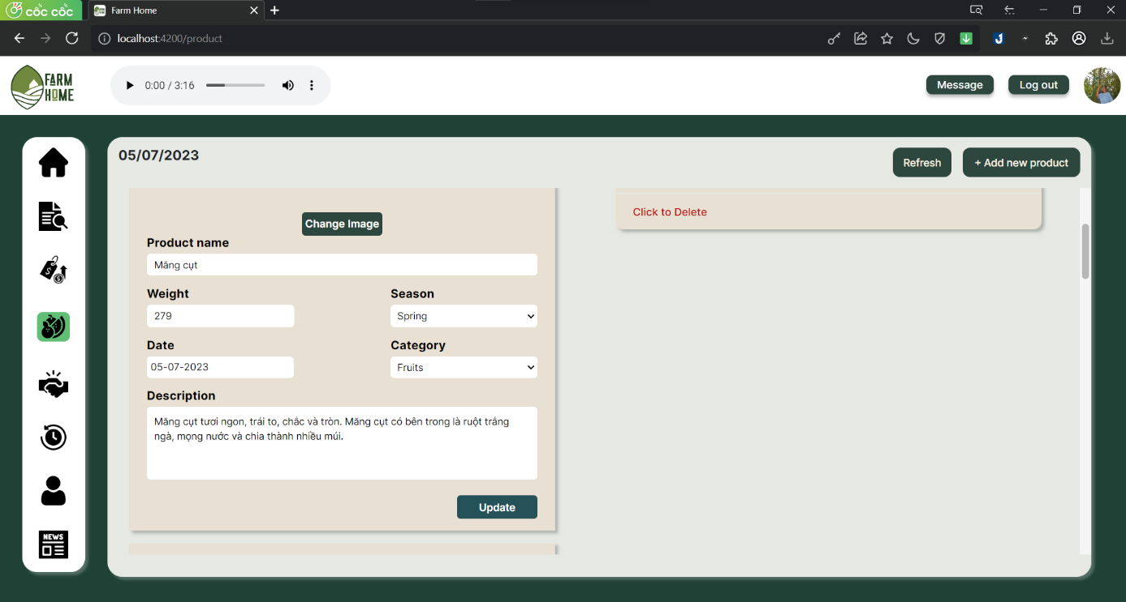

Figure 2. . Update product

|  |  |  |  |
| --- | --- | --- | --- |
| **No** | **Name** | **Type** | **Event** |
| 1 | Change image button | Button | Click to get new image for product |
| 2 | Input product name | Textbox | For user input product name |
| 3 | Input product weight | Textbox | For user input product weight |
| 4 | Input product season | Textbox | For user input product season |
| 5 | Input product date | Textbox | For user input product date |
| 6 | Input product category | Textbox | For user input product category |
| 7 | Input product description | Textarea | For user input product description |
| 8 | Update button | Button | Click to update new information |

Table 2. . Update product event

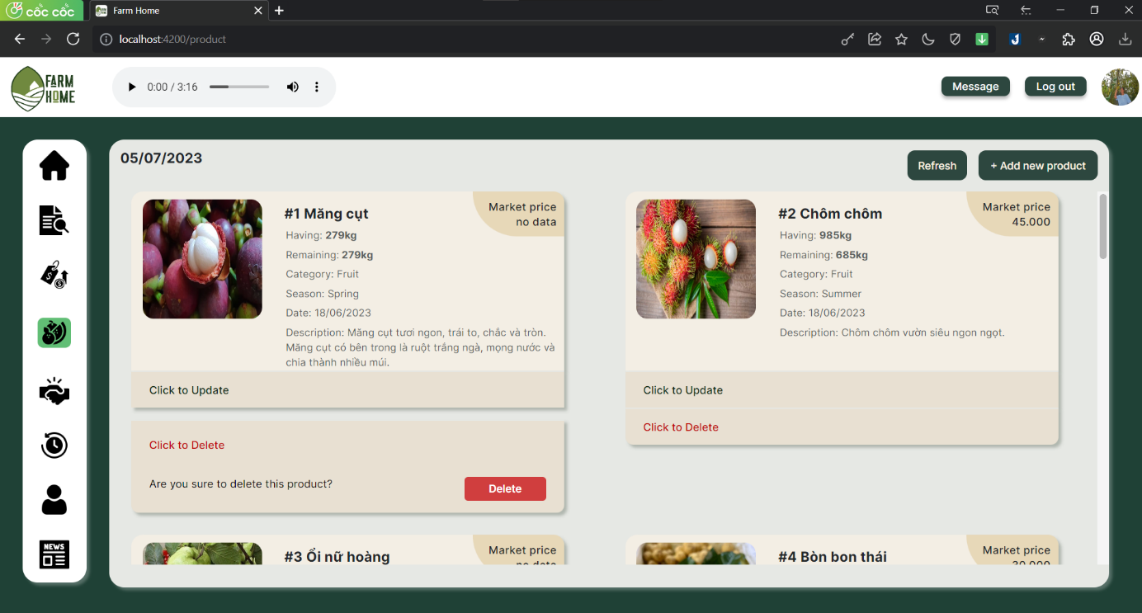

Figure 2. . Delete product

|  |  |  |  |
| --- | --- | --- | --- |
| **No** | **Name** | **Type** | **Event** |
| 1 | Delete button | Button | Click delete the product |

Table 2. . Delete product event

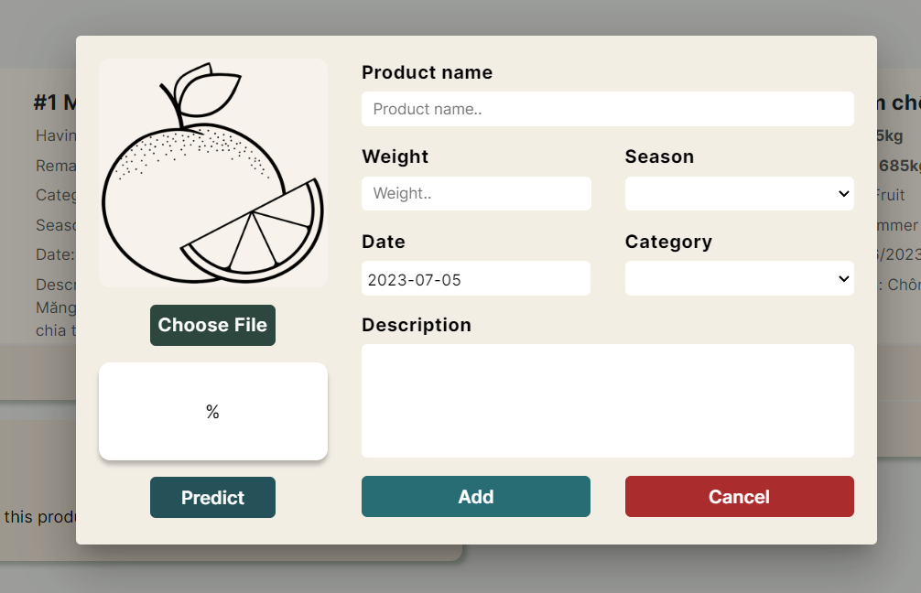

Figure 2. . Add product dialog

|  |  |  |  |
| --- | --- | --- | --- |
| **No** | **Name** | **Type** | **Event** |
| 1 | Product image | Image | Show image after got |
| 2 | Choose image | Button | Click to add image for product |
| 3 | Detect result | Text area | Show the confidence and name after detected |
| 4 | Predict button | Button | Click to detect fruit |
| 5 | Input product name | Textbox | For user input product name |
| 6 | Input product weight | Textbox | For user input product weight |
| 7 | Input product season | Textbox | For user input product season |
| 8 | Input product date | Textbox | For user input product date |
| 9 | Input product category | Textbox | For user input product category |
| 10 | Input product description | Textarea | For user input product description |
| 11 | Add button | Button | Click to add new product with all filled information |
| 12 | Cancel | Button | Close the dialog |

Table 2. . Add product dialog event

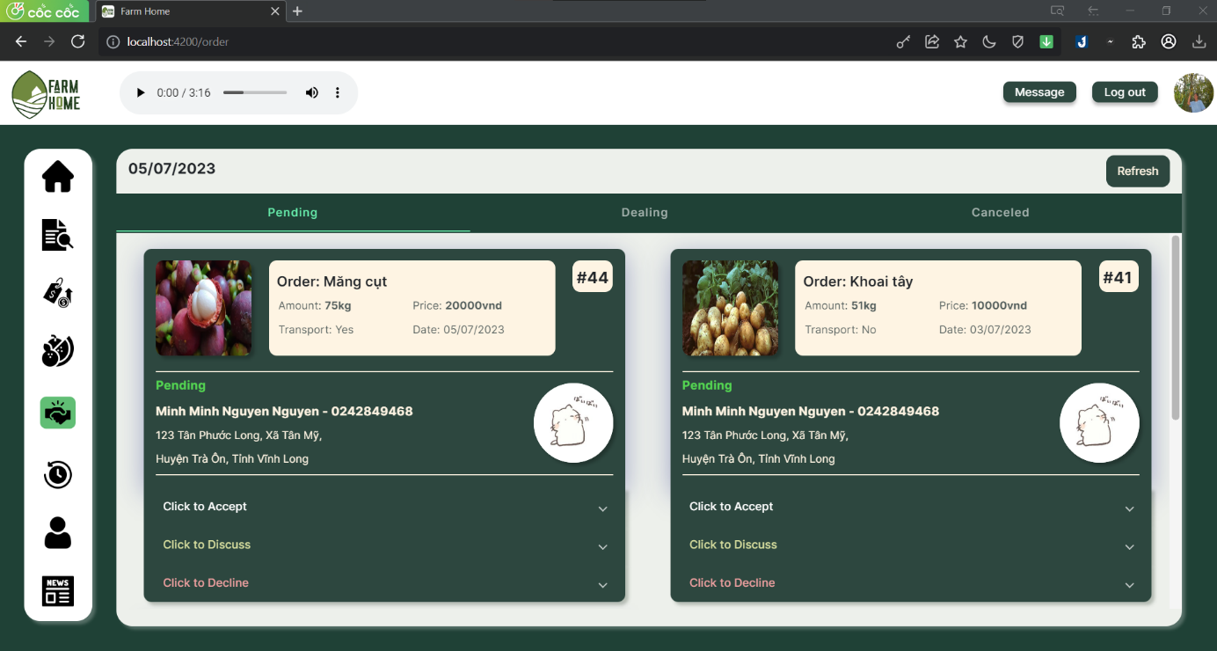

Figure 2. . Order page

|  |  |  |  |
| --- | --- | --- | --- |
| **No** | **Name** | **Type** | **Event** |
| 1 | Pending tab | Tab | After clicking, switch to pending panel |
| 2 | Dealing tab | Tab | After clicking, switch to dealing panel |
| 3 | Canceled tab | Tab | After clicking, switch to canceled panel |
| 4 | Order information | Text | Show all information of the order |
| 5 | Merchant information | Text | Show all information of the merchant that ordered |
| 6 | Expansion panel | Panel | Expand to accept/discuss/decline order |

Table 2. . Order page event

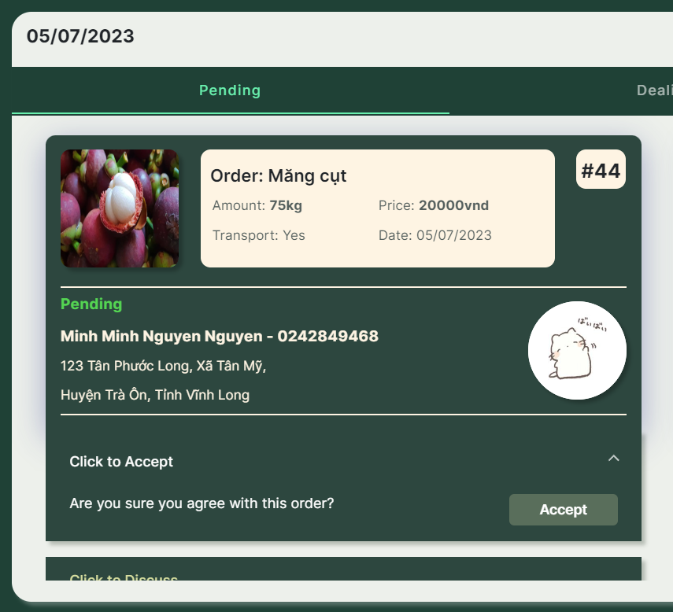

Figure 2. . Accept order

|  |  |  |  |
| --- | --- | --- | --- |
| **No** | **Name** | **Type** | **Event** |
| 1 | Accept button | Button | After clicking, the order will be placed successfully |

Table 2. . Accept order event

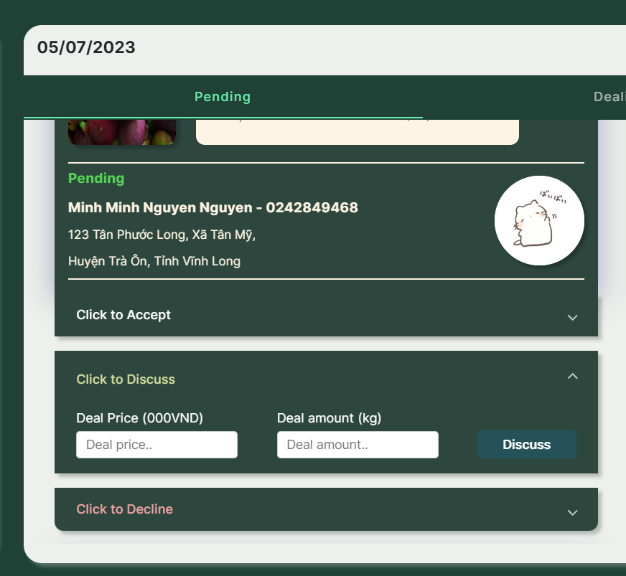

Figure 2. . Discuss price

|  |  |  |  |
| --- | --- | --- | --- |
| **No** | **Name** | **Type** | **Event** |
| 1 | Input deal price | Input | For user input new deal price |
| 2 | Input deal amount | Input | For user input new deal amount |
| 3 | Discuss button | Button | Click to confirm new order deal |

Table 2. . Discuss price event

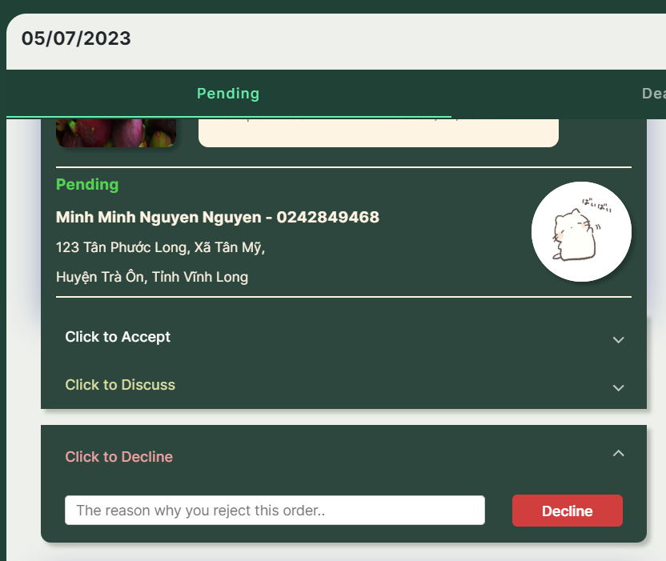

Figure 2. . Decline order

|  |  |  |  |
| --- | --- | --- | --- |
| **No** | **Name** | **Type** | **Event** |
| 1 | Input reason | Input | For user input the reason why user reject the order |
| 2 | Decline button | Button | Click to decline the order |

Table 2. . Decline order event

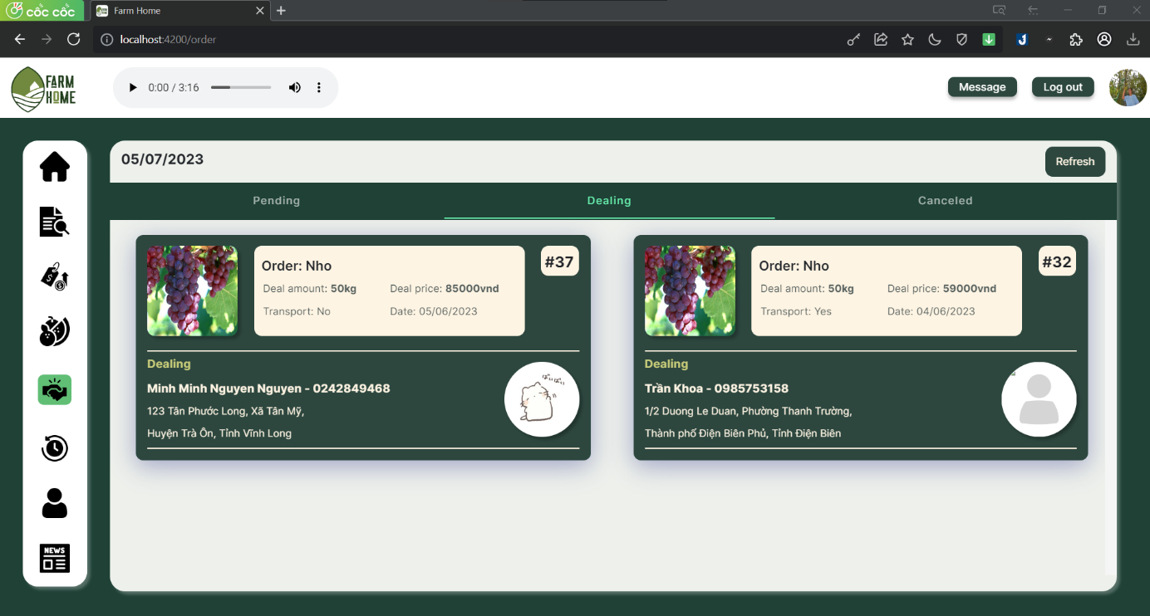

Figure 2. . Order with dealing status

|  |  |  |  |
| --- | --- | --- | --- |
| **No** | **Name** | **Type** | **Event** |
| 1 | Dealing card | Card | Display all information of order after a deal |

Table 2. . Order with dealing status event

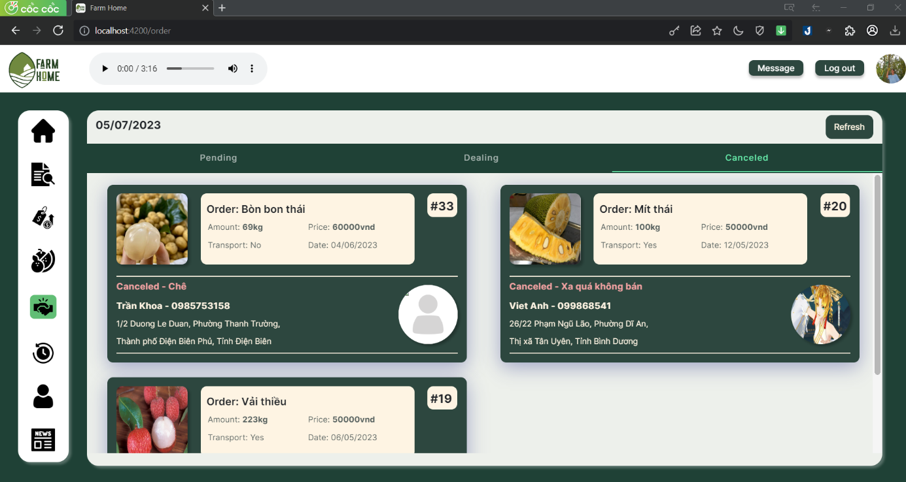

Figure 2. . Order with canceled status

|  |  |  |  |
| --- | --- | --- | --- |
| **No** | **Name** | **Type** | **Event** |
| 1 | Decline card | Card | Display all information of order after a decline |

Table 2. . Order with canceled status event

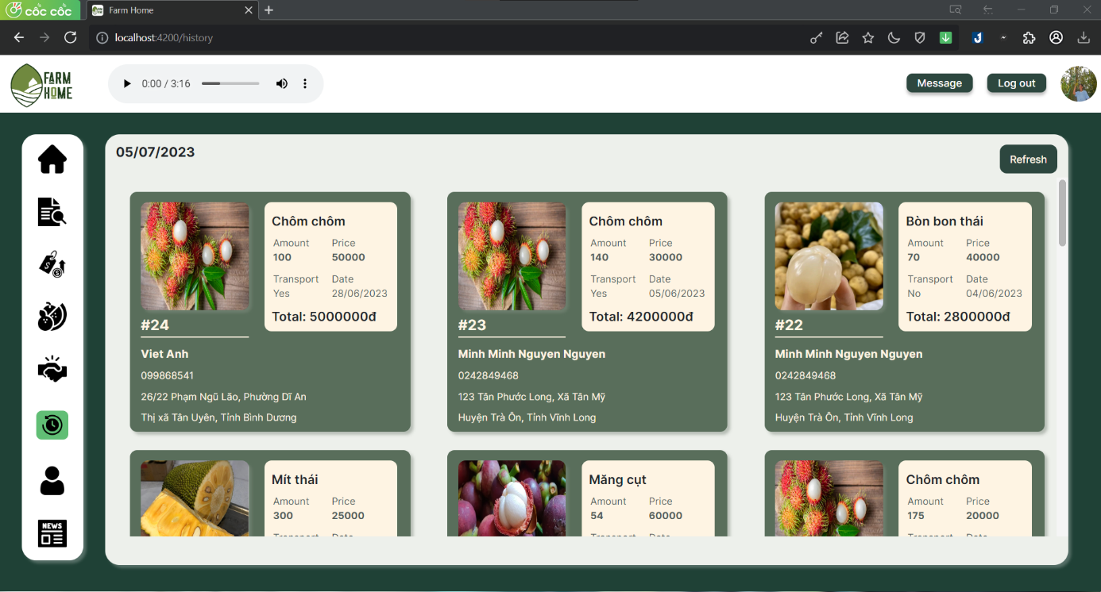

Figure 2. . History page

|  |  |  |  |
| --- | --- | --- | --- |
| **No** | **Name** | **Type** | **Event** |
| 1 | History card | Card | Display information of completed orders |

Table 2. . History page event

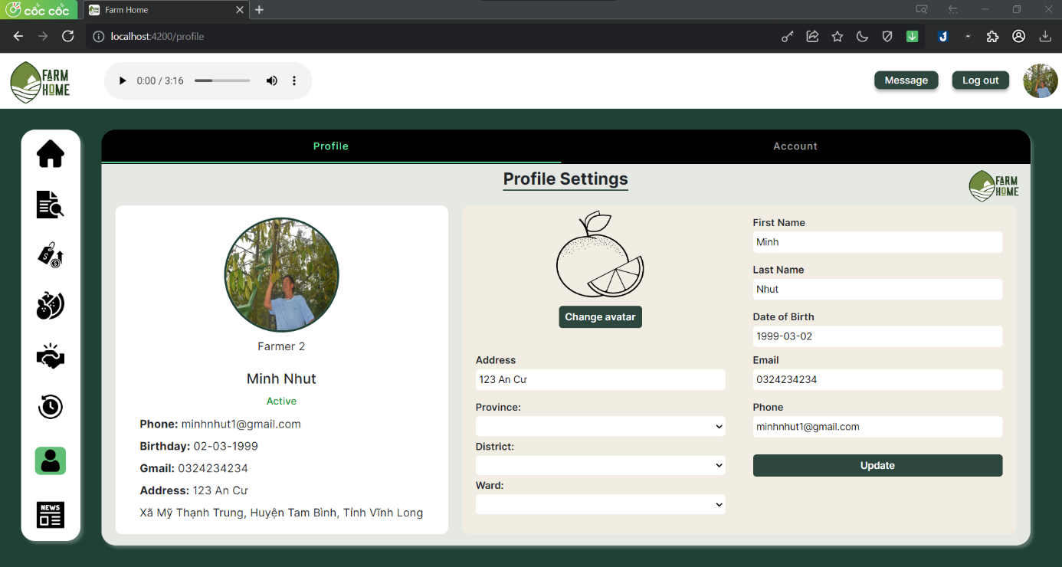

Figure 2. . Profile page

|  |  |  |  |
| --- | --- | --- | --- |
| **No** | **Name** | **Type** | **Event** |
| 1 | User avatar | Image | Display the avatar of user |
| 2 | Personal information | Text | Display all information of user |
| 3 | Upload image | Button | Choose new image to update |
| 4 | Input personal information | Texbox | For user to input all information to update |
| 5 | Input location information | Textbox | For user to input location |
| 6 | Update button | Button | Click to update new information |

Table 2. . Profile page event

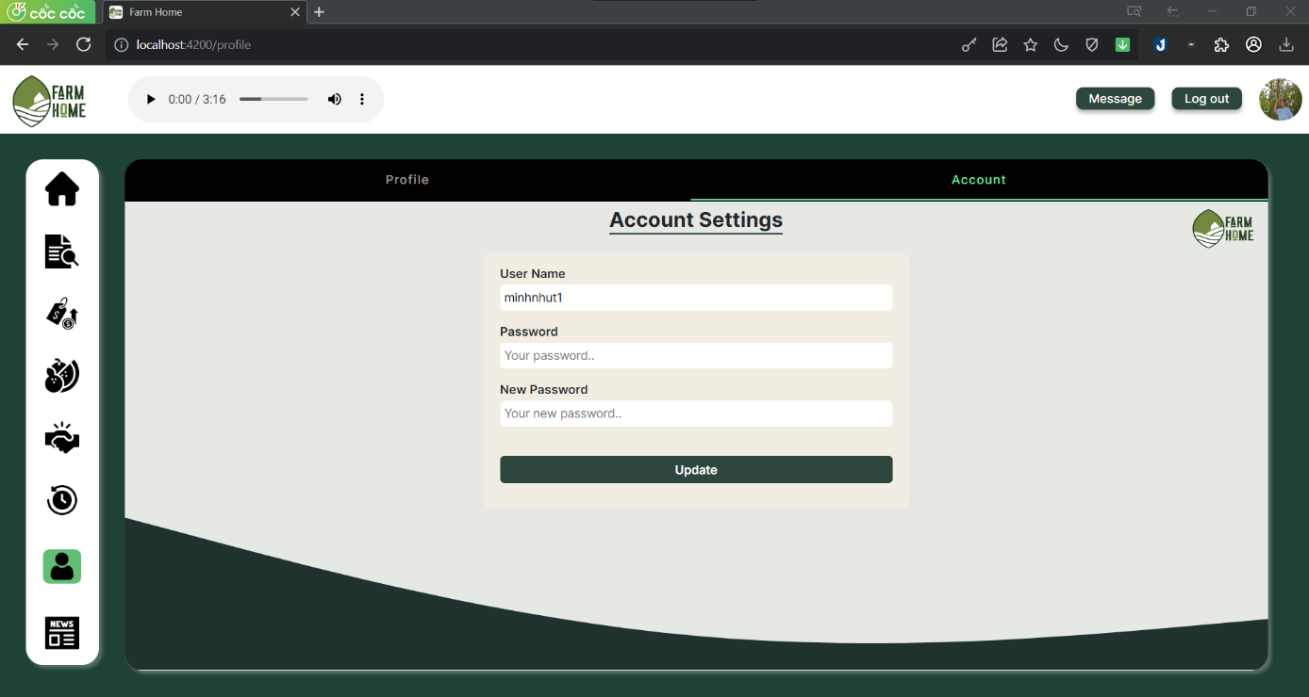

Figure 2. . Change password

|  |  |  |  |
| --- | --- | --- | --- |
| **No** | **Name** | **Type** | **Event** |
| 1 | Input username | Textbox | For user see username (readonly) |
| 2 | Input old password | Textbox | For user input old password |
| 3 | Input new password | Textbox | For user input new password |
| 4 | Update button | Button | Confirm the action |
| 5 | Profile tab | Tab | After clicking, switch to profile panel |
| 6 | Account tab | Tab | After clicking, switch to account panel |

Table 2. . Change password event

### 4.5.3. Website for admin

|  |  |  |
| --- | --- | --- |
| **No.** | **Screen name** | **Description** |
| **1** | Login | Login for admins |
| **2** | Statistics | Display statistical information |
| **3** | Merchants | Display merchants information |
| **4** | Farmers | Display farmers information |
| **5** | News | Display news information |
| **6** | Category | Display categories information |
| **7** | Reports | Display reports information |
| **8** | Logout | Leave the admin page |

Table 2. . List of website page for admin

The current administration's website serves multiple purposes, primarily focusing on the display of statistical information and providing relevant details about users and products. The website plays a crucial role in presenting a wide range of statistical data related to the administration's performance, enabling transparency and accountability in its actions.

The website serves as a comprehensive platform for sharing information about users and products. It provides a valuable resource by showcasing details about registered user.

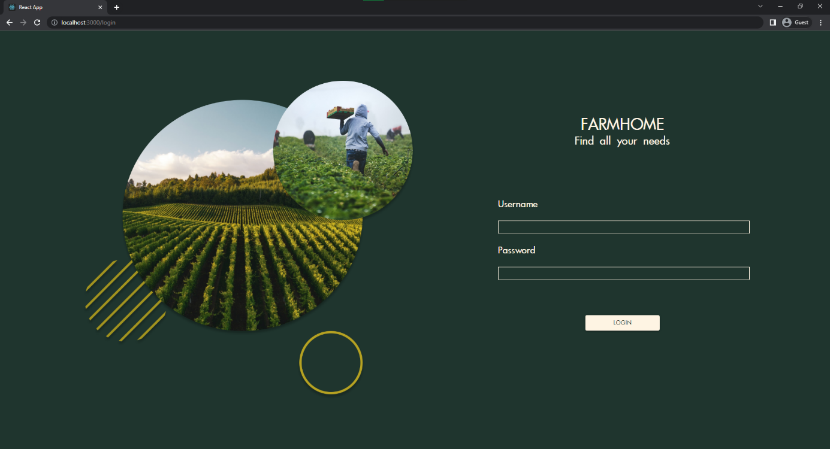

Figure 2. . Login Page

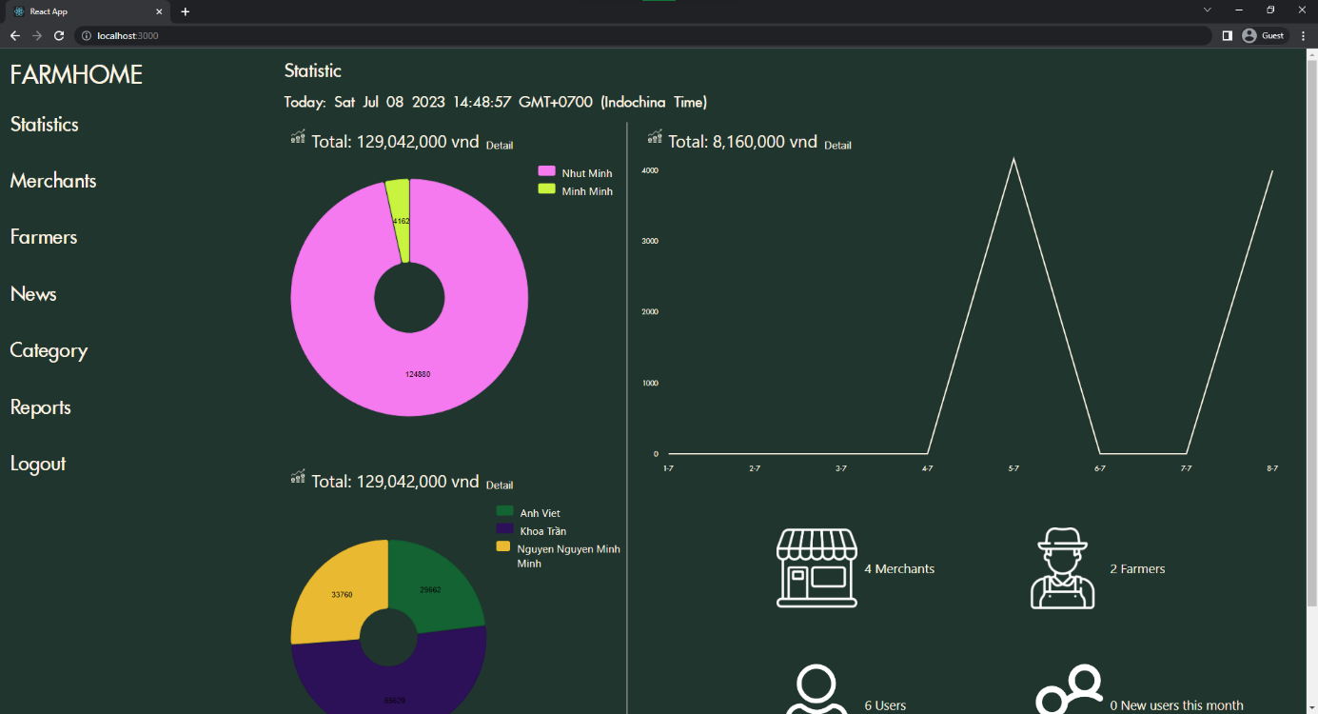

Figure 2. . Statistic Page

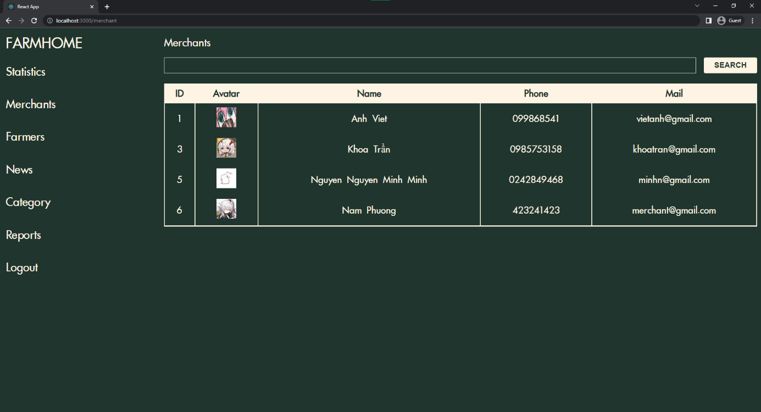

Figure 2. . Merchant List Page

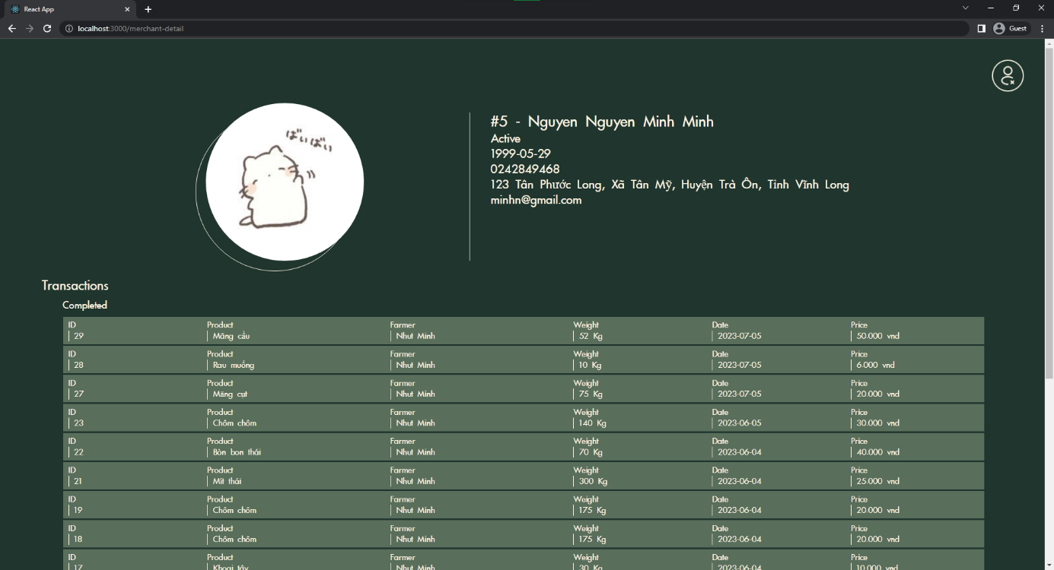

Figure 2. . Merchant detail page

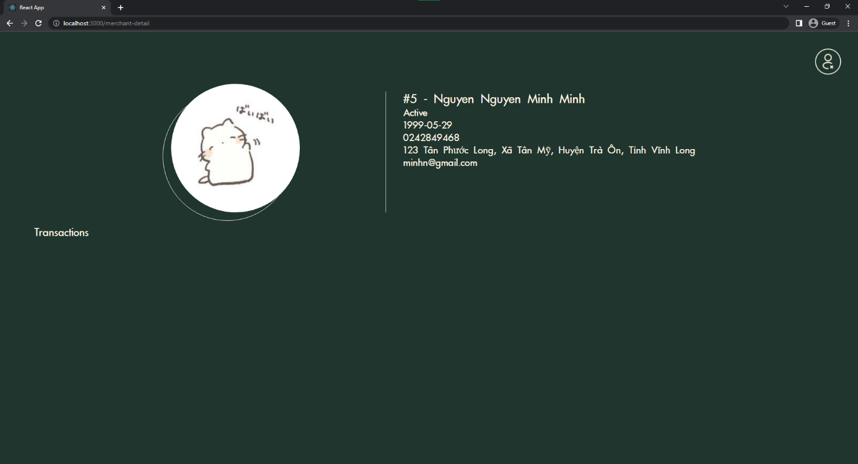

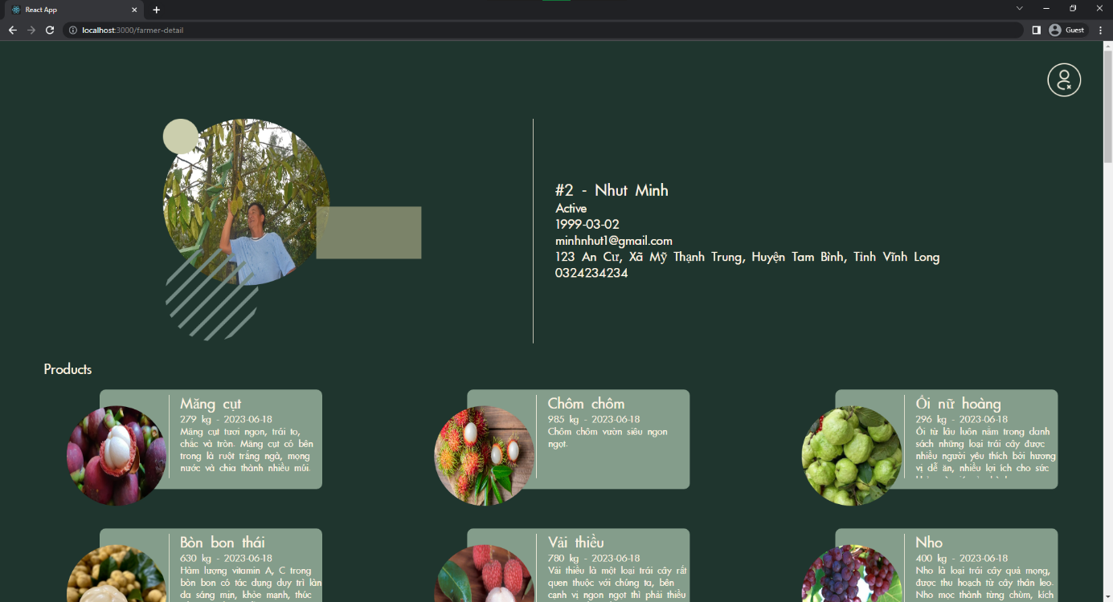

Figure 2. . Farmer detail page

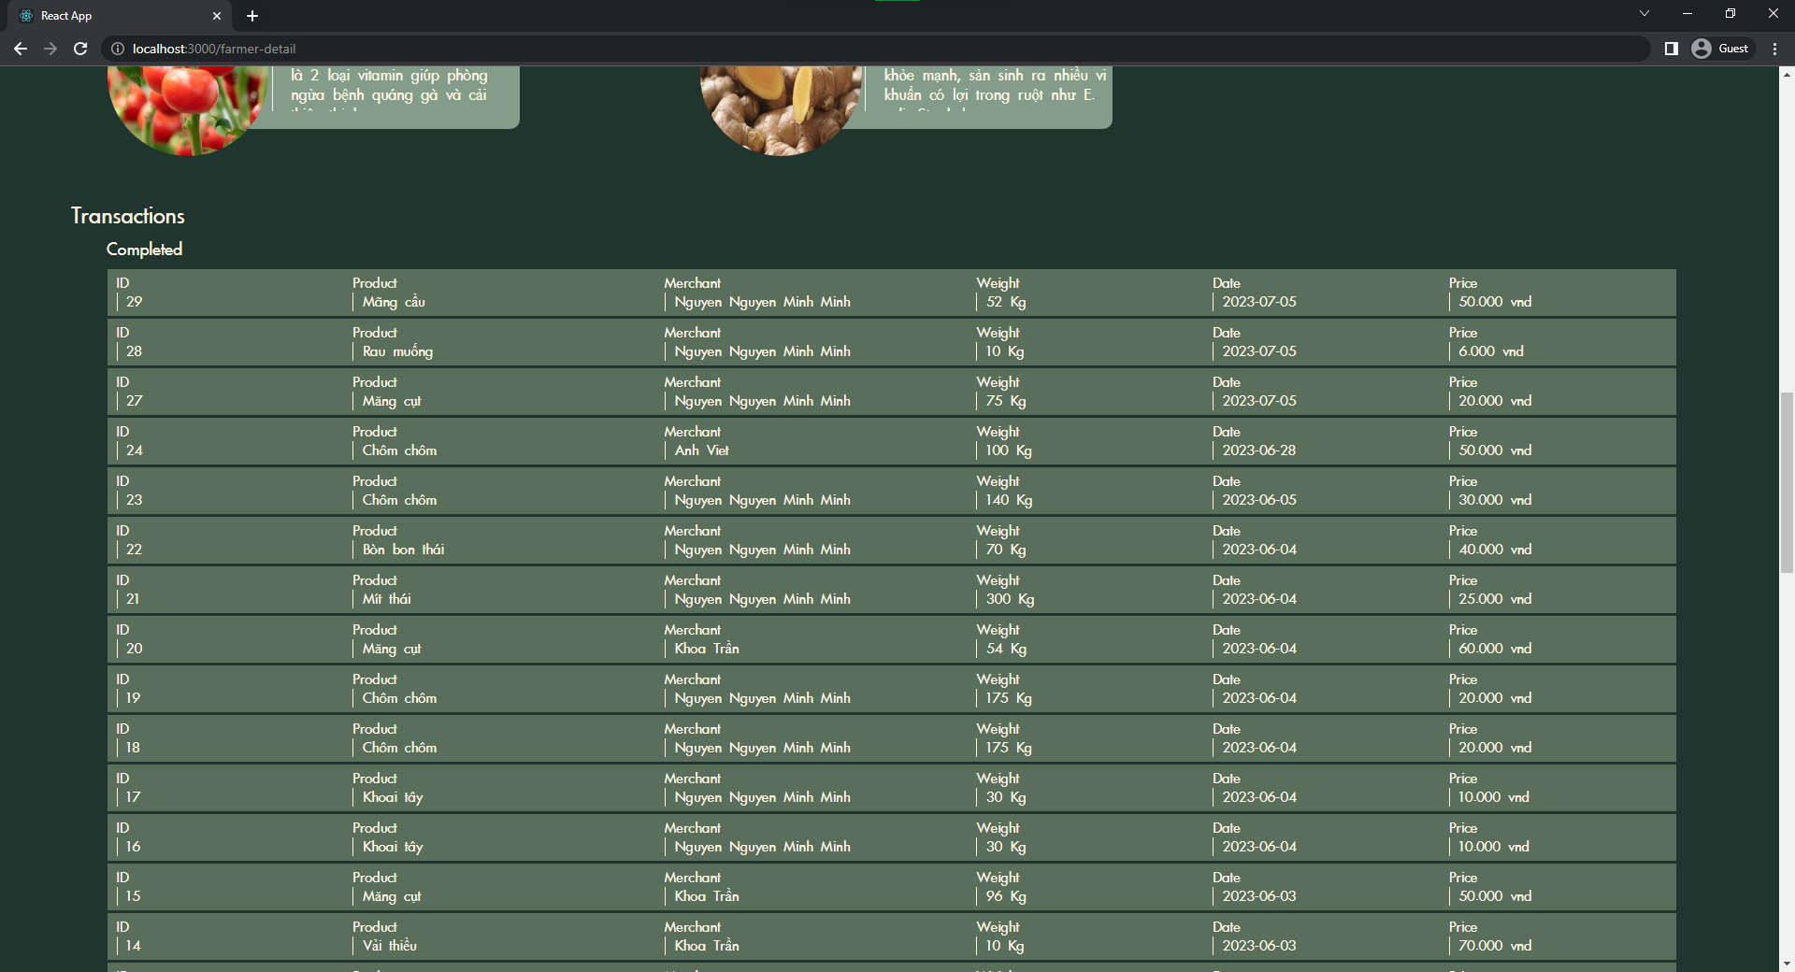

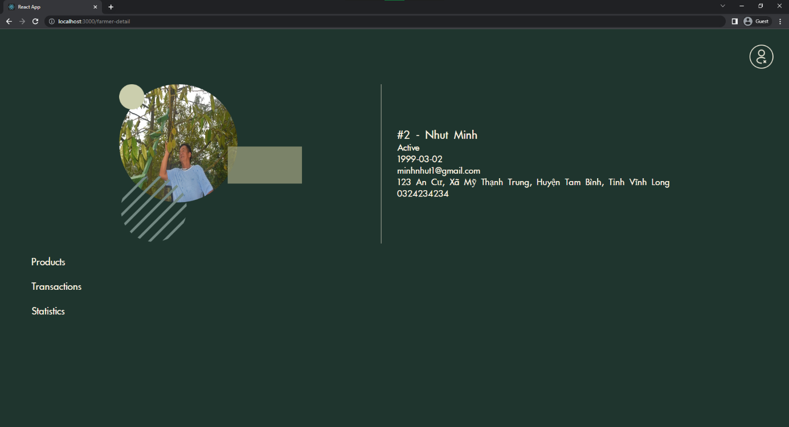

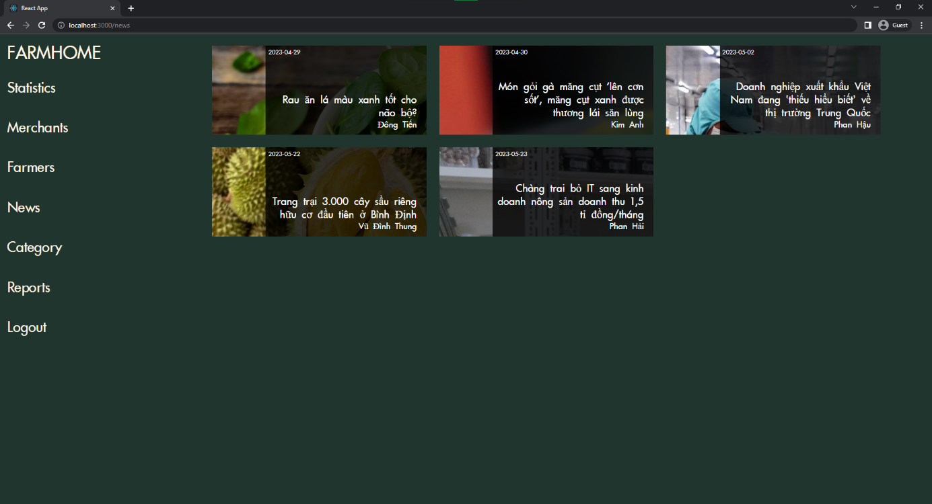

Figure 2. . News list page

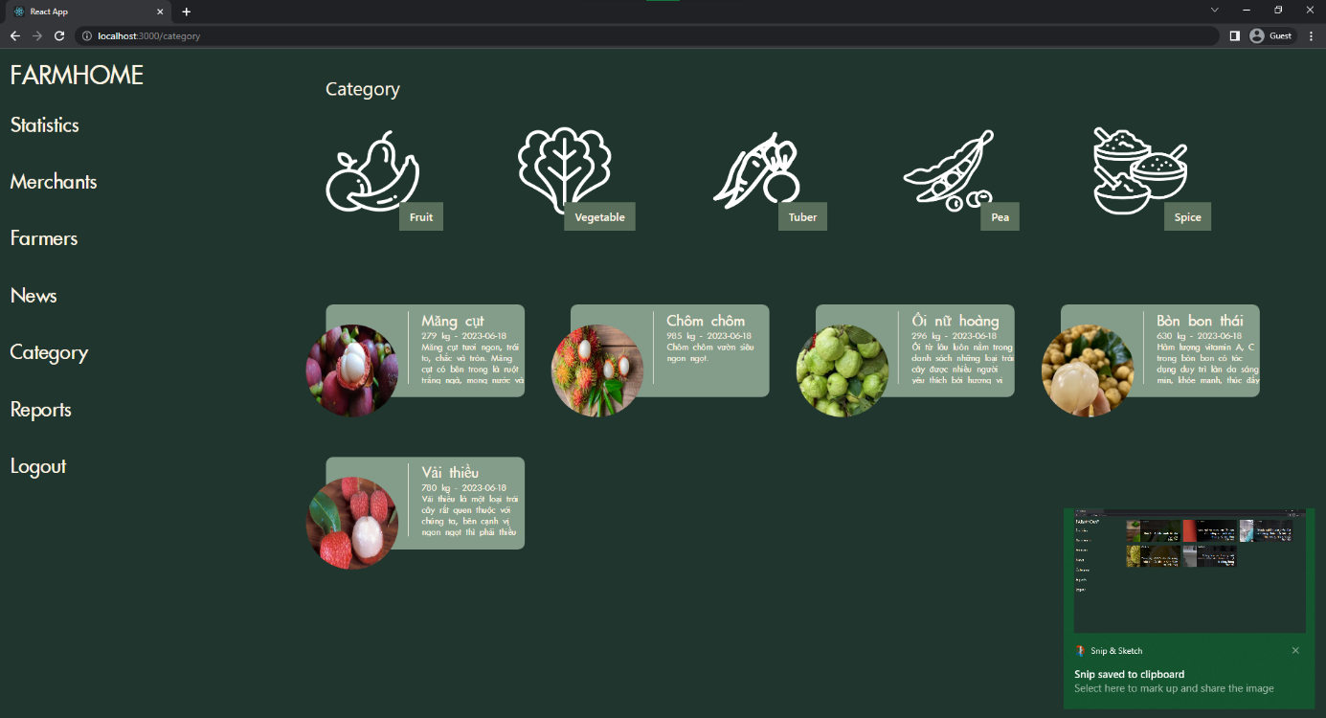

Figure 2. . Category list page

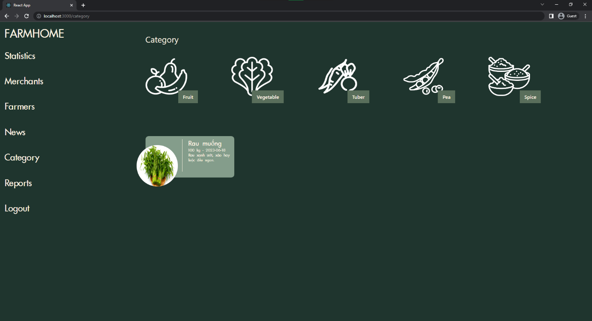

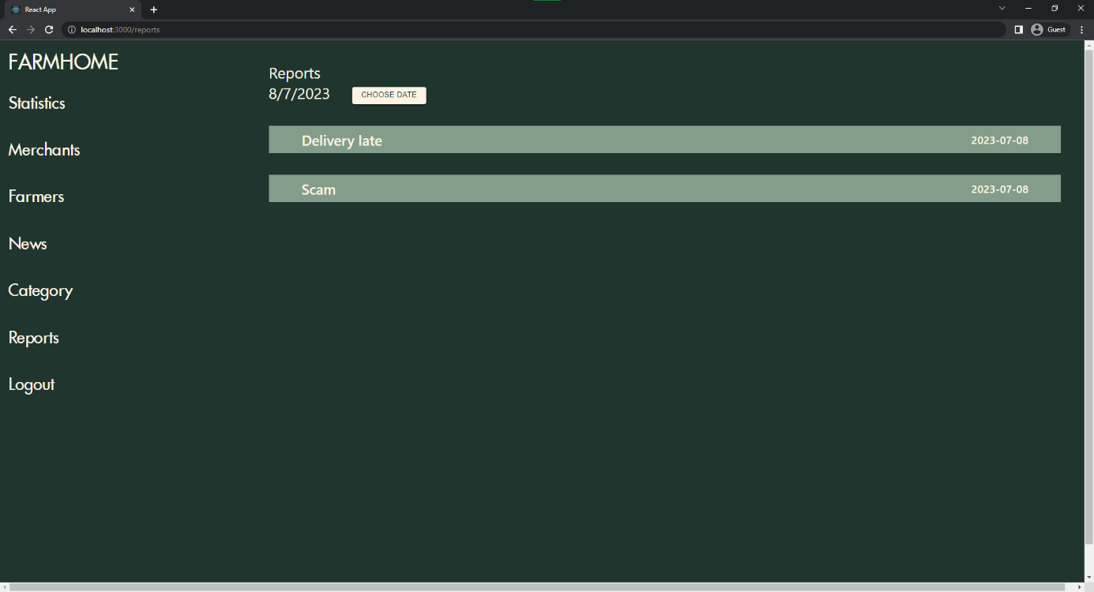

Figure 2. . Report list page

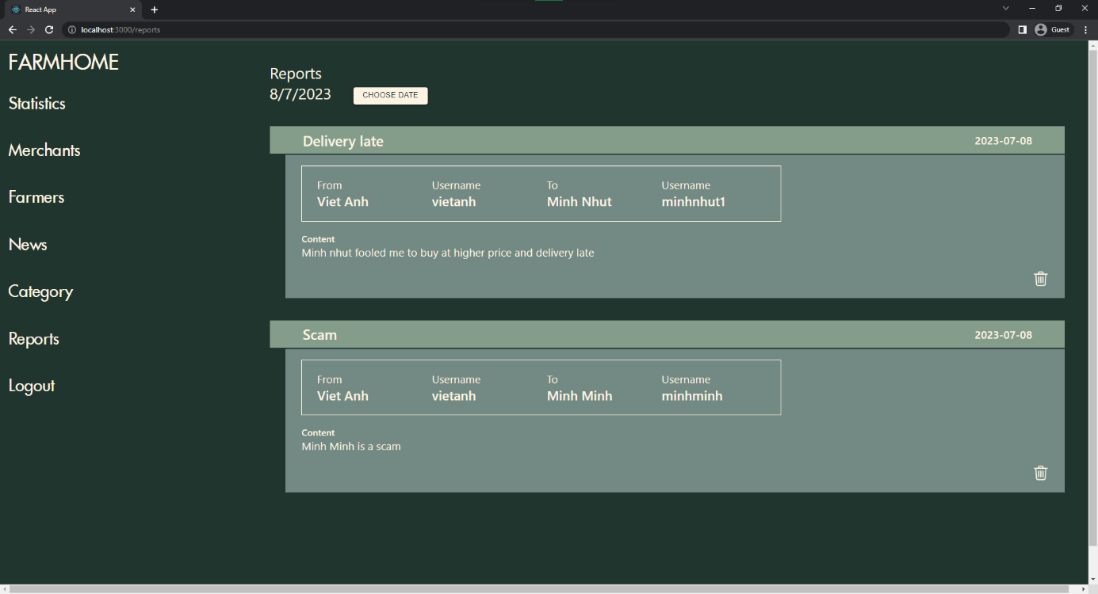

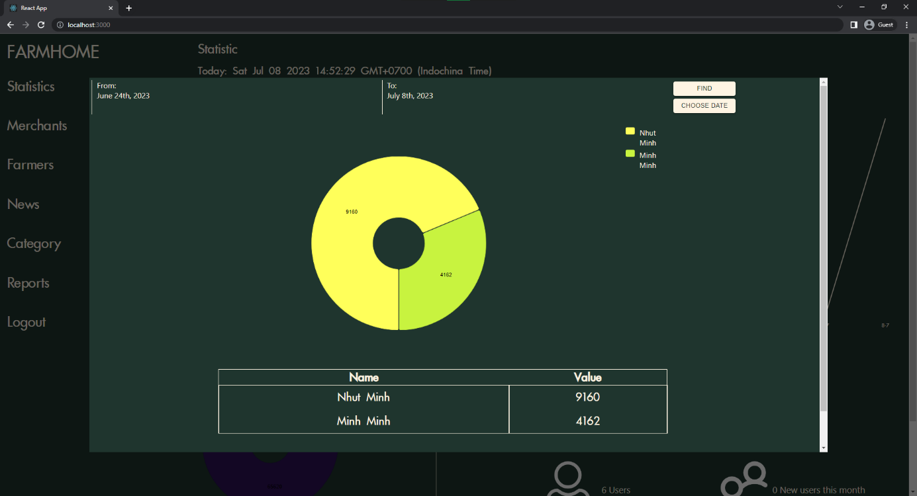

Figure 2. . Statistic detail

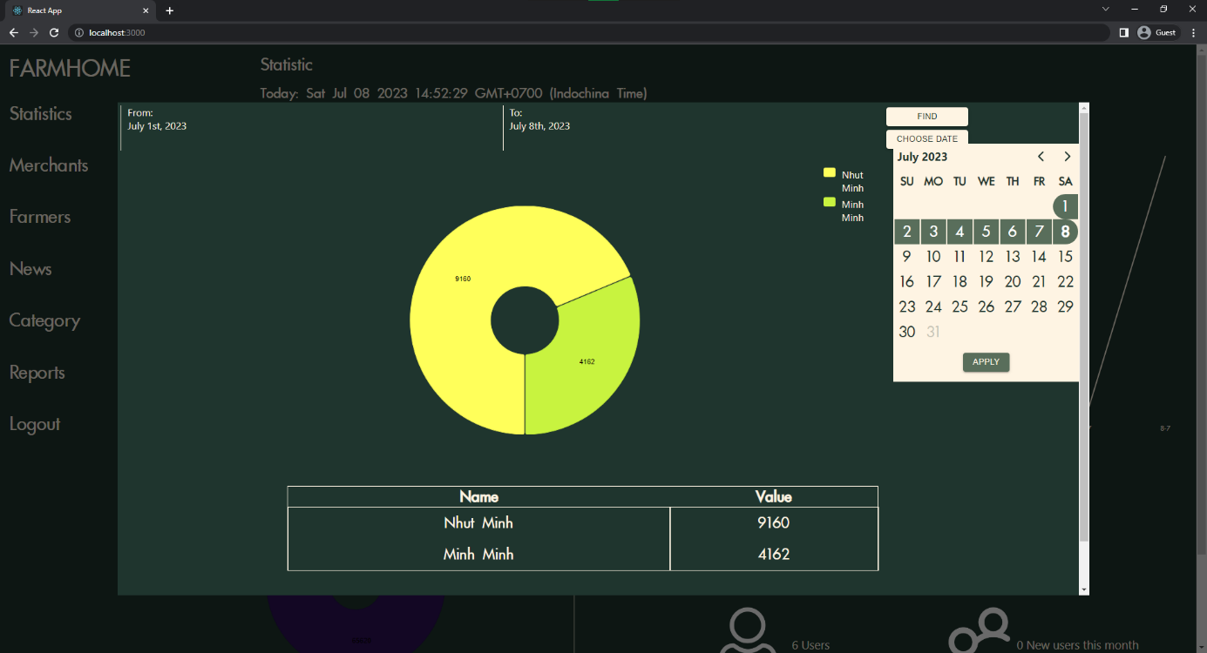

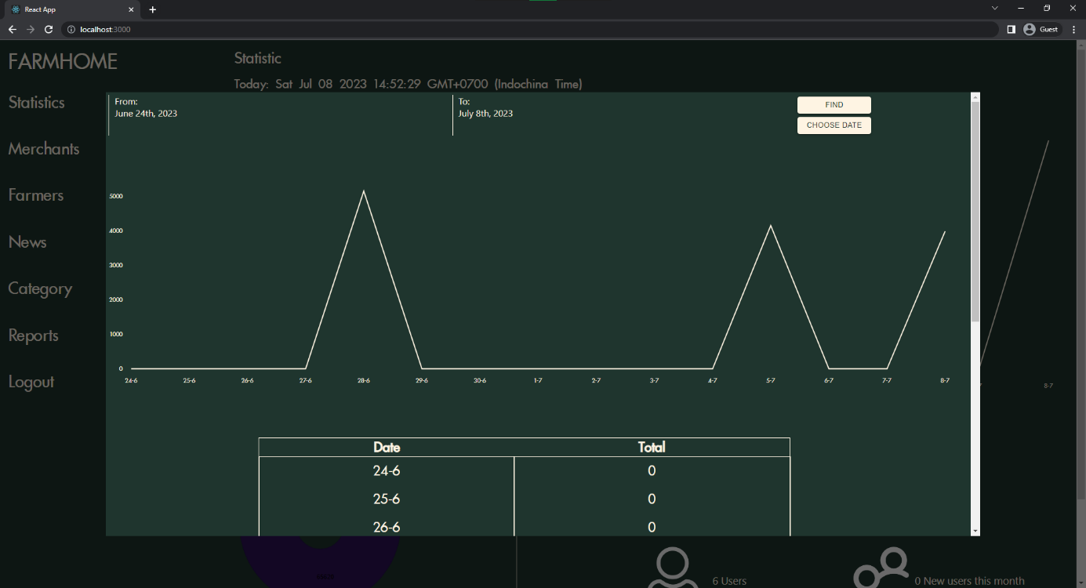

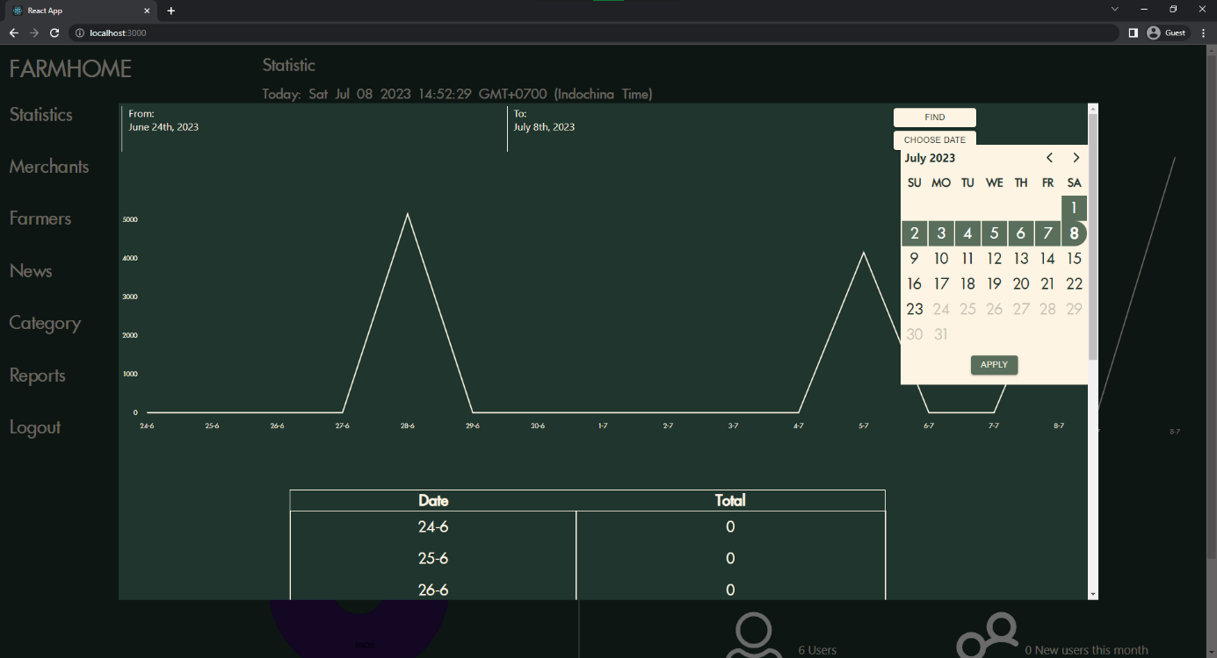

# CHAPTER 5: IMPLEMENTATION AND TESTING

## 5.1. Overall architecture of the system

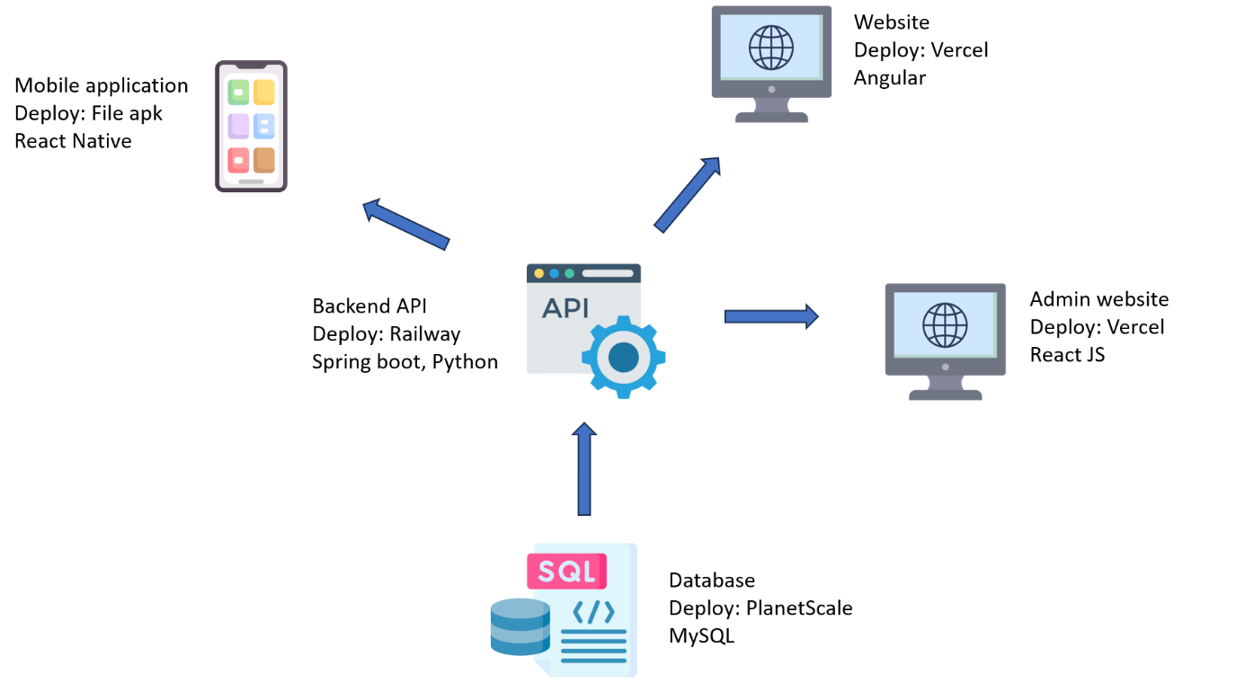

Figure 3. . Architecture of the system

Firstly, the system will consist of a website dedicated to farmers to post information about agricultural products, carry out product transactions, and manage their orders. They can add their products to their store to be displayed on the merchant's application.

Meanwhile, on the merchant's mobile application, they can log in (or register) to access the marketplace and view the products posted by farmers and engage in buying and selling transactions if needed. Additionally, the application also supports some features to enhance the user experience, such as language switching, reading news, or receiving notifications related to their orders.

Furthermore, the system includes an admin management page. The main purpose of the website is to monitor, evaluate, and track user data, orders, and products on the marketplace by displaying statistical charts and information tables. The admin also has the authority to block users if any suspicious or invalid actions or transactions are detected. The admin page can also view reports from users to identify difficulties or disputes they may be facing.

Moreover, to ensure effective communication between all components of the system, an API management system has been developed. This system provides routes to perform various functionalities and utilizes connections to write or retrieve information from the database. As for the database, it is provided by a specialized website for online database rentals, ensuring data backup synchronization and access from anywhere.

## 5.2. Tensorflow

Dataset source: Kaggle – Fruits and Vegetables Image Recognition Dataset

https://www.kaggle.com/datasets/kritikseth/fruit-and-vegetable-image-recognition

Use Shallow Neural Networks

Number of pictures: 3193

Number of different labels: 36

Labels: ['grapes' 'pomegranate' 'banana' 'carrot' 'garlic' 'onion' 'pineapple'

'orange' 'capsicum' 'jalepeno' 'paprika' 'watermelon' 'raddish' 'lettuce'

'spinach' 'tomato' 'sweetpotato' 'cauliflower' 'bell pepper' 'peas'

'lemon' 'kiwi' 'chilli pepper' 'cabbage' 'turnip' 'eggplant' 'potato'

'soy beans' 'pear' 'mango' 'beetroot' 'sweetcorn' 'cucumber' 'corn'

'apple' 'ginger']

Data processing:

- Use tf.keras preprocessing.image.ImageDataGenerator with config:

dataframe=train_df,

x_col='Filepath',

y_col='Label',

target_size=(224, 224),

color_mode='rgb',

class_mode='categorical',

batch_size=32,

shuffle=True,

seed=0,

rotation_range=30,

zoom_range=0.15,

width_shift_range=0.2,

height_shift_range=0.2,

shear_range=0.15,

horizontal_flip=True,

fill_mode="nearest"

Model training:

- 2 layers of Dense with 128 units and Rectified Linear Unit activation

- output layer: 36 units and softmax activation

- model compile:

optimizer='adam',

loss='categorical_crossentropy',

metrics=['accuracy']

- model train:

Batch_size = 32

Epochs = 5

EarlyStopping(monitor=“val_loss”, patience=2, restore_best_weights=True)

- Accuracy: 0.9417

- loss: 0.1790

- val_accuracy: 0.9521

- val_loss: 0.1094

## 5.3. Testing

We will start with the website for farmers, login if you already have an account, or proceed to register if you don't.

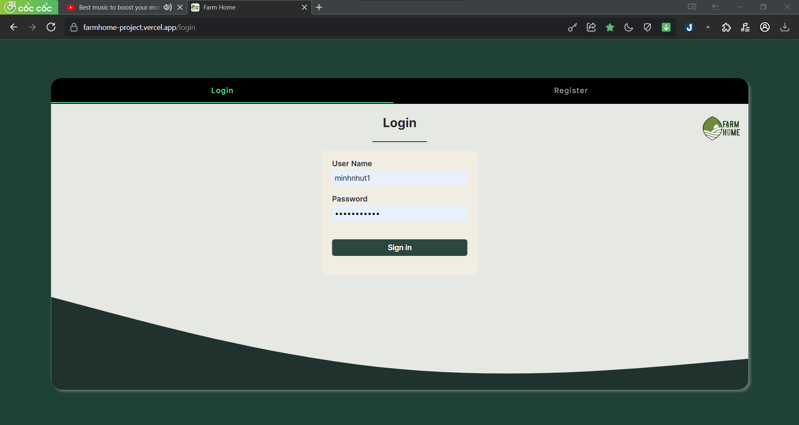

Figure 3. . Login page

After logging in, you will be on the home screen, where you can access the product page by clicking the "Let start" button or using the icon in the sidebar to navigate to the products.

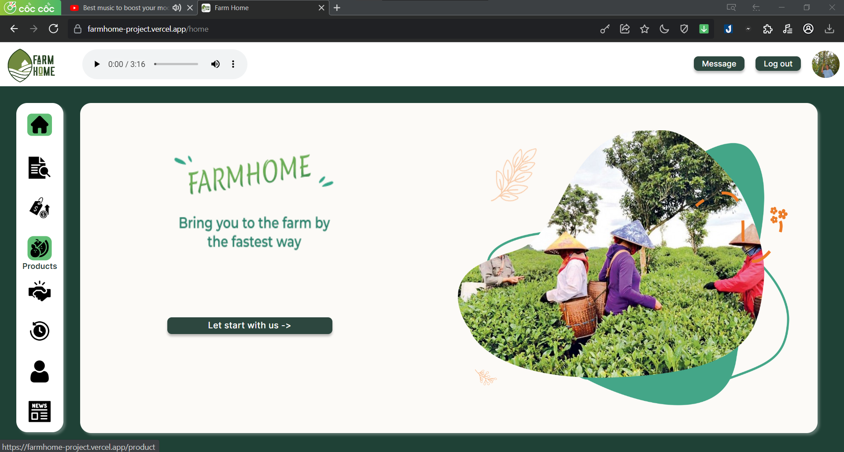

Figure 3. . Home page

Here, we can perform functions such as adding, editing, and deleting products.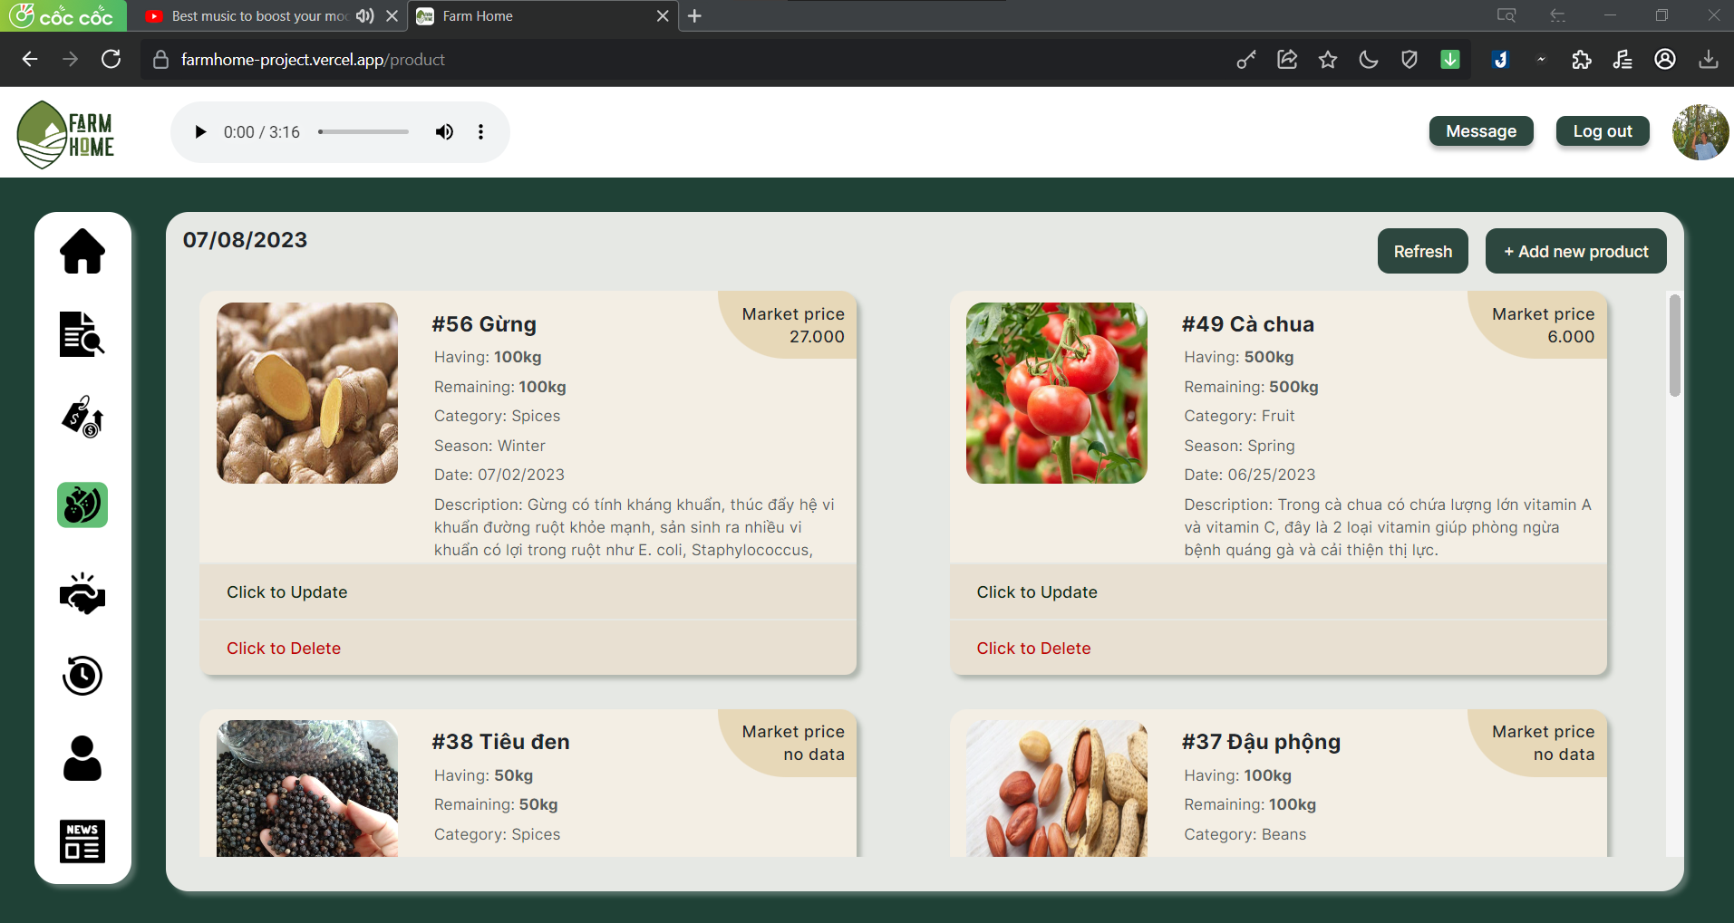

Figure 3. . Product page

Add product.

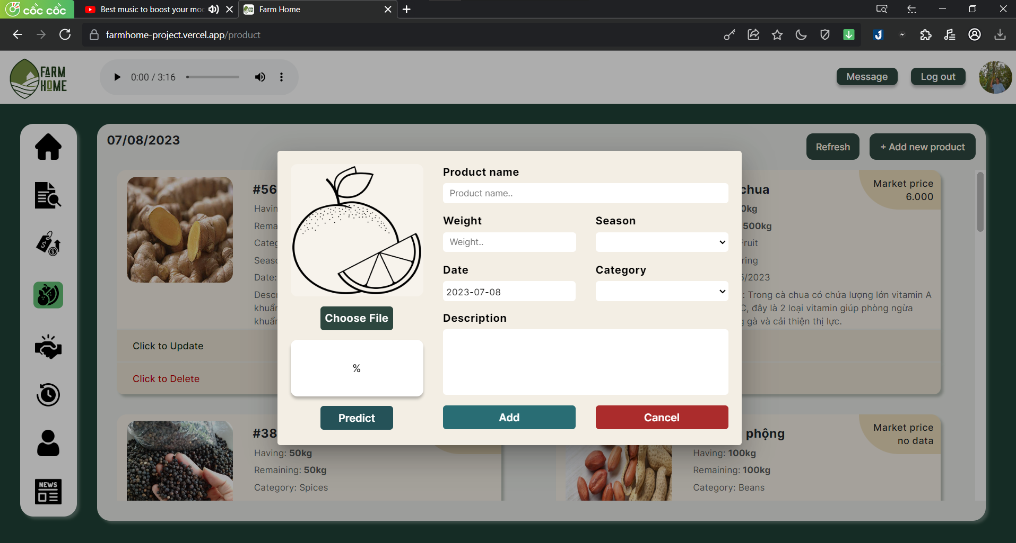

Figure 3. . Add new product

After the dialog appears, we can add a new product by uploading an image and filling in all the required fields. Additionally, the system supports user assistance in detecting the product using a pre-trained model, which automatically fills in the fields such as name, season, and type with a determined level of accuracy.

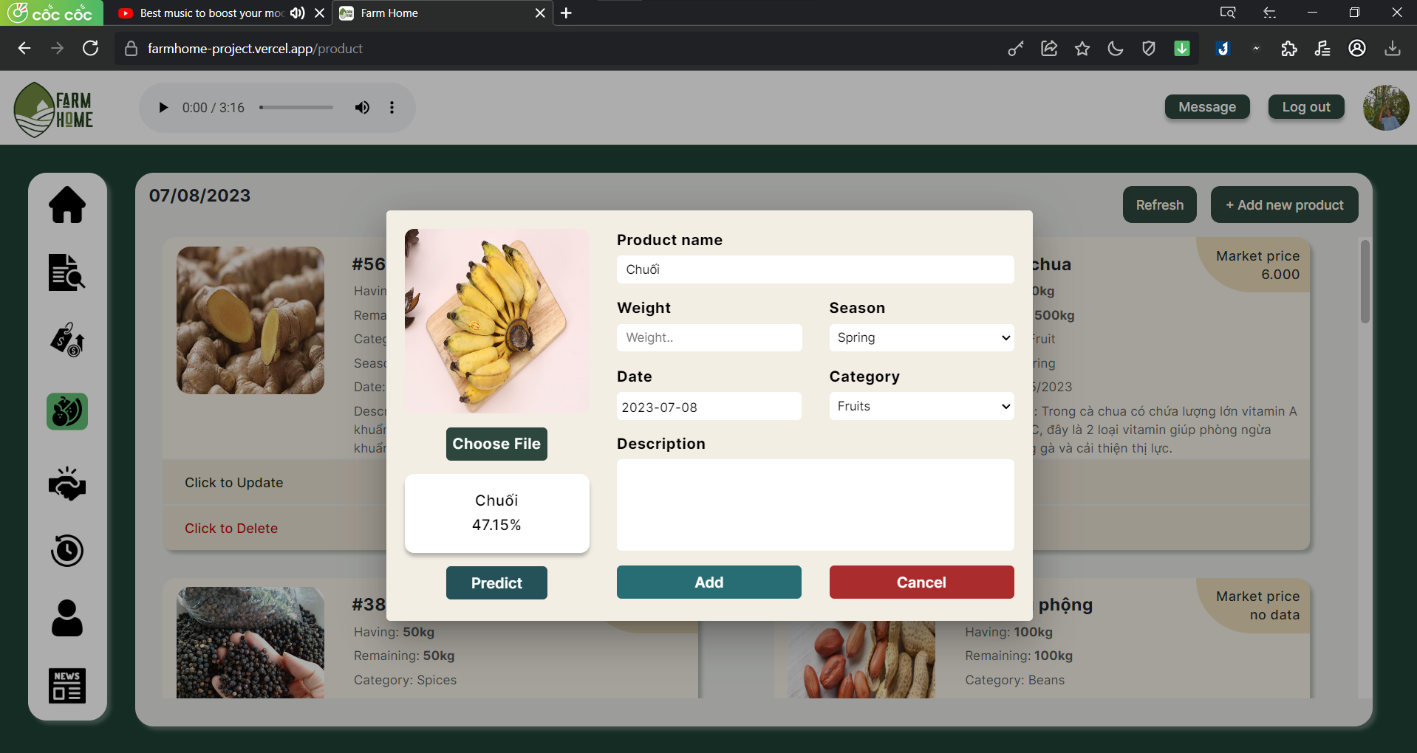

Figure 3. . Detect product

New product “Chuối xiêm” is added.

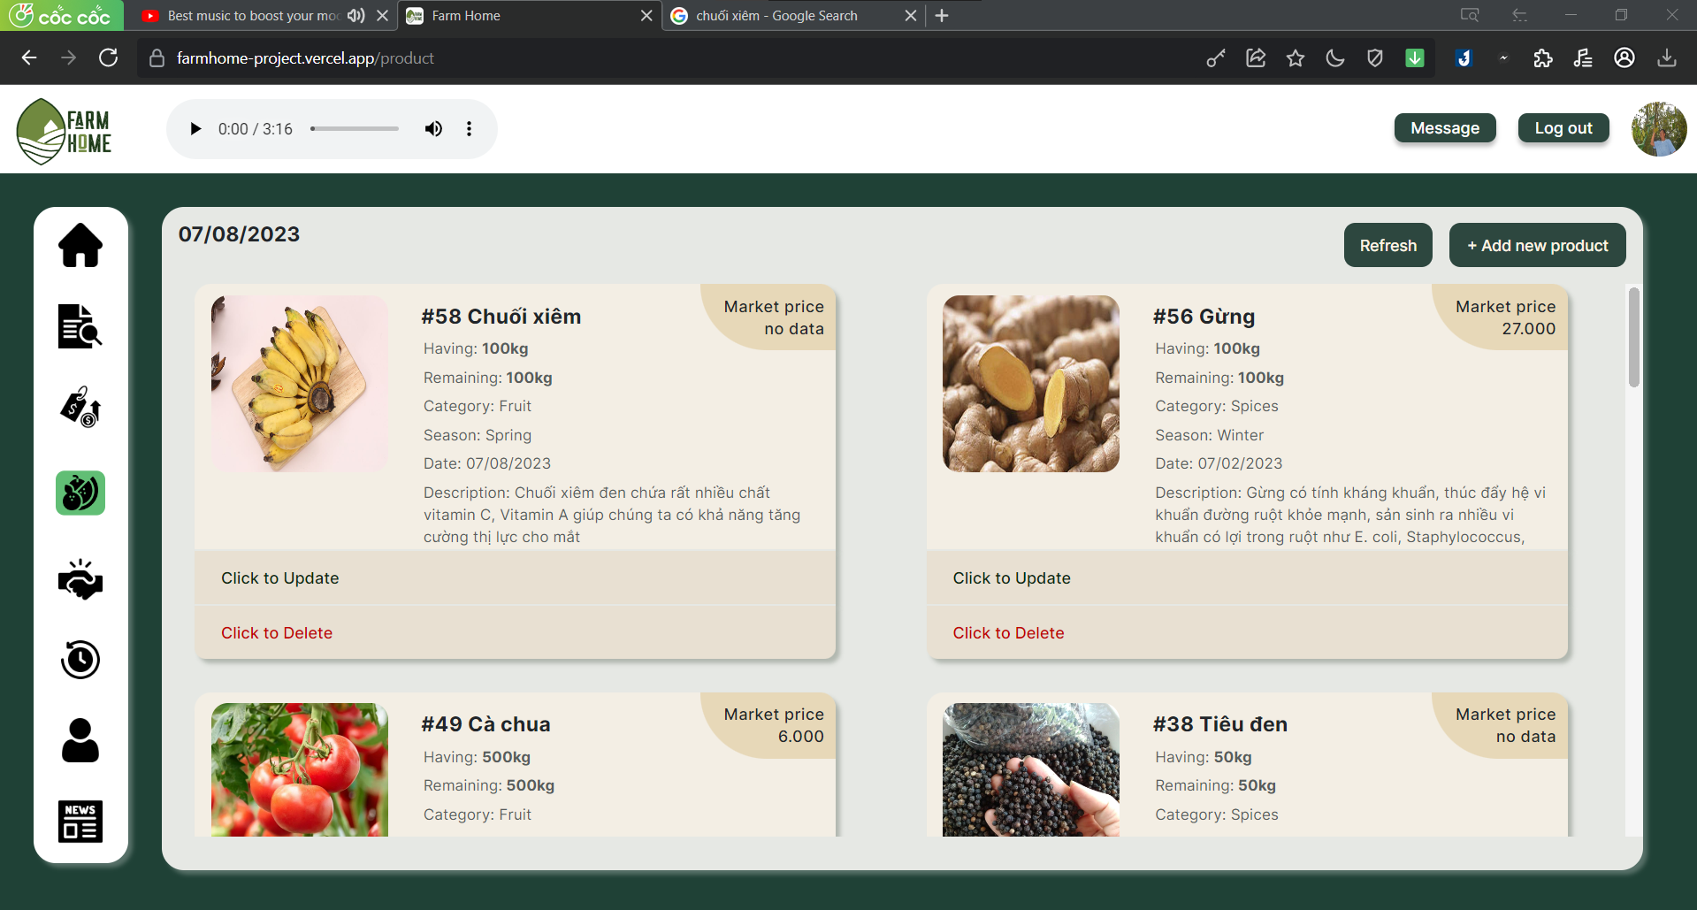

Figure 3. . New product is added

Edit.

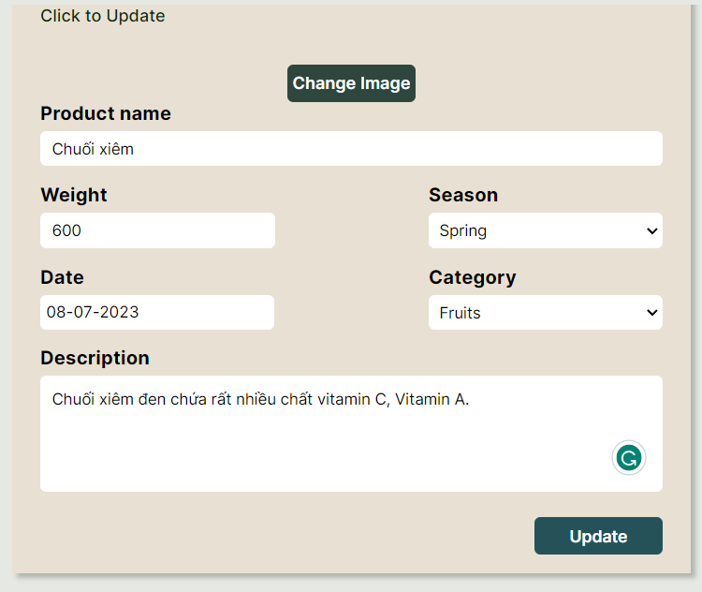

Figure 3. . Edit product

Delete product.

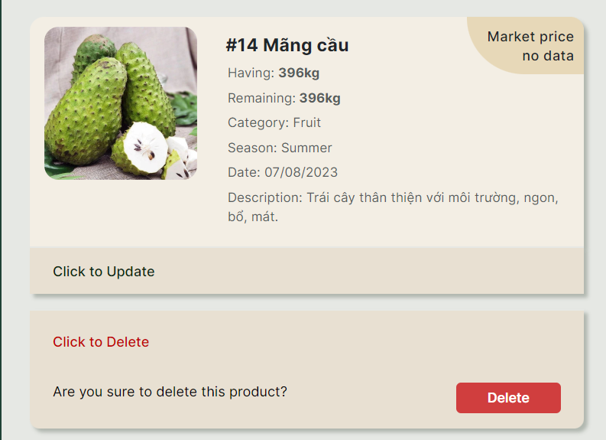

Figure 3. . Delete product

Now, let's switch to the mobile app in the role of a merchant.

Login.

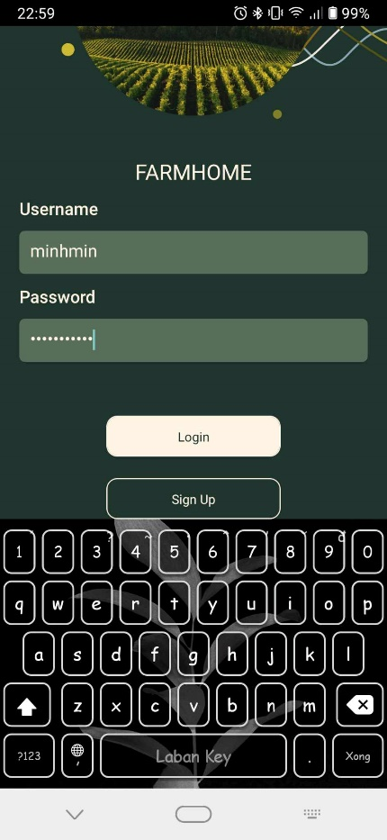

Figure 3. . Login screen

Arriving at the product display screen.

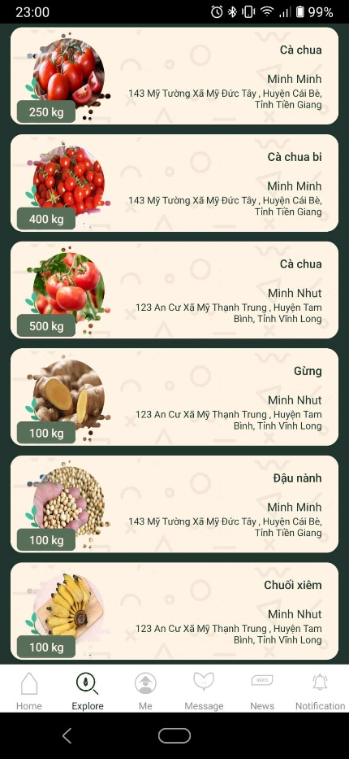

Figure 3. . Explore screen

Choose product.

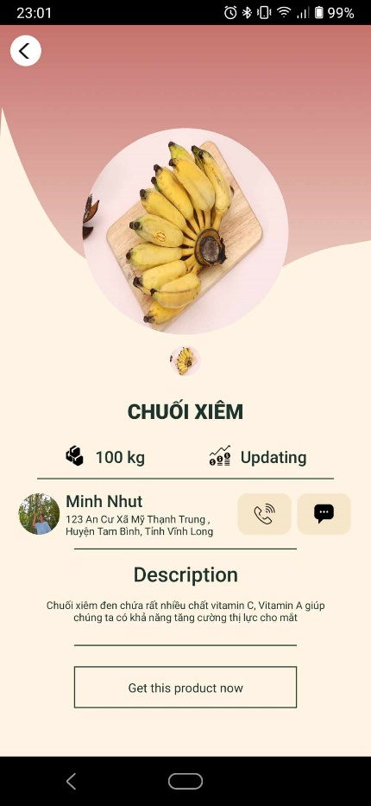

Figure 3. . Product details screen

Order.

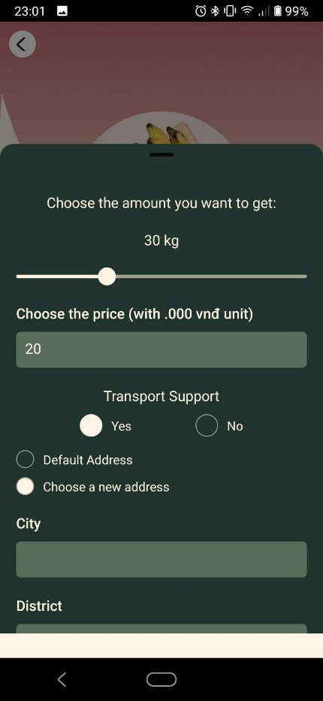

Figure 3. . Order

If you need transport assistance, there will be an option to select the address.

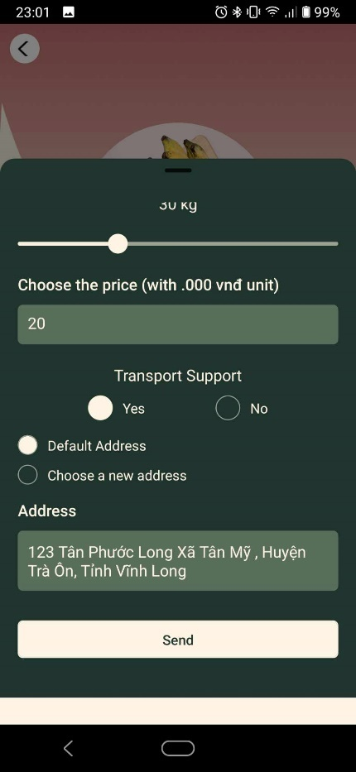

Figure 3. . Choose location

Navigate to the screen to view the order.

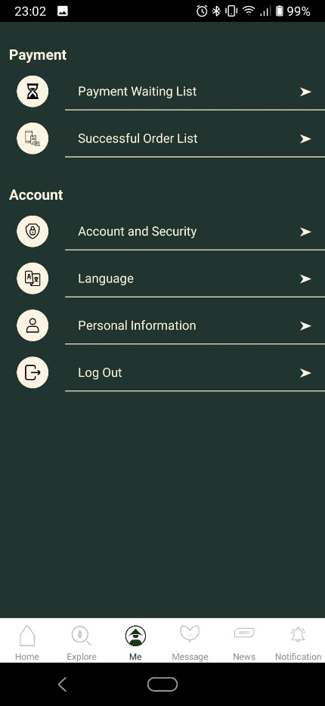

Figure 3. . Go to payment waiting list

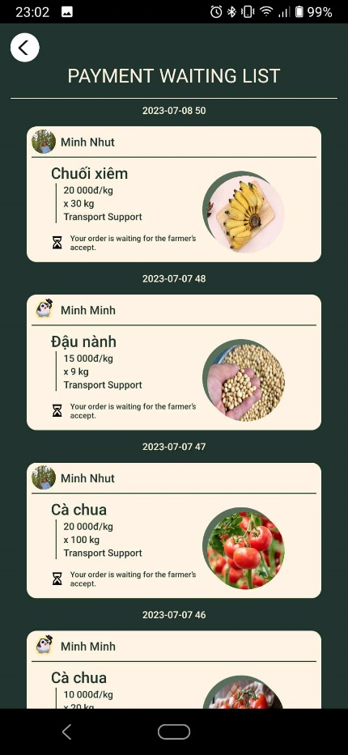

Figure 3. . Payment waiting list

Returning to the role of a farmer, let's navigate to the orders page.

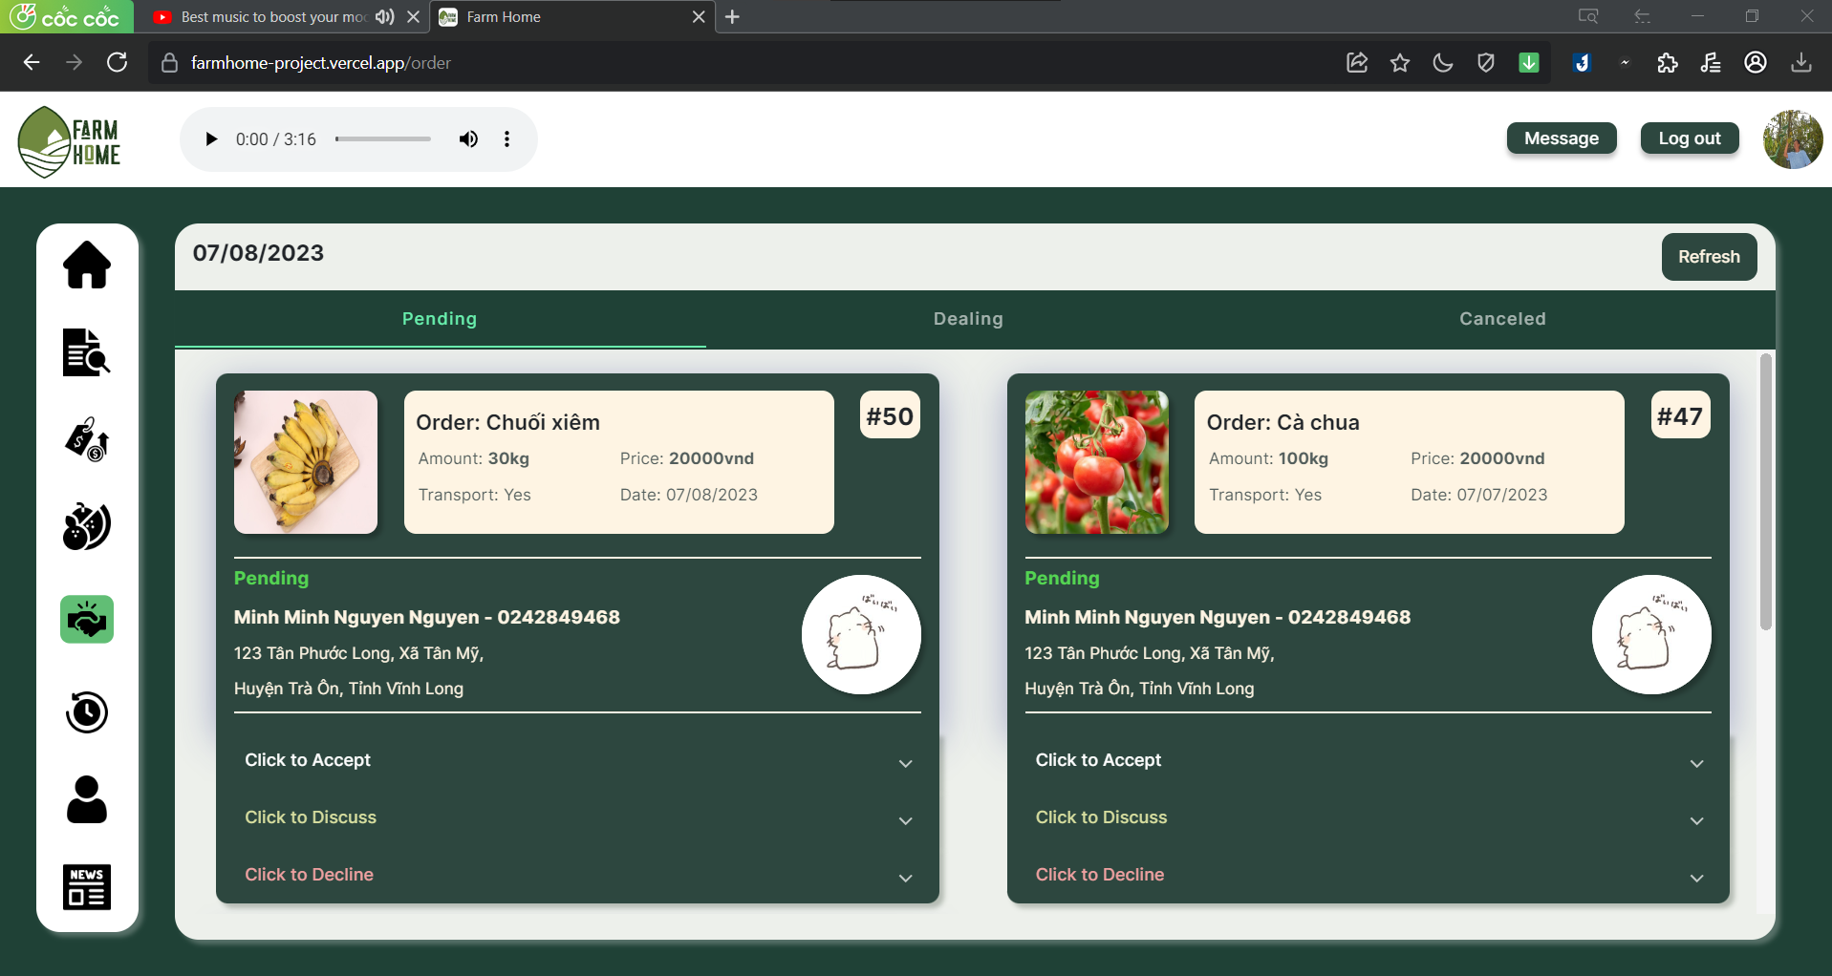

Figure 3. . Order page

Accept order.

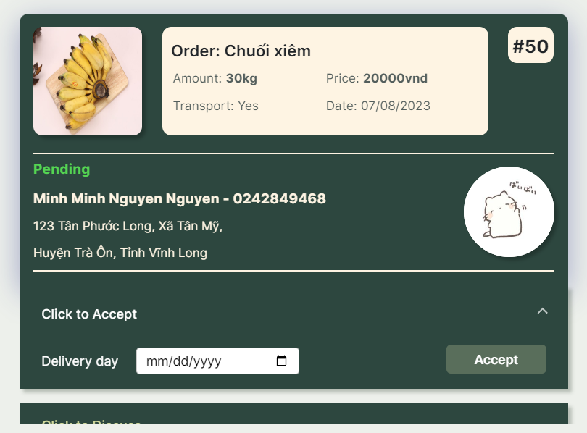

Figure 3. . Accept order

Negotiating about the new price.

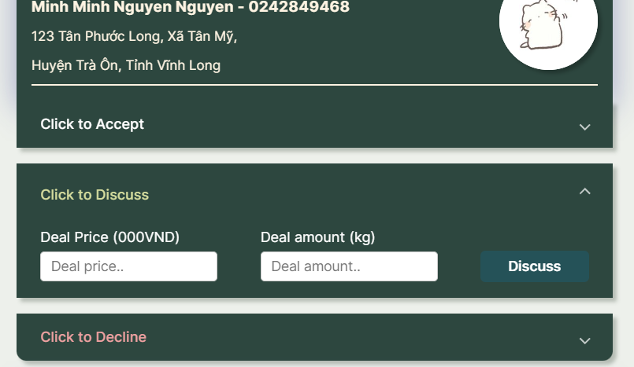

Figure 3. . Negotiating about the new price

Decline this order.

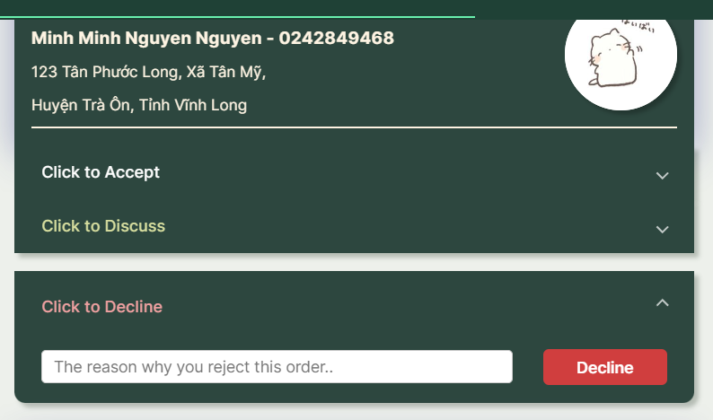

Figure 3. . Decline order

Let's try to negotiate a new price..



Figure 3. . Discuss new price and amount

The order will be moved from "Pending" to "Dealing" status with the new price and quantity.

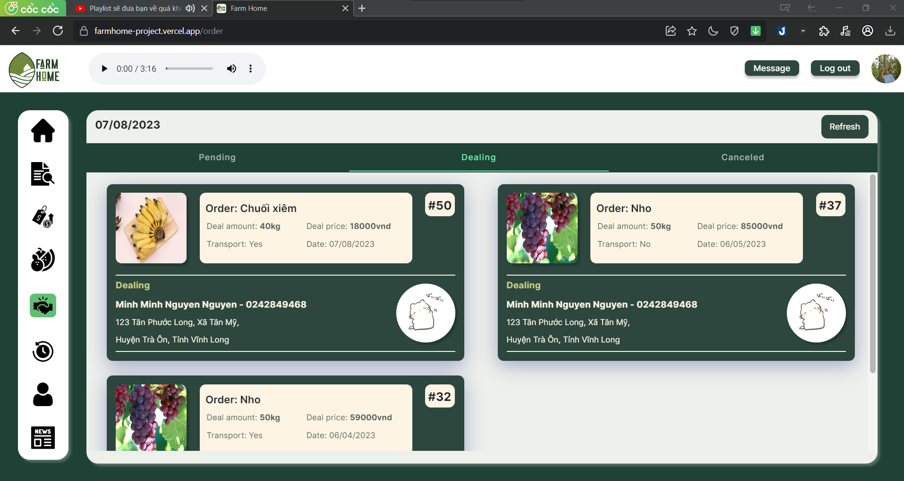

Figure 3. . Dealing tab

The phone will receive a notification.

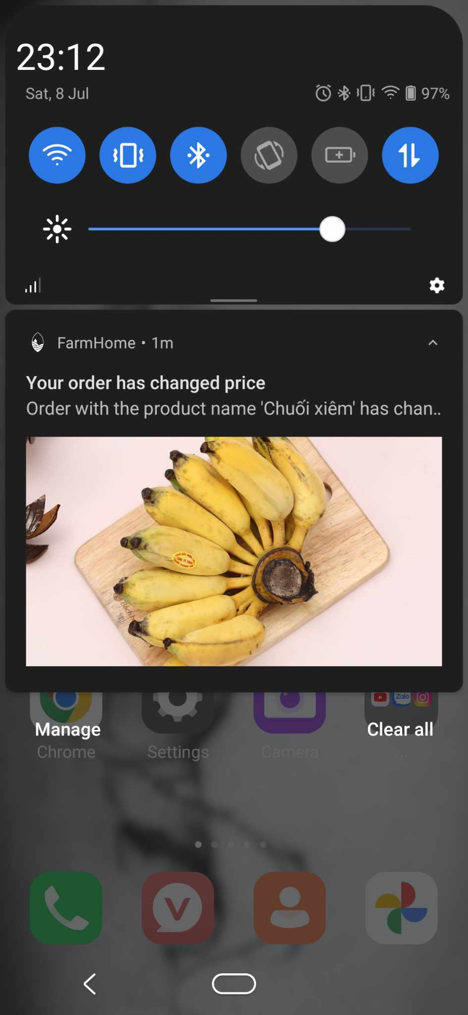

Figure 3. . Phone recived notification

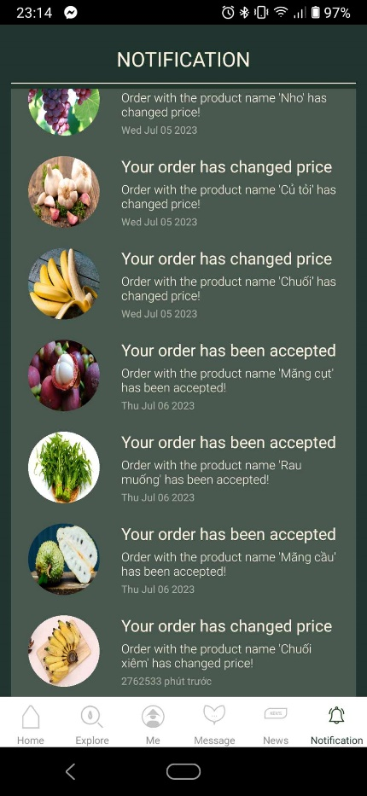

Going into the order details, you will see a section to confirm the deal price. Agreeing to it.

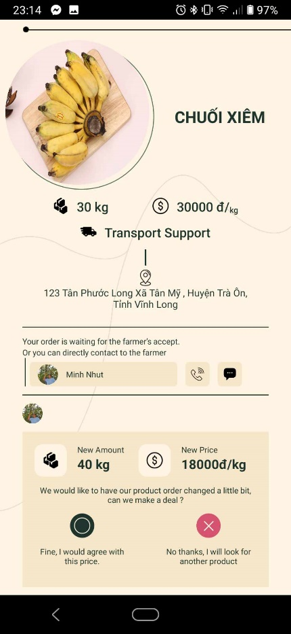

Figure 3. . Order details

After the merchant agrees to the new price, the order will be moved back to the "Pending" status.

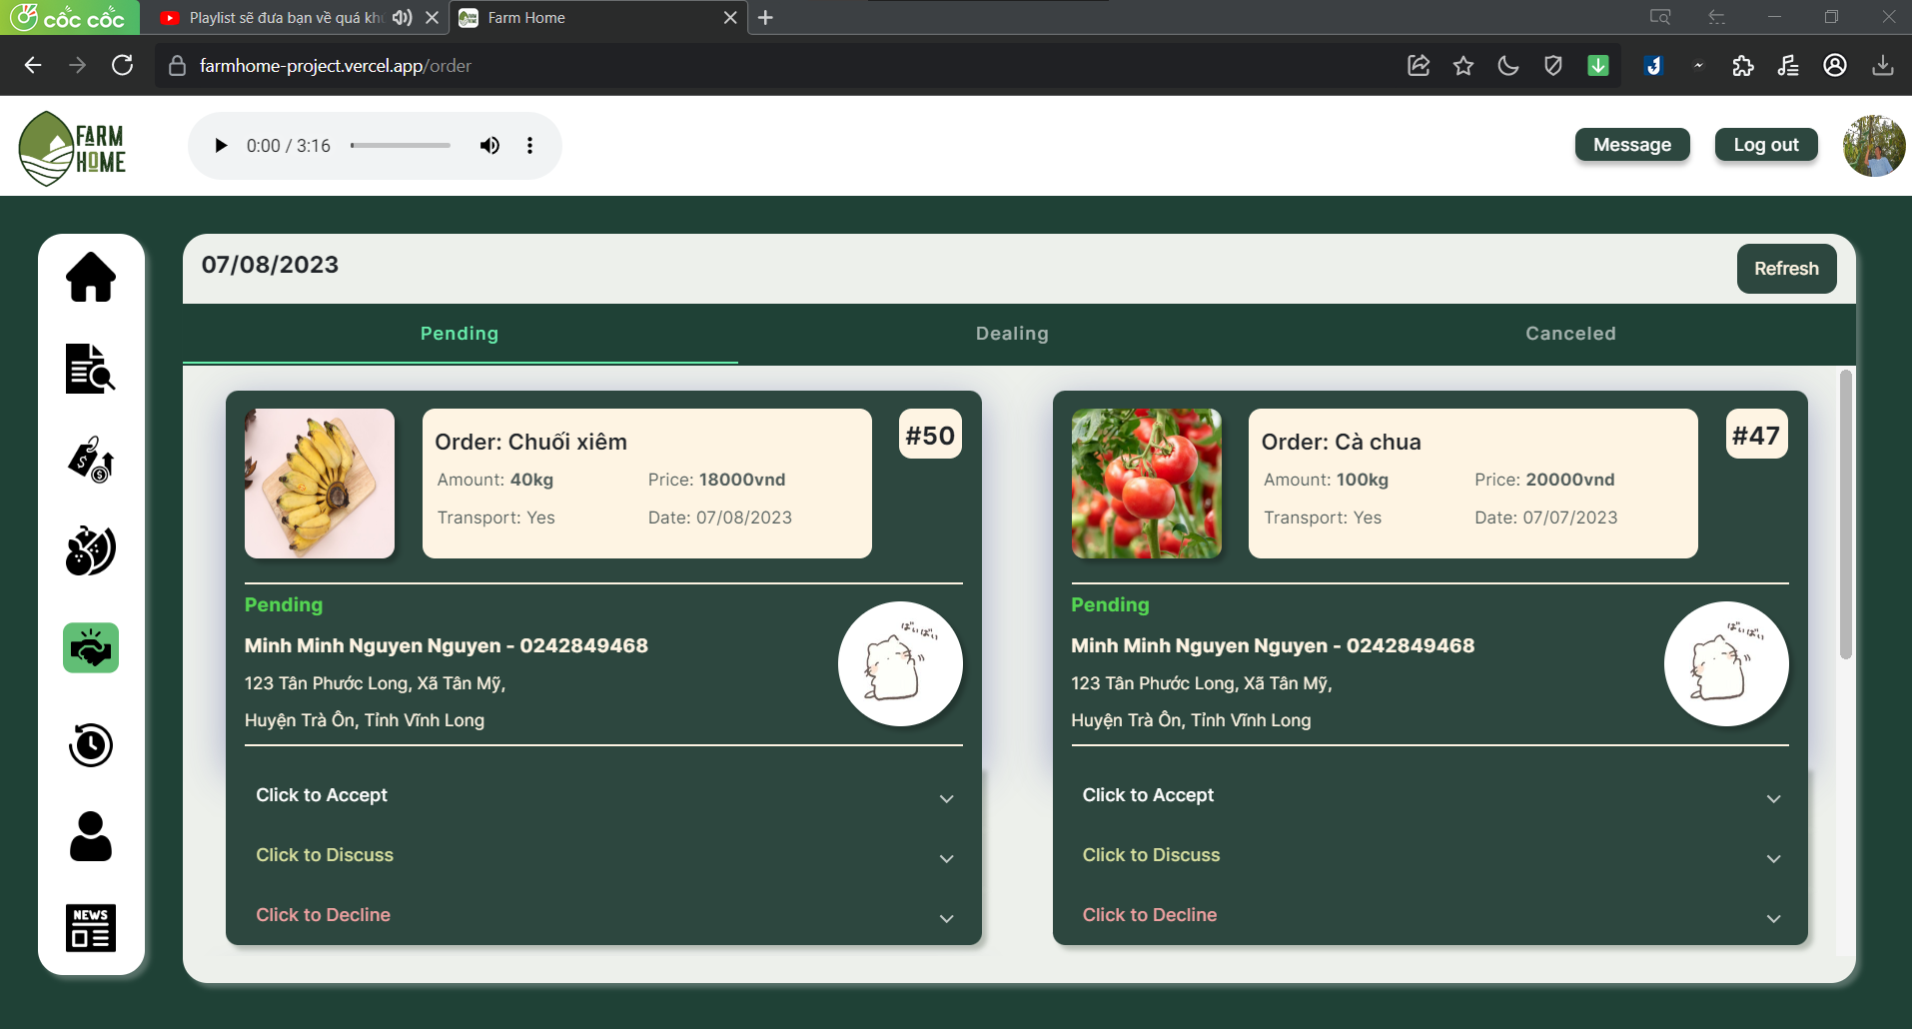

Figure 3. . Pending tab

Agree to the order and select the delivery date (if there is a delivery option available, otherwise this section may not be present).

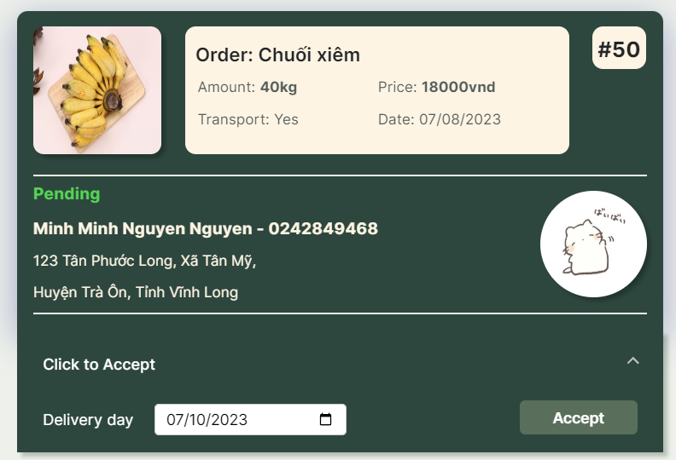

Figure 3. . Accept order

After the order is successfully confirmed.

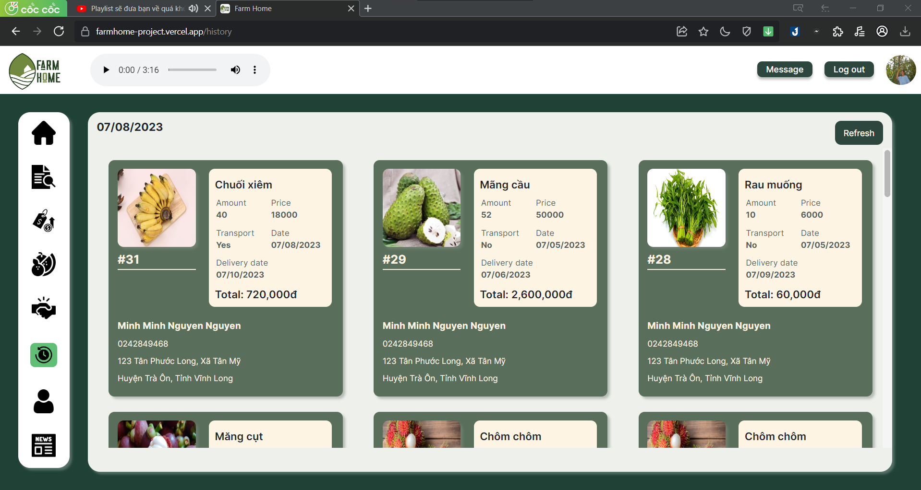

Figure 3. . History page

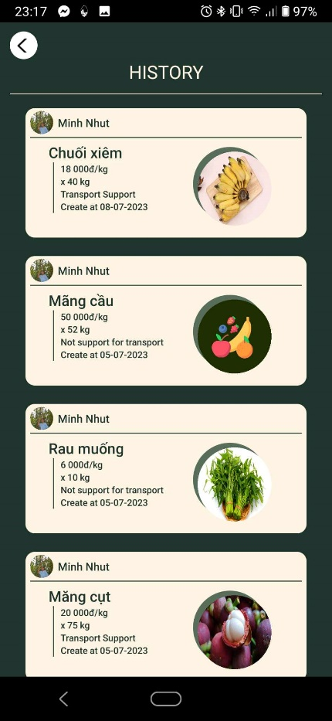

Figure 3. . History screen

In addition, there are other features to explore, such as profile management, search with image in mobile, etc …

# CHAPTER 6. CONCLUSION

## 6.1. Achieved result

### 6.1.1. About knowledge and skills:

We see the use of Java with the Spring Boot framework and a small portion of Python for backend development. This enables the creation of APIs to support frontend and mobile applications efficiently. Students are equipped with fundamental knowledge of Java with the Spring Boot framework and Python, including object-oriented programming, data structures, and algorithms. They also learn about web development, including handling HTTP requests and responses, creating RESTful APIs, and implementing web security.

Additionally, Spring Boot facilitates database connection, allowing students to learn about object-relational mapping and writing efficient queries. It is crucial for students to understand how to deploy Spring Boot applications to different environments and platforms, and they can explore other technologies through cloud platforms like Google Cloud Console or Railway to enhance continuous integration and delivery pipelines. Moreover, working with TensorFlow makes the exploration of machine learning and AI applications more practical.

Bugging plays a vital role in the development process as students encounter issues and errors, and they enhance their troubleshooting and problem analysis skills using debugging tools.

The system highlights the use of JavaScript, Typescript, SASS/SCSS with the React JS, React Native library as well as Angular with its material for developing the admin page, website for farmers, mobile app for merchants enabling dynamic styling, animations, and interactivity for the website.

Students gain fundamental knowledge of JavaScript, Typescript, SASS/SCSS and the React library, Angular material, including syntax, data types, variables, control flow, and manipulation of HTML elements through the Document Object Model (DOM). They also learn about handling asynchronous operations and user interactions, such as making API requests, managing callbacks, and responding to events.

The JavaScript ecosystem offers a variety of third-party libraries and frameworks, like Axios for HTTP requests and Redux for managing application state, providing additional features and functionalities for specific purposes. Debugging is also emphasized as an essential skill for troubleshooting and analyzing problems encountered during the development process.

### 6.1.2. About the topic:

The backend program is built to provide comprehensive support and ensure the required APIs of the frontend and mobile applications are met.

The admin website provides features for user monitoring, user management, product management, category management, and sales data analytics.

A mobile app used for “Merchant” role to view and order products, also support for other support feature like chat, change information and read news, etc... When there is an event that they will have a notification sent back to their phone.

The website is designed to assist farmers in managing agricultural products and handling orders. Users can log in to their accounts and manage information about various agricultural products, including detailed descriptions, images, descriptions, and prices. They can add, modify, or delete products as needed. It also provides features to manage orders placed by customers. Farmers can view a list of pending orders, confirm, discuss or decline orders, etc…

## 6.2. Strengths

Using a third-party file storage provider ensures seamless and efficient uploading of images and files without interruptions or excessive load.

Database and applications are hosted on the internet, users do not need to install third-party applications to be able to use them.

Intergrated a agricultural detection model that can be used to classify those products for further automation process in the project such as classification, searching by image.

The errors have been thoroughly tested by all members who have been learning through the software testing course. Understand the procedures for finding errors and making corrections.

The interface undergoes continuous improvements based on feedback from instructors, resulting in enhanced user suitability. Careful sourcing and consultation with experts ensure the accuracy and relevance of statistical indicators. By optimizing simple functions, the platform achieves higher efficiency and effectiveness.

The platform caters to both "Merchant" and "Farmer" sides of agricultural product trading, offering essential functions for trading purposes. Additional support functions are available to facilitate the trading process.

The platform collects data to provide users with real-time market prices, enabling them to stay updated with current pricing trends. Notifications are sent directly to users's mobile phones, ensuring prompt awareness of any events or updates related to their orders.

With the assistance of fruit detection technology, users can easily identify different types of fruits by capturing images. This streamlined process simplifies data recording and information retrieval, thanks to the utilization of a pre-trained model.

## 6.3. Drawbacks

Although some functions within the application have not been fully optimized, they may not provide optimal access speed. As the application has not been specifically optimized for high frequency and large-scale usage, there is a possibility of encountering errors related to speed or storage capacity.

While some errors can be returned to the frontend for self-adjustment, they are not completely resolved autonomously. It's important to note that the machine learning model used for classification purposes may misclassify some new agricultural products.

In real-world scenarios, there may be instances where certain features are missing or insufficient, which can present challenges for users. For example, the absence of comprehensive statistical data can create difficulties for individuals in financial fields who rely on detailed statistics for documentation and analysis purposes.

Another potential challenge arises from the limited availability of advanced permission management features, which can make it challenging to effectively manage user roles and access levels, potentially compromising system security and control.

Furthermore, the absence of a dedicated reference price management feature for farmers can pose difficulties. Farmers often rely on reference prices to make informed decisions about pricing their products, and the lack of this functionality can complicate the process of setting competitive prices in the market.

The current website for farmers lacks important functions such as messaging, notifications, and language switching. Additionally, mobile does not support IOS devices at the moment. Furthermore, there is a lack of detailed delivery statuses for both farmers and merchants, which can impact tracking and managing orders effectively. The performance of the chat service is not up to the desired standard. Moreover, the website does not offer support for social media login, as well as features like rating and comments for farmers, limiting engagement and feedback from users.

## 6.4. Future developments

Improve the limitations that have not been reached.

To accommodate future development, potential APIs can be integrated to introduce functionalities like social media login, rating, commenting, and more. Clearer user categorization can be achieved by implementing additional roles such as a super admin or external service providers for agricultural products. Optimizing coding logic and algorithms will enhance access speed. Furthermore, the development of a new self-learning model can enable the system to learn and detect a wider range of agricultural products with improved accuracy.

Introducing a super admin role to facilitate systematic management of other admins would be a valuable improvement. Additionally, incorporating a feature that enables admins to make decisions and adjust reference prices for farmers' products would enhance functionality. Furthermore, implementing programs to identify and retain potential users, along with incentives for popular products, would contribute to the platform's growth and engagement.

Creating a better business model for the circular economy entails providing solutions for farmers to address issues related to bad harvests and damaged products. By implementing strategies such as crop diversification, climate-resilient farming practices, and effective post-harvest management techniques, farmers can mitigate the impact of unfavorable harvests. Additionally, introducing innovative packaging and storage methods can help reduce product damage and waste, promoting sustainable agricultural practices and resource optimization.

To enhance the delivery process, it is essential to offer more options to users. This can be achieved by providing merchants with access to warehouses where they can store their products conveniently and securely. Moreover, integrating with third-party delivery services can offer greater flexibility and choice for both farmers and merchants, ensuring efficient and reliable delivery of agricultural products to customers. These initiatives contribute to the overall improvement of the supply chain and facilitate smoother transactions within the agricultural ecosystem.

**REFERENCES**

[1]. ThS. Phạm Phương Trung và Bùi Dạ Quỳnh, Nghiên cứu đề xuất hoạt động bán hàng trực tuyến trên sàn thương mại điện tử cho cửa hàng Sepon 8s (2021).

[2]. Phạm Việt Phương, Thương mại điện tử cho mặt hàng nông sản gắn với nông hộ, 2016, Luận văn Thạc sĩ Quản trị Kinh doanh, Trường Đại học Kinh Tế (2016).

[3]. Krishna Murthy R and Noor Sumaiya, E-Commerce Agricultural Products Based on Blockchain, International Research Journal of Engineering and Technology, Volume 08, Issue 05 (May 2021).

[4]. Dariusz Strzębicki, The Development of Electronic Commerce in Agribusiness – The Polish Example, Procedia Economics and Finance 23 (2015), 1314 – 1320.

[5]. Amigoscode, Spring Boot and Spring Security with JWT including Access and Refresh Tokens (July 25th 2021).

Retrieved from:

[*https://www.youtube.com/watch?v=VVn9OG9nfH0&ab_channel=Amigoscode*](https://www.youtube.com/watch?v=VVn9OG9nfH0&ab_channel=Amigoscode)

[6]. loda.me, Hướng dẫn Spring Security + JWT (Json Web Token) + Hibernate (May 31st, 2019).

Retrieved from:

[*https://viblo.asia/p/huong-dan-spring-security-jwt-json-web-token-hibernate-oOVlYGmoK8W*](https://viblo.asia/p/huong-dan-spring-security-jwt-json-web-token-hibernate-oOVlYGmoK8W)

[7]. baeldung, Spring Data JPA Delete and Relationships (September 5th, 2022).

Retrieved from:

[*https://www.baeldung.com/spring-data-jpa-delete*](https://www.baeldung.com/spring-data-jpa-delete)

[8]. Michał Pierzchała - Head of Technology at Callstack, React Native Core Contributor Summit 2022.

Retrieved from:

[*https://reactnative.dev/blog*](https://reactnative.dev/blog)

[9]. Angular Official Documentation.

Retrieved from:

[*https://angular.io/docs*](https://angular.io/docs)

[10]. Yakov Fain and Anton Moiseev, Angular Development with TypeScript (December 2018).

Retrieved from:

[*https://www.manning.com/books/angular-development-with-typescript-second-edition*](https://www.manning.com/books/angular-development-with-typescript-second-edition)

[11]. React Official Documentation.

Retrieved from:

[*https://legacy.reactjs.org/docs/getting-started.html*](https://legacy.reactjs.org/docs/getting-started.html)

[12]. Alex Banks and Eve Porcello, Learning React: Functional Web Development with React and Redux.

Retrieved from:

[*https://www.oreilly.com/library/view/learning-react/9781491954589*/](https://www.oreilly.com/library/view/learning-react/9781491954589/)

[13]. React Native Official Documentation.

Retrieved from:

[*https://reactnative.dev/docs*](https://reactnative.dev/docs)

[14]. Spring Boot Official Documentation.

Retrieved from:

[*https://spring.io/projects/spring-boot#learn*](https://spring.io/projects/spring-boot#learn)

[15]. TensorFlow Official Documentation.

Retrieved from:

[*https://www.tensorflow.org/guide*](https://www.tensorflow.org/guide)

[16]. MySQL Official Documentation.

Retrieved from:

[*https://dev.mysql.com/doc/*](https://dev.mysql.com/doc/)

**WORKFLOW**

|  |  |  |
| --- | --- | --- |
| **ID** | **Student Name** | **Work** |
| 19110151 | Pham Viet Anh | Spring boot, Tensorflow, React JS |
| 19110145 | Tran Dang Khoa | React Native, React JS |
| 19110100 | Nguyen Le Minh Nhut | Angular, Report |